English Phonetics and Phonology
Week 15 – Exam Week
Lecturer: Maria Dewi Rosari, M.Pd.
ANSWER KEY

Name :
Affiliated university :

Here are the answers for the final exam of English Phonetics and Phonology Course. Please kindly check your own answers and assign scores to your own work. Good luck!

Question | Answer:
1  - What is the difference between phonetic and phonology?  - What is the difference between phoneme and allophone? Give examples | - Phonetics is the study of the speech sounds. For example, it studies the characteristics of the speech sound. It is made of symbols.  Phonology is the description of the systems and patterns of speech sounds in a language. It is the rules that every speaker of a language knows about the patterns of that language, unconsciously. An example of one such rule would be the understanding that the words “eighth” and “butter” both have the letter [t], but they are pronounced differently based on the other letters around them.  - A phoneme is an abstract unit, the smallest segment which can be used to differentiate meanings in a given language. Meanwhile, allophone is the variant of the phoneme. Examples: phoneme [p] has the allophones/variants of [p] and [p^{h}].
2  Why do [p^{e}] and [pº] belong to the same phoneme in English? | - [pº] is for final [p] released and [p^{e}] is for final [p] not released.  - They are interchangeably in pronouncing a word (e.g. map) and it doesn’t change the meaning.
3  What is the difference between active and passive articulator? Provide some examples of active and passive articulators! (10pt) | Passive articulators are speech organs that don’t move while the active ones are the ones that move. The example of passive: upper lip and active: tongue.
4  What is the difference between fortis and lenis consonant? Provide some examples of fortis and lenis consonants! | Fortis: characterized by strong force of articulation. Example: p, t, k, tʃ, f, Ѳ, s, ʃ  Lenis: weak strong of articulation. Example: b, d, g, dʒ, v, δ, z, ʒ
5  - What is friction produced?  - What are aspirated phonemes?  - What is the difference of the aspiration in between ban and pan?  - How is the aspiration of /p/ in “pin” different from the one in “apple”? | - The [h] sound is a cavity friction released when pronouncing certain consonants  - [p, t, k]  - [p] in pan is aspirated (has [h] sound]) and [b] is not aspirated.  - [p] has a strong aspiration when it is in the initial position of a stressed syllable before vowels such as in pin. [p] in apple, on the contrary, is not in the initial position so the allophone [ph] is not as strong as the one in pin because it comes before a syllabic sonorant.
6  - Mention some stop consonants!  - Mention some words that contains stop consonants | - [p, t, k, tʃ, b, d, g, dʒ]  - Pain, take, kick
7  When making the sound of phoneme /l/, “darkening” happens. Explain the position of our tongue when “darkening” takes place in the pronunciation of phoneme /l/!  Mention some words in English written with [l] darkened! | Darkening is a situation where the tongue is raised during the articulation of /l/. The higher the back of the tongue, the darker (i.e. the more velar) the quality of the /l/ sound. Darkening is symbolized [l]  Example: leap, left, ladder
8  What is minimal pair and provide some examples of two English words that are minimal pairs! | Minimal pairs are pairs of words or phrases in a particular language, spoken or signed, that differ in only one phonological element, such as a phoneme. Example: beat and bit, bait and bet
9  Explain the four parameters of the articulation of vowels! | Height: about the distance between the active articulator (the tongue) and the passive articulator (the roof of the mouth).  Depth: about the part of the tongue and the part of the roof of the mouth involved in the articulation of the vowels.  Lip rounding: rounded vowels (u, U, o, Ɔ) and unrounded vowels (i, ɪ, e, Ɛ)  Diphthongization about a vowel segment which occurs as a single syllable, acts as a single unit. It is characterized articulatory by a glide from the position for one vowel toward the position for another.
10  What is the difference between diphthongs and monophthongs? Mention some examples for each! | A monophthong is a pure vowel sound, one whose articulation at both beginning and end is relatively fixed, and which does not glide up or down towards a new position of articulation.  Diphthongization about a vowel segment which occurs as a single syllable, acts as a single unit. It is characterized articulatory by a glide from the position for one vowel toward the position for another.
11  Explain how a vowel can be nasalized? Provide some nasalized vowels! | In the normal articulation for all vowels in English, the velum is raised blocking off the nasal cavity, so that all the air escapes through the mouth.  However, whenever a nasal consonant follows a vowel, the lowering of the velum is likely to be premature, occurring before the oral closure has been formed. This means that (the last part of) the vowel is nasalized in words like Ann, dim, song.
12  How do AE speakers differentiate the sound between /e/, / Ɛ/, and /ӕ/! Answer it by explaining the vowel quality! | American English speakers distinguish between /e/, / Ɛ/ and / ӕ / before /r/ just like in the words of Mary, merry, marry.
13  - What are the similarities in the pronunciation of /i/ and /ɪ/?  - What are the differences in the pronunciation of /i/ and /ɪ/? | - When we pronounce /i/ and /ɪ/ our lips are not rounded. When we pronounce both vowels the velum is raised, and the front tongue is moved to the hard palate  - The difference is /i/ is close and /ɪ/ is a half close. The lips in /i/ is spread while in /ɪ/ is neutral.
14  - What are the similarities in the pronunciation of /u/ and / ʊ /?  - What are the differences in the pronunciation of /u/ and / ʊ /?  - When is the distinction between /u/ and / ʊ / neutralized? Provide some examples! | - When we pronounce /u/ and /ʊ/ our lips are rounded. When we pronounce both vowels the velum is raised, and the back of the tongue is raised toward the velum.  - The difference is /u/ is a close and /ʊ/ is a half-close vowel. The lips in /u/ are protruded while the ones in /ʊ/ are rounded.
15  - How does our tongue glide when articulating /aɪ/?  - How is the diphthong /aɪ/ regularly spelled in English? Provide some examples! | - The tongue glides from the position for an open central vowel toward the position for a half-close front vowel without necessarily reaching this final position.  - /aɪ/ is regularly spelled i (in words that end in e) and y: mine.
16  - How does our tongue glide when articulating /aU/?  - How does our lip move when articulating /aU/?  - Mention 3 ways of how the diphthong /aU/ is regularly spelled in English! Provide some examples! | - The lips start in neutral position and become rounded in the course of the articulation of the sound.  - The lips start in neutral position, and become rounded in the course of the articulation of the sound.  - /aʊ/ is regularly spelled ou, ow: sound, now.
17  - How does our tongue glide when articulating /Ɔɪ/?  - How does our lip move when articulating /Ɔɪ/?  - How is the diphthong /Ɔɪ/ regularly spelled in English? Provide some examples! | - The tongue glides from the position for a mid back vowel toward the position for a half-close front vowel without necessarily reaching this final position.  - The lips are slightly rounded or neutral for the first element and neutral or slightly spread for the second element.  - /Ɔɪ/ is spelled oi and oy (soil, boy).
18  Please prove that the word “dated” has two syllables by showing and explaining the variation between peaks and trough of sonority in a graph! | 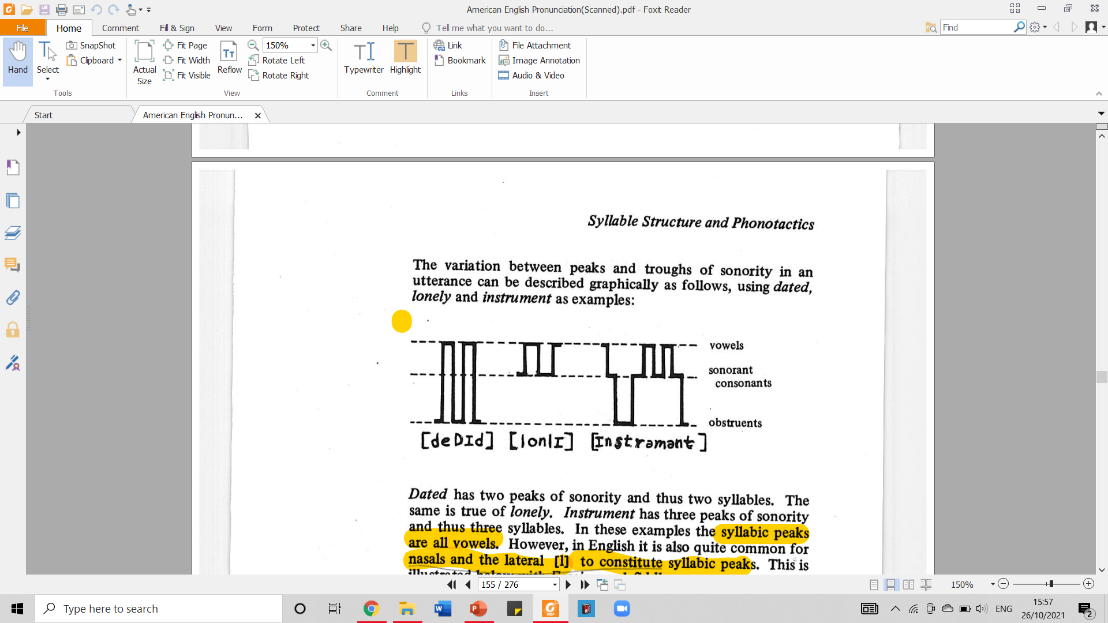  Taken from American English Pronunciation Book of Bauer et al., (1980)  The word “dated” has two peaks, one of which represent each syllable of the word.
19  - What is the definition of onset?  - What is the definition of coda?  - Please draw the graph showing the structure of a syllable!  - Please analyze the structure of the syllable of the following words: cat, ought, and leave | - Onset is the one consisting of segments with increasing sonority  - Coda is the one consisting of segments with decreasing sonority.  - 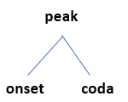  - 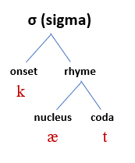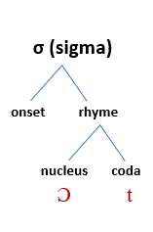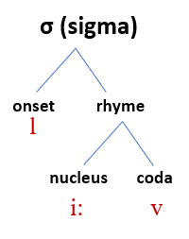
20  - What is assimilation?  - What is disassimilation? | - Assimilation is when two segments become more like each other.  - Dissimilation is when two segments become less like each other.
21  Provide one example where assimilation takes place:  - within a word!  - across a word! | - Happen  - Ten minutes
22  - What is regressive assimilation?  - Provide an example showing a regressive assimilation happens!  - What is progressive assimilation?  - Provide an example showing a regressive assimilation happens! | - Regressive assimilation is assimilation whose influence works backwards.  - love me /lʌv/ /mi:/ /lʌm mi:/  - Progressive assimilation is the one whose influence work forward.  - Read These /ri:d ði:z/ /ri:d di:z/
23  - Where does assimilation commonly take place?  - What is the downside of not using assimilation? | - Assimilation is more common in fast colloquial speech than in very formal speech, it is always present.  - Speakers who do not use assimilation will sound stilted and foreign. The student is therefore advised to note assimilation in the speech of native speakers, and to imitate this feature of natural English.
24  - What is simultaneous articulation?  - Explain the simultaneous articulation occurring in “blend”!  - What is continued articulation?  - Explain the continued articulation occurring in “ample”! | - Just by its name “simultaneous (occurring, operating, or done at the same time) articulation” we can conclude that it is the branch of co-articulation which happens when two phonemes articulated at the same time by the non-essential articulators.  - In the word “blend”. The [l] is actually articulated at the same time as the [b] (This when the simultaneous articulation occurs). How it happens? Well, when we pronounce it, our lips are closed (an essential feature of the [b]) and simultaneously the tip of our tongue is in contact with the alveolar ridge (non-essential for the [b] but compatible with it; Essential for the [l].  - When we pronounce the word “ample”, we do not open our lips between the phoneme [m] and [p]. This when continued articulation occurs as there is no break/ it is on-going as we pronounce the [m] and [p].
25  What are the root stress rules (RSR) for:  - Roots of 3 syllable or less?  - Roots of more than 3 syllable?  Provide some examples of each! | - Primary stress initial syllable  - Primary stress antepenultimate syllable
26  How does “trace” or the occurrence of secondary stress exist in a suffixation? | If the primary stress is pulled at least two syllables to the right.
27  - What does prefixation rule say about primary stress placement?  - Provide some examples! | - Prefix addition generally has no effect on the placement of primary stress  - Unkínd
28  - What does prefixation rule say about secondary stress placement?  - Provide some examples and explain them! | - Prefixation rule said that primarly stress fall on the final syllable, but generally prefixation addition has no effect on the placement of primary stress, but increase the number of secondary stresses.  - Example  Unki'nd/u`nki'nd  Unha'ppy/u`nha'ppy  Prono'unce  Prohi'bit
29  When nominal form is as the second element of a collocation,  - What is the general stress placement rule?  - Show the stress placement (by giving some examples) when the nominal form is preceded by  - Nominal  - Adjective  - Verb  - Particle  - How about the stress placement rule in compound like collocations when nominal form is as the second element? | - This type of Compounds generally follows the normal pattern in stress the first element.  - 1. Nominal+ Nominal; bedroom, wállpaper and cówboy.  2. adjective+ Nominal; whíte house, quícksand and bláckboard  3. verb+ Nominal; dróp leaf, stóp watch and wéar pants.  4. particle+ Nominal; óverdose, áfterlife and óvercome.  - when compound are collocations of two or more simple words only one of which receives primary stress. Example paper doll, paper mill. Stone wall, stone mason.
30  When past participle is as the second element in compounds collocation:  - What is the stress placement rule?  - What are the examples of words that belong to this type of collocation? Show the stress placement as well! | - The stress placement rule follows the normal stress pattern: stressing the first element  - Hair-cut: hair is the noun element and cut is the past participle.  Head-set: here head is the noun element and the set is past participle.

