Business English
Chapter 6
Buyers, sellers and the market
Lecturer: N.A.Mukhitdinova, PhD
Customers and clients
customer base – a business’s customer base is all its regular customers, considered as a group
clientele - all the clients of a business or all the customers of a shop
Key Differences Between Customer and Client
- A person who purchases goods and services, from the company is known as the Customer. Client refers to someone who seeks professional services from the company;
- There exist an agency agreement between the client and the service provider. Conversely, there is no such agreement between the customer and the business entity;
- A company focuses on selling the product and services to the customer. On the other hand, the company focuses on serving the client;
- The company offers goods and services to its customers. Talking about clients, who seek for professional services like advisory, legal, consultancy and may more;
- The degree of personal attention required in case of the customer is less as compared to the client;
- A relationship between customer and business exist for a short term only. However, a customer can have repeated transactions but only for a limited time. In the case of a client, the business engages in a long-term project with the client.
end – user - the person or organization that uses something rather than an organization that orders, pays for in it
consumer – a person who buys goods or services for their own use
Consumer vs end user
We can use the term “consumer” to refer to “consumer products” as in products sold to individuals (B2C) vs enterprise customers or B2B customers. End users exist in both consumer and business sales. For example, a mother may buy a child an educational toy. The mother is the consumer but the child is the end-user and both must have a satisfactory customer experience. Similarly, the decision maker for a B2B solution or enterprise sale is typically a department had while the end-users are the employees who consume the product, be it software or office furniture or equipment of some kind.
People who buy IBM’s products and services are IBM’s customers or clients.
Foster and Partners, a big architectural firm, has clients, rather than customers. Client often refers to people and organizations who buy the services of professionals such as accountants, lawyers, etc.
IBM’s customers considered as a group make up its customer base. Foster and Partners’ clients considered as a group form a client base. These are slightly technical expressions, used for example in business journalism.
People who buy a company’s or a professional’s products or services, especially expensive or exclusive ones, are its clientele.
You can also talk about the users of a product or service who may not be the organizations who actually buy it. The expression end-users refer especially to people who use products, particularly computer equipment and other technology. These expressions are often used in contrast to the producers and distributors of a product. For example, IBM sells products through various channels, but the end-users are the employees of the companies that buy its products. People who buy products or services for their own use are consumers, especially when considered as members of large groups of people buying things in advanced economies.
buyer – (a) is a person who is buying something or who intends to buy it;
- (b) is a person who works for a large store deciding what goods will be bought from manufacturers to be sold in the store;
purchaser – person or entity that is a recipient of a good or service provided by a seller under a purchase order or contract of sale. Also called buyer;
buying manager - The buying manager of a store is a senior employee whose job is to manage the purchase and delivery of products and supplies, maintaining stock levels;
vendor – someone who sells something, especially property;
street vendor - a vendor is someone who sells things such as newspapers, cigarettes or food from a small stall or cart in the street, sometimes illegally;
the market – is defined as the sum total of all the buyers and sellers in the area or region under consideration. The area may be the earth, or countries, regions, states, or cities;
the free market – is an economic system in which business organizations decide things such as prices and wages and are not controlled by the government;
market economy - is an economic system in which economic decisions and the pricing of goods and services are guided by the interactions of a country's individual citizens and businesses;
market forces (market pressures) - the actions of buyers and sellers that cause the prices of goods and services to change without being controlled by the government;
market place – a set of trading conditions or the business environment;
market price –is the current price at which an asset or service can be bought or sold;
Buyers and sellers of goods or services in a particular place form a market.
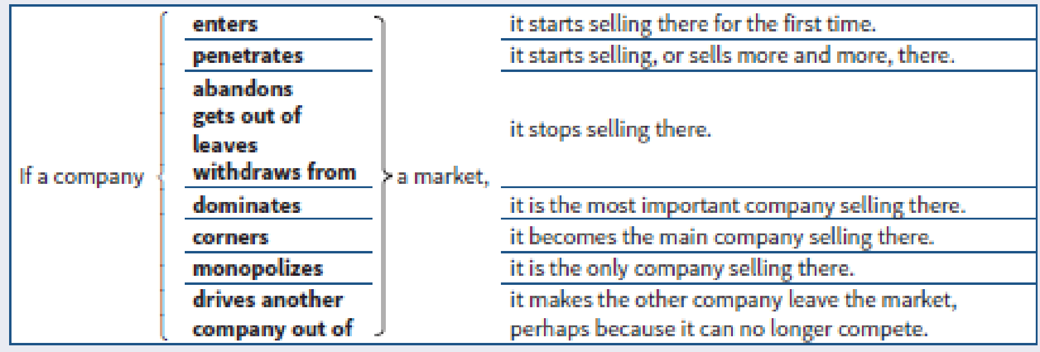
Market is often used in these combinations.

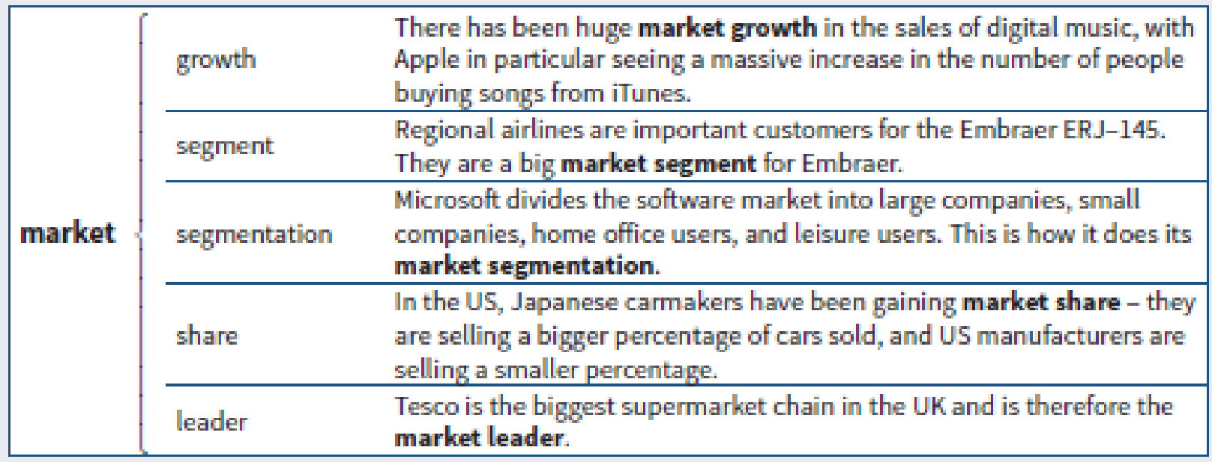
a competitor - is a person, business, team, or organization that competes against you or your company. If somebody is trying to beat you in a race, that person is your competitor;
a rival – is a person, business, or organization who you are competing or fighting against in the same area or for the same things;
key players – an important person or company, etc. in a particular area of activity;
low key - if you say that something is low-key, you mean that it is on a small scale rather than involving a lot of activity or being made to seem impressive or important.
Competition is used to talk about the activity of trying to sell more, be more successful, etc. When competition is strong, you can say that it is intense, stiff, fierce or tough. If competition isn’t strong, it may be described as low-key.
The competition refers to all the products, businesses, etc. competing in a particular situation, seen as a group.
Reference
- Business Vocabulary in use, Bill Mascull, Cambridge University Press, 2017.
- Business English, Course handbook, Giedre Rimkiene, SMK University of Applied Social Sciences, 2014.
- https://www.channels.app/blog/client-vs-customer
- https://www.smartkarrot.com/resources/blog/consumer-vs-customer/

