Business English
Chapter 12
Sales and costs
Lecturer: N.A.Mukhitdinova, PhD
Profit and profitability
Although the two terms are used interchangeably, profit and profitability are not the same. Both are accounting metrics in analyzing the financial success of a company, but there are distinct differences between the two. To adequately determine whether a company is financially sound or poised for growth, investors must first understand what differentiates a company’s profit from its profitability.
Profit is an absolute number determined by the amount of income or revenue above and beyond the costs or expenses a company incurs. It is calculated as total revenue minus total expenses and appears on a company's income statement. No matter the size or scope of the business or the industry in which it operates, a company's objective is always to make a profit.
Profitability
Profitability is closely related to profit – but with one key difference. While profit is an absolute amount, profitability is a relative one. It is the metric used to determine the scope of a company's profit in relation to the size of the business. Profitability is a measurement of efficiency – and ultimately its success or failure. A further definition of profitability is a business's ability to produce a return on an investment based on its resources in comparison with an alternative investment. Although a company can realize a profit, this does not necessarily mean that the company is profitable.
Unprofitability - the quality of affording no gain or no benefit or no profit
A supermarket manager talks about the costs and prices for some of its products.

Budgets and expenditure
Like all companies Nordsee and Vaclav have to budget for, or plan, their costs, and have a budget. Look at the graphs comparing their planned budgets with their expenditure (what they actually spend)
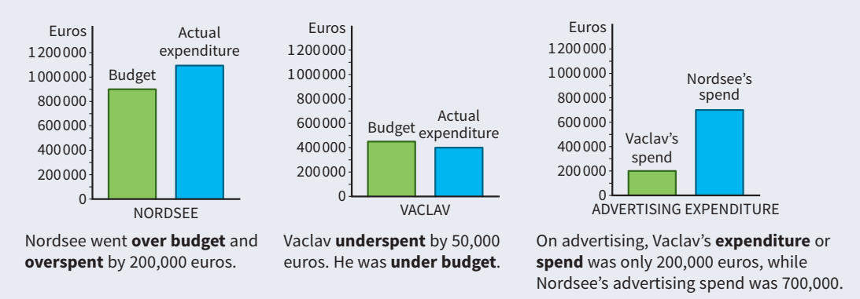
What is expenditure budget?
Expenditure Budget provides complete information about the total expenditure of the Union government in a financial year. This exhaustive information is classified into two broad categories as per the end-use – capital expenditure and revenue expenditure. While the former results in the creation of a physical asset or investment, the latter comprises mainly operational expenses such as payment of wages, pensions, subsidies, and interest.
What Are Economies of Scale?
Economies of scale are cost advantages reaped by companies when production becomes efficient. Companies can achieve economies of scale by increasing production and lowering costs. This happens because costs are spread over a larger number of goods. Costs can be both fixed and variable.
Learning curve
The learning curve also is referred to as the experience curve, the cost curve, the efficiency curve, or the productivity curve. The idea behind this is that any employee, regardless of position, takes time to learn how to carry out a specific task or duty. The amount of time needed to produce the associated output is high. Then, as the task is repeated, the employee learns how to complete it quickly, and that reduces the amount of time needed for a unit of output.
Reference
1. Business vocabulary in use, bill Mascull, Cambridge university press, 2017.
2. Business English, course handbook, Giedre Rimkiene, SMK university of applied social sciences, 2014.
3. https://www.investopedia.com
4. https://www.accountingtools.com
5. https://www.business-standard.com

