Business English Course
Lesson 10: Project management
Lecturer: Nasiba Valiyeva
OUTLINE
- What is a project?
- New words and phrases
- Talking about the project
- Questions
- Reading: Project analysis
- Hometask
- References
Project management- goals, planning, risks, control, teamwork, cost, communication, problem solving.
A project is the work that has a definite beginning and a definite end, and the work result is different in one or more ways from anything the organization has produced before. Projects are all around us and they come in every shape and size. This summary of different project types may help you in identifying projects around you.
Type | Description | Examples
New product development | A new product not present in the market | A new chocolate bar
Construction | Physical construction of a building or an infrastructure | The new underground line in London
Software development | A new software, information system or game | New version of Microsoft Office  New PlayStation game
Event | Events of different types: small and big, personal, leisure or business related | Concert by famous band  A sports match

Sometimes we work on a project with other people and sometimes we work individually. Projects can be big or small, but it is always important to know the aim (goal). Important projects usually have a project manager ( a person responsible for the budget and schedule). Many projects have a deadline (a fixed date when they need to finish).
We must finish on time
Josh Damon is a building engineer with a construction company: 'I'm working on an important project at the moment, a very big office building. I manage the project. I'm a project manager. The building must be completed by December next year. It mustn't be late. We must finish on time. Any delay (a period of time when you wait something to happen) would be bad. Projects must not take longer than planned. This is one of the most important things in project management.'

This is the schedule for the project.
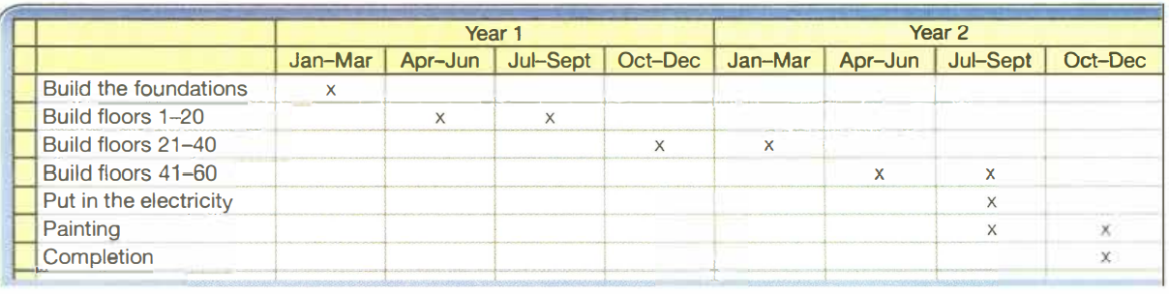
It is now January in Year 1. Look at the different stages of the project. Oct-Dec For example, building the foundations - the part under the ground - will take three months, from January to March in Year 1. Building floors 1-20 is going to take six months, from April to September in Year 1.
Josh explains: 'If we finish on schedule, the building will be completed in December next year. In other words, the deadline is December next year. It would be great if we finish ahead of schedule - before the time planned - or on schedule - at the time planned. We don't want to get behind schedule - finish after the time planned.'
We're behind schedule
Look at what really happened to the building project.
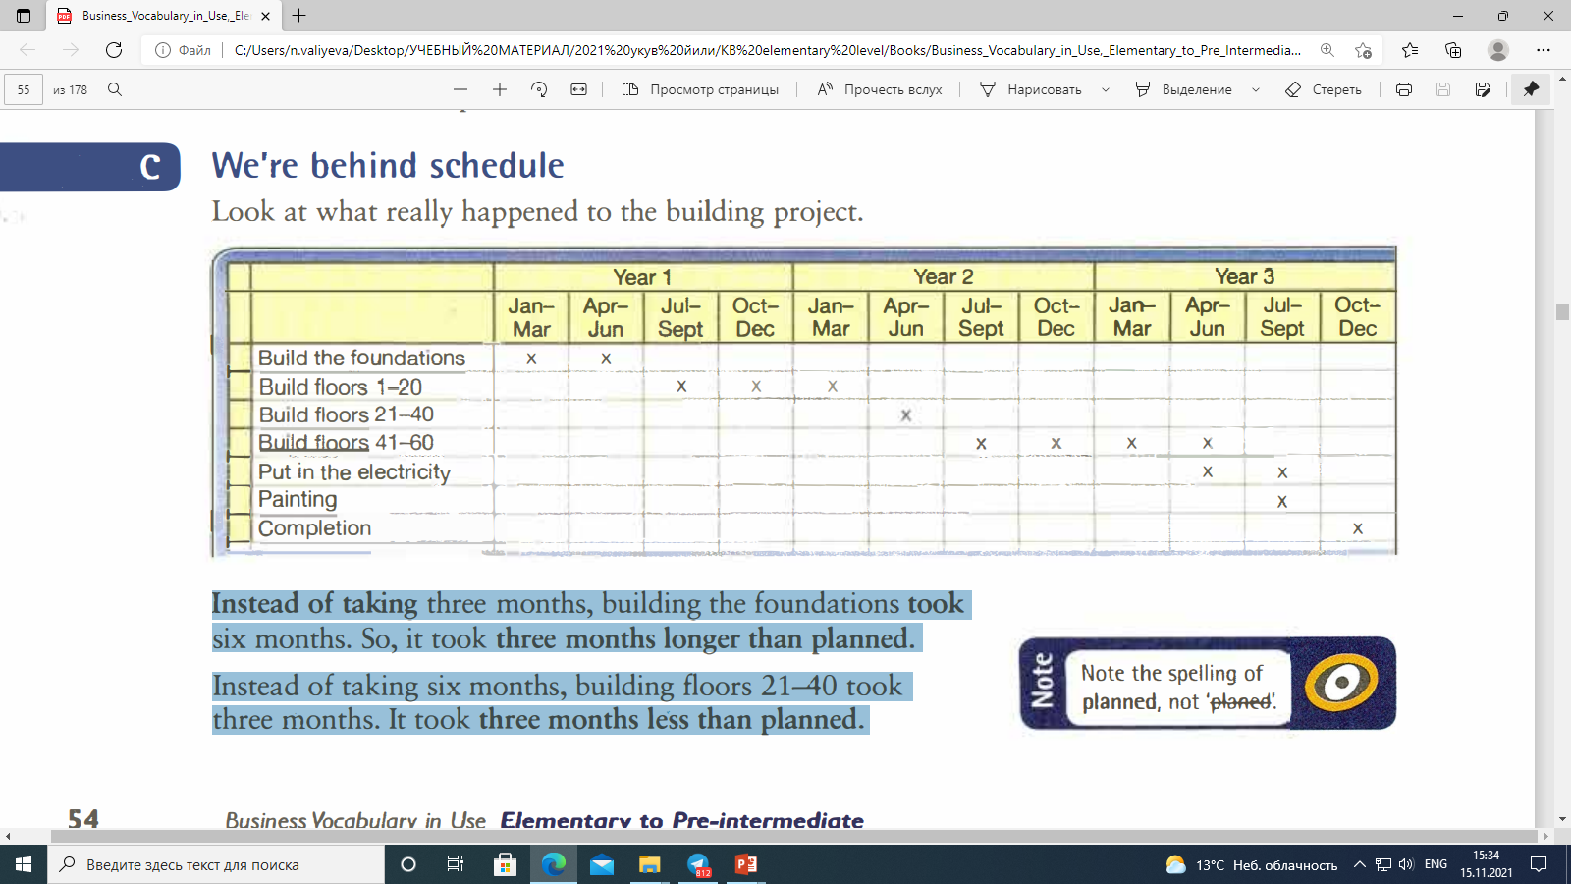
Instead of taking three months, building the foundations took six months. So, it took three months longer than planned. Instead of taking six months, building floors 21-40 took three months. It took three months less than planned.

1. Which three prepositions can be used with the word schedule?
on ahead of in behind
Which three prepositions can be used with the word budget?
under behind over on
2. Which preposition + noun above has a similar meaning to the following?
- On time __________
- Late __________
- Early __________
- At the money available __________
- More than the money available __________
(Answer key: on schedule, behind schedule, ahead of schedule, on budget, over budget)
Look at the information about 3 projects and complete the sentences. Use the expressions
under budget/on budget/over budget, ahead of schedule/ on schedule/behind schedule.

(Answer key:1 behind schedule; 2 on schedule, over budget;3 on budget, ahead of schedule.)
Talking about the project
We often use the words and phrases below to show the sequence of actions:
First…..
Second …..
Third…..
After that ……
Then…/so then…..
Next…..
Finally…..
Jack describes a project to buy new paintings for the bank’s head office. Pay attention how he uses the sequence words.
Jack Delaney: I’d like to tell you about a project to buy some new paintings for the bank’s head office.
First, I discussed the idea with the board of directors. Everyone thought it was a good idea. So then we looked at the finances and we agreed the budget of three million dollars for the project.
Next I set up a project team. I asked three people to be responsible for choosing the paintings. Their task was complete the project within three months and to stay within the budget.
Then, in the next two months, the project team visited different art galleries and looked at all the options. They had regular meetings to discuss their ideas and choose the paintings they wanted to buy.
After that they presented their choices to the board. The board agreed, and finally, we ordered the paintings.
Now order the actions 1-6.
Visit different art galleries
Discuss the idea with the board of directors.
Order the paintings.
Set up a project team.
Look at the finances and agree the budget.
Present choices to the board.
(Answer key: 4,1,6,3,2,5.)
Questions
1.What makes a project successful?
2.What project are you currently involved in?
Put the following in order of importance (1=most important)
- deadline
- good communication
- an aim
- a good team
- a team leader
- a budget
Max Show describes the past project. Was it successful?
Complete the chart with the past simple verbs: decided, had, met, started, looked
- The project ……….three months ago on 8th May.
- First, we ……….a meeting and discussed the aim of the project.
- Then we ……….at the plans and agreed on a budget.
- After that we ……….who to have on the project team.
- The project team ……….once a week to talk about the project.
(Answer key: 1 started,2 had, 3 looked,4 decided, 5 met)
Read the article Project analysis and answer the question Why do so many projects fail?
fail = to be unsuccessful
Succeed=to be successful
Pipeline =pipes used for carrying gas from one place to another.
Article Project analysis,The Economist
George Stephenson built a railway from Liverpool to Manchester in the 1820s. It was 45 per cent over budget and there were a lot of delays. Today, it is still difficult to manage big projects. The construction of Wembley Stadium. the home of English soccer, was £750m ($1.4 billion) over budget and the project finished late.
2 Smaller projects can also have problems. Research shows that IT projects often have problems with budgets and deadlines. In 2004, the cost of IT projects was usually 56 per cent more than the budget, and most projects took 84 per cent more time than planned.
3 Some projects fail because the work takes longer than planned. Sometimes the cost of labour or materials is more than the agreed budget. But good project management can increase a company's profits. A big German company decided to improve its project management, and the result was that it added one billion euros per year to its profits.
4 Project management isn't a new science. It has an international association, the Project Management Institute (PMI), based in Pennsylvania, USA. The PMI sets professional exams that thousands of people take every year. It has 150.000 members in 150 countries. All of the members are specialists in managing projects.
5 So, it 15 possible for big projects to succeed. The Saudi-Aramco Haradh gas pipeline is one example. The $2 billion project finished six months early and 27 per cent under budget. The project manager and the client were both very happy.

How many new words and expressions have you memorized from today’s lesson?

Hometask 1 Complete these sentences. The first letter of the hidden word is given.
1. When something is planned to take six months and it takes a year, there is a d....
2. When you finish a project, you can say that it is c……… .
3. The person who manages a project is the p…… m…… .
4. If something isn't finished on time, it is finished l… .
(Answer key :delay completed project manager late)
Hometask 2 Read Elsa’s talk and choose the correct words in italics.
I’d like to tell you about a project that my team finished last month. The aim/plan of the project was to produce a website to help international employees improve/increase their English. There were three/five stages. First, we agreed on a budget of $13.000/$3.000. Next we planned the schedule. We had four months/weeks to arrange everything. After that we did research. We emailed/talked to international employees about the information/facts they wanted on the website. Then we had regular meetings to discuss progress/problems. Finally, we designed the website when we had all the information that we needed. The project succeeded because we were a good team and we had good communication.
(Answer Keys: the aim, improve, five, weeks, e-mailed, information, problems )
References
1. Bill Mascull, Business Vocabulary in use. Elementary to pre-intermediate, Cambridge University Press, 2010;
2. Irene Barrall, Nikolas Barrall, Intelligent Business. Elementary. Skills book, Pearson Longman, 2008;
3. Christine Johnson. Intelligent Business. Elementary.Course book, Pearson Education Limited, 2010.

