Lecture 10.
Authenticity in ESP Materials.
Outline
- What is an authentic material?
- Categories of ESP authentic materials
- Why use authentic materials in ESP classes?
- Text authenticity and Task authenticity
- Authentic materials in ESP: benefits and drawbacks
- Text-related characteristics
- Factors affecting the degree of authenticity of materials

Prior to analysis of potential benefits and drawbacks of authentic materials, it is important to define the notion of authenticity and authentic materials. Gilmore (2007) provides eight meanings of the notion authentic. According to Gilmore (2007), authenticity relates to:
- The language produced and used by native speakers in a language community
- The language produced by a real speaker or writer for a real audience and for the purpose of delivering a real message
- The qualities given to the text/ message by the listener or reader
- The interaction between student and teachers
- The tasks given
- The assessment
- The culture and the ability to adapt to target language group
- The social situation in the classroom

Among Howard and Major’s (2004) guidelines for materials development, one focuses on the authenticity. Referring to a number of authors, they note that much space has been devoted in language teaching literature to debating the desirability (and otherwise) of using authentic materials in language teaching classrooms and, indeed, to deﬁning exactly what constitutes genuine versus simulated texts (e.g., Harmer. 1998; Hedge. 2000; Nunan, 1988, 1991). It is the authors’ view that it is imperative for second language learners to be regularly exposed in the classroom to real, unscripted language—to passages that have not been produced speciﬁcally for language learning purposes. As Nunan points out, “texts written speciﬁcally for the classroom generally distort the language in some way” (1988, p. 6).
According to Bernardo (2006:60), “one of the main reasons for using authentic materials in the classroom is once outside the “safe” controlled language learning environment, the learner will not encounter the artificial language of the classroom but the real world and language how it is really used”.
Spirovska, E.T (2018:60) argues that “one of the characteristic features of ESP setting is the necessity to use authentic materials in teaching the target language and establishing two types of authentic interaction”. Learner authenticity, defined by Lee (1995) is the interaction between the language learner and the context in which the language is being used. Classroom authenticity, defined by MacDonald et al. (2006) is authenticity created in the context of language learning classroom and by creating meaningful learning contexts in which the participants can discuss, share their opinions and engage in socially motivated and meaningful activities. Therefore, the purpose of ESP leaning materials is to create opportunities for meaningful interaction and an appropriate and motivating context. For that reason, authentic texts and other documents or materials can be used. They expose the learners to a meaningful context, provide the authentic and needed vocabulary and establish a link with the content area of study. They can include authentic texts from the content area of study, journal articles and texts and visual materials, forms and documents, instructions and other types of materials.
Bondarenko (2018) reports that scholars distinguish three broad categories of ESP authentic materials:
- daily objects such as business cards, bank leaflets, photographs, receipts, catalogues, currency, reports, financial statements, instructions, bank accounts, application forms, pictures, registration forms, letters/emails, diagrams, agreements, etc;
- broadcast texts such as newspapers, journals, TV and radio programs, films, documentaries, general or special literature;
- websites.

Howard and Major’s (2004) emphasize that
When the aim for authenticity in terms of the texts presented to learners is discussed, a common tendency is to immediately think of written material such as newspapers and magazines. Materials designers should also aim for authentic spoken and visual texts. Learners need to hear, see and read the way native speakers communicate with each other naturally. Arguably more important than the provision of authentic texts, is authenticity in terms of the tasks which students are required to perform with them. Consideration of the types of real-world tasks speciﬁc groups of learners commonly need to perform will allow designers to generate materials where both the texts and the things learners are required to do with them reﬂect the language and behaviours required of them in the world outside the classroom.

Authentic materials in ESP: benefits and drawbacks
According to Bondarenko (2018), using Authentic materials can bring the following benefits:
- scaffold learners' learning of a target language more sufficiently
- helps students to produce better language;
- helps students to acquire the language faster;
- makes students more confident in real situations;
- brings cultural information to the students’ attention;
- strengthens motivation
Bernardo (2006:64) highlights the main advantages of using authentic materials in the classroom:
- having a positive effect on student motivation;
- giving authentic cultural information;
- exposing students to real language;
- relating more closely to students’ needs;
- supporting a more creative approach to teaching.
Although authentic materials provide a rich source of learning opportunities for ESP teachers and language learning and teaching situations, it needs to be emphasized that there are potential drawbacks. Probably the most notable drawback is that the majority of authentic materials were not designed for the purpose of language learning. As a result, these materials can be either too difficult or too easy for a group of language learners.
Using authentic materials can also require a large amount of preparation on behalf of the ESP instructor, which includes searching for relevant and appropriate materials, selecting the vocabulary or grammar items to be taught, adapting the materials to serve the teaching goals and objectives, adapting the materials in terms of language difficulty and adapting the materials in order to fit them in the frame of a class time. Thus, using authentic materials requires significant experience and knowledge on behalf of the ESP practitioner. The above-mentioned reasons sometimes raise the issue of practicality of using authentic materials in a typical ESP or general language teaching and learning context.
In addition to learner-related factors, Nuttall (1996) refers to some of the text- related characteristics to be viewed in the development of ELT materials. Of vital importance in choosing reading materials for a language course are content suitability, exploitability and readability. For the reading materials to be suitable for a given group of readers, they should be both interesting and motivating and relevant to their age, developmental level and needs. In a similar way, an exploitable text is one that can be used to develop the reader's competence in the language. Despite the huge volume of English texts, only the materials that can be used in the classroom. Context can be of instructional value. Moreover, if the text is heavily loaded with new structural and lexical items and offers too much of new information, it would be too difficult for the reader to read and get any meaning from it. To sum up, attempt should be made to maximize comprehension by providing culturally relevant, schematically related and interesting materials. The reading passages should be levelled appropriately not only for the reader's grade and age but also for his interest, schema and objectives
There are some factors that influence the degree of authenticity of materials.
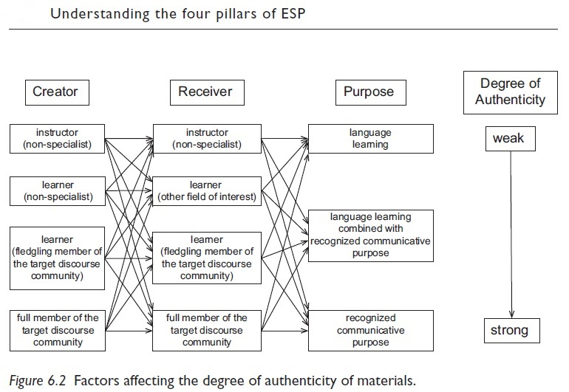

References:
Bernardo, S.S. (2006). The use of authentic materials in the teaching of reading. The Reading Matrix. Vol.6, No.2.
Bondarenko, O.I. (2018). Authentic materials in ESP classroom. Retrieved from http://www.kamts1.kpi.ua/en/node/2409
Gilmore, A. (2007). Authentic materials and authenticity in foreign language learning. Language Teaching, Vol. 40(02), pp.97-118.
Harmer, J. (1998). How to teach: English. Harlow, Essex: Pearson Educational Ltd.
Hedge, T. (2000). Teaching and learning in the language classroom. Oxford: Oxford University Press.
Howard, J., Major, J. (2004). Guidelines for Designing Effective English Language Teaching Materials https://www.researchgate.net/publication/237476568_Guidelines_for_Designing_Effective_English_Language_Teaching_Materials
House S. Authentic materials in the classroom / S. House // Didactic approaches for teachers of English in an international context // Salamanca: Ediciones Universidad de Salamanca. – 2008. – N 138. – P. 53–70.
Lansford L. Authentic materials in the classroom: the advantages / Lewis Lansford // CUP. – 2014. – Retrieved from: http://www.cambridge.org/elt/blog/2014/05/16/authentic-materials-classroom-advantages/.
Lee, W. (1995). “Authenticity revisited: Text authenticity and learner authenticity” ELT Journal, Vol.49, No.4, pp.323-328.

Lowe, I. (2010). authentic lesson materials in ESP,1-12 pages. Retrieved from www.scientificlanguage.com/esp/authentic.pdf

Nunan (1988). Principles for designing language teaching materials. Guidelines, 10(2), 1-24.
Spirovska, E.T (2018). Authentic materials vs textbooks in ESP. Journal of Languages for Specific Purposes. 1(5), 57-66.

Further Reading
Dumitrescu V. (2000). Authentic materials: Selection and implementation in exercise language training. Forum, 38(2), 20-25.
Carton, S., & Graves, K. (Eds.). (2014). International perspectives on materials in ELT. Basingstoke: Palgrave Macmillan.
Harwood, N. (Ed.). (2014). English language teaching textbooks: Content, consumption, production. Basingstoke: Palgrave Macmillan.
Maley, A., & Tomlinson, B. (Eds.). (2018). Authenticity in materials development for language learning. Newcastle upon Tyne: Cambridge Scholars.
Masuhara, H., Mishan, F., & Tomlinson, B. (Eds.). (2017). Practice and theory for materials development in L2 learning. Newcastle upon Tyne: Cambridge Scholars.
McGrath, I. (2013). Teaching materials and the roles of ESL/EFL teachers: Practice and theory. London: Bloomsbury.
Tomlinson, B., & Masuhara, H. (Eds.). (2010). Research for materials development in language learning: evidence for best practice. London: Continuum.

Home assignments
Reflection task
Based on what you have learnt from this lecture, write a one-page reflection focusing on what kind of authentic materials you use and how it affects teaching & leaning.
Question/Answer
1. What is the notion “authenticity related to?
2. What are the benefits and drawbacks of authentic materials?
3. Why is it important to use authentic materials in ESP teaching?
A Practical Task
Within the selected branch of ESP, select an authentic piece of teaching material, use it in your class, conduct a discussion with your students on their perceptions of using authentic materials.

