Lecture 11
Creating Tasks. Listening
Outline
- Listening as a skill
- Keys to teaching listening
- Model of listening materials development
- A framework for teaching listening
- Ten Factors to consider when choosing Listening Materials
- Challenges in developing a Listening course
- Micro skills of Listening

Listening as a receptive skill is considered the oral skill which is the primary ability developed in first language acquisition. Nunan (1999) states that listening is Cinderella skill in the second language context because it is overlooked by its elder sister, speaking. Moreover, Nunan (1999) and Zaenuri (2015) note that EFL students spend a lot of class time for listening, but it is the most unnoticed of the four skills in EFL contexts. Traditionally, speaking was emphasized more than listening. However, with the emergence of Comprehension Approach and Natural Approach more attention was paid to listening. In this regard, Cahyono (1997:14) points out that listening possesses essential role in the development of language proficiency. Below are some of the keys to teaching Listening:
- Create tasks (and use live speakers) that approximate real-life situations
- Progress from semi-authentic speech to genuine authentic speech
- Don’t use tasks that result in cognitive overload
- Design tasks that are success-oriented
- Build upon learner’s background knowledge
- Allow time for collaborative listening and discussion to clarify and restate ideas
- Progress from finding the gist of the conversation, to main ideas, to critical thinking skills where students construct meaning on their own.
A teacher should also remember that testing listening is not teaching to Listening and for teaching purposes it is important to create engaging activities that teach listening, not just test it. It is also essential to provide rich content that is within the linguistic reach of your students. Finally, effective listening materials should encourage the use of critical thinking and problem-solving skills that are needed in and out of the language classroom.
Zaenuri (2015:125) proposes a model of listening materials development as follows:
Conducting needs analysis
Selecting materials
Developing materials
Expert and practitioner’s validation
Evaluation and revision
Conducting the try-out
Evaluation and revision
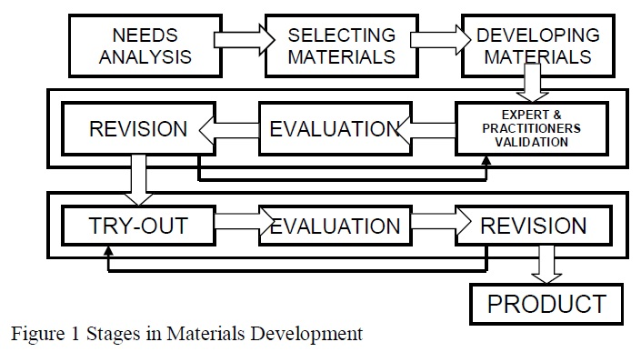

Now as the model is clear, it should also be highlighted that a teacher should employ a framework to be able to structure the teaching material and for this reason, Nik Peachey (teacher and materials writer at British Council) suggests a framework which involve three main stages:
- Pre-listening -during which we help our students to prepare to listen
- While-listening -during which we help to focus their attention on the listening text and guide the development of their understanding of it
- Post-listening -during which we help our students integrate what they have learnt from the text into their existing knowledge.
According to englishpost.org, listening materials can be categorized according to:
1. their authenticity
2. their level
3. their purpose
There are two factors that make a good listening material:
- Content
- Delivery
Content Factors
1. Interest Factor: It is obvious that the listening material should be interesting enough to engage students. Appropriate pre-listening task can help develop interest in students about something that they did know before.
2. Entertainment Factor: something interesting will probably be entertaining as well, therefore these two factors are interconnected.
3. Cultural Accessibility: It is important that the content a listening teaching material is culturally accessible to learners. A teacher must be careful in choices, as some concepts simply do not exist in certain countries. For example, Uzbek learners may not understand Thanksgiving Day or some other celebration.
4. Speech Acts. It is essential that learners understand whether the speaker in the listening material is narrating, criticizing, giving instructions or suggesting. If the learners cannot understand those, it might increase the difficulty of the listening.
5. Discourse Structures. There are different discourse structures and understanding them can help learners to recognize the organization of a text and be prepared for a particular type of content. For example, it can be cause and effect structured text and students may comprehend the materials easily.
6. Density: This feature refers to the amount of information in a text. It means that listening materials may contain a lot of information even if the length of track is short or vice versa.
7. Language Level: This feature refers to the complexity of grammar structures or the level of vocabulary. Sometimes the listening material may contain too formal or too informal content thus affecting the language level.
8. Length: one more important consideration is the amount of input that students can deal with. When new pieces of information arrive with very short intervals one after the other, it may cause difficulties to learners, therefore, the suggested length is usually one minute.
9. Quality of Recordings: The problems with understanding can be caused by the quality of the audio itself. This undoubtedly influences understanding.
10. Accent, speed and number of speakers: Certain accents may cause difficulty during listening. Such contributing factors as rapid speed or many speakers talking may create confusion.

When it comes to possible issues with the skill of Listening, two main challenges for the development of an L2 listening course are reported by Burns and Siegal (2018: 53):
1. To provide practice in identifying words in the speech stream so that listeners can develop the essential skill.
2. To provide opportunities to apply this skill in situations that require the deployment of complementary skills such as the use of textual, topic and world knowledge.
However, when micro skills of Listening are taken into account, they may help teachers to break down what it is that the learners need to actually perform as they acquire effective listening strategies (Zaenuri, 2015:123).
(1) retain chinks of language of different lengths in short-term memory;
(2) discriminate among the distinctive sounds of English;
(3) recognize English stress patterns, words in stressed and unstressed positions, rhythmic structure, intonational contours, and their role in signaling information;
(4) recognize reduced forms of words;
(5) distinguish word boundaries, recognize a core of words, and interpret word order patterns and their significance;
(6) process speech at different rates of delivery;
(7) process speech containing pauses, errors, corrections, and other performance variables;
(8) recognize grammatical word classes (nouns, verbs, etc.), systems (e.g. tense, agreement, pluralization). Patterns, rules, and elliptical forms;
(9) detect sentence constituents and distinguish between major and minor constituents;
(10) recognize that a particular meaning may be expressed in different grammatical forms;
(11) recognize cohesive devices in spoken discourse
(12) recognize the communicative functions of utterances, according to situations, participants, goals;
(13) infer situations, participants, goals using real-world knowledge;
(14) from events, ideas, etc., described, predict outcomes, infer links and connections between events, deduce causes and effects, and detect such relations as main idea, supporting idea, new information, given information, generalization, and exemplification;
(15) distinguish between literal and implied meanings;
(16) use facial, kinesics, body language, and other nonverbal clues to decipher meanings;
(17) develop and use a battery of listening strategies, such as detecting key words, guessing the meaning of words from context, appeal for help, and signaling comprehension or lack thereof.

References:
Azarnoosh, M., Zeraatpishe, M., Faravani A., Kargozari H.R. (Eds.) (2016). Issues in Materials Development. Rotterdam: Sense Publishers.
Davis, R. (2007). Creating Listening Activities that work. Carolina TESOL Conference and the International TESOL Annual Convention.
https://www.teachingenglish.org.uk/article/a-framework-planning-a-listening-skills-lesson
https://englishpost.org/choose-right-listening-materials/
Qodir, A., Baehaqi, L. & Miftah M.Z. (2016). Developing materials of listening comprehension for the English department students. Journal on English as a Foreign Language. 6(1).
Zaenuri, M. (2015). A model of EFL listening materials development. Indonesian EFL Journal, 1(2), 119-130.

Further reading
Chang, C.-S. (2016). Teaching L2 listening: In and outside the classroom. In W.A. Renandya & H.P. Widodo (Eds.), English language teaching today: Linking theory and practice (pp.111-126). New York: Springer.
Field, J. (2008). Listening in the language classroom. Cambridge: Cambridge University Press.
Field, J. (2009). More listening or better listeners? English Teaching Professional, 61, 12-14.
Johnson, O. (2005). Listening activities. New York: Eli.
Richards, J.C. (2003). Basic tactics for listening (2nd Ed). Oxford: Oxford University Press.
Developing Materials of Listening Comprehension for the English Department Students - http://e-journal.iain-palangkaraya.ac.id/index.php/jefl/article/download/379/631
Developing Listening Skills with Authentic Materials - http://dl.ueb.vnu.edu.vn/bitstream/1247/9968/1/Developing%20Listening%20Skills%20with%20Authentic%20Materials%281%29.pdf

Home assignment
Reflection task
Based on what you have learnt from this lecture, consider the other factors that you think can influence the success of a listening material. Make the list of qualities of your listening materials that your students liked or disliked.
Question/Answer
- 1. What factors are important to be considered when creating listening materials?
- 2. What are the keys to teaching Listening
- 3. What challenges are there in developing a Listening course?
A Practical Task
Within the selected branch of ESP, develop a listening material and use it with your students. Collect their feedback by asking the questions based on the 10 factors given in the lecture.

