Creating Tasks. Writing.
Outline
- The Definition of Writing
- Approaches in Writing
- Research findings
- Types of writing
- Programmed and Spontaneous Writing
- General principles in teaching Writing

According to Azarnoosh et al. (2016), “writing is something, which has an aim, purpose and meaning to convey. It is not just a grammatical exercise and a sequence of sentences. Hubbard et al. (1999:6) note that “the ultimate meaning of the word writing, is to use orthography in order to construct grammatically-correct sentences which communicate meaning to the readers”.
There are a number of approaches in teaching of writing:
- Traditional product-oriented approach
In this approach, teachers believed that if learners are given a text produced by a competent writer, they will learn how to write well. But this approach did not work, as students were still poor in writing (Oluwadiya, 1992:12).
- Process oriented approach
In this case, the aim was to explore and use the whole process of writing to achieve the skill of written production.
- The modern approach
In this approach both product and process are equally important. The followings are stressed in the modern approach:
1. People write to communicate with readers
2. People write to accomplish specific purpose
3. Writing is a complex process.
Azarnoosh et al. (2016) also warn about the three important constituents in writing:
- Audience
- Purpose
- Meaning
Research (Habelman & Wiriyachitria) in writing revealed the following findings:
1. Writers discover meaning through writing. Writing is a process of extending and refining an initial idea.
2. Writers often go back over what they have written before moving onward again. Writing is recursive process.
3. The flow of ideas of unskilled writers is often blocked by too much attention to form (1990:37).

As each case of writing, there is a certain purpose. Below are the different types of writing which can be used by teachers in creating their writing materials.

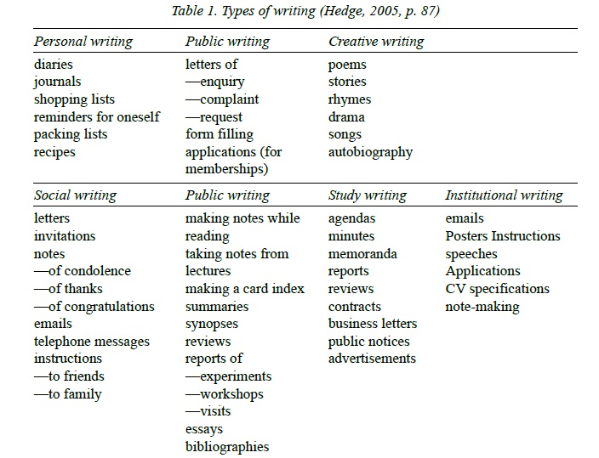

Taking into account that in real world perfect writing is not the aim, and we also write in unplanned without revising or editing, it may sometimes be useful to create learners these conditions. Thus, writing can be
- Programmed
- Spontaneous
Spontaneous writing can be very interesting for students as they do not feel strain. This leads to more motivation on the part of both students and teachers. Instead of focusing on teaching grammar structures, learning targets more communicative ability (Stapa, 2004).
Asarnoosh et al. cite Saxenian (1998) who states that “in order to write a precise thesis statement and a coherent final draft, students must know their purpose. However, it is unreasonable to expect students to be absolutely clear about their purpose at the onset of writing. They like many other writers need the time to discover their exact purpose in the process of writing (p.30). On the other hand, a teacher should have a clear purpose on his mind while teaching writing to his students. It is difficult to write in a foreign language but it becomes even more difficult for a student if he does not have a clear-cut and well-defined reason or purpose to communicate.
To the question how the writing skills can be improved Masood and Farooq (2013) highlight several techniques and strategies. For example: pictures, reading authentic texts, using other language skills, practical writing, control writing, organization of ideas, radio and TV programmes. Also, very good resources are drawings, photographs, posters, slides, cartoons, magazine advertisements, diagrams, graphs, tables, charts and maps.
Laurence (2018) suggest the general principles that can be appropriate for teaching writing in most of the ESP settings:
- adopting and adapting commonly used written genres
- building a productive knowledge of written general, academic, and technical vocabulary
- citing and paraphrasing information obtained from external sources
- crafting surface-levels features (e.g. layout, color, font types, font styles)
- deciding the target reader
- deciding what information is relevant
- employing hedging and persuasive devices
- organizing ideas using rhetorical patterns
- planning the message through brainstorming and outlining
- presenting main ideas, supporting ideas, and examples
- reﬁning the message through drafting and revising
- signaling relations within and between sentences, paragraphs, and sections using cohesive and discourse markers
- understanding the target discourse community
- using models and templates
- utilizing machine translation

References:
Azarnoosh, M., Zeraatpishe, M., Faravani A., Kargozari H.R. (Eds.) (2016). Issues in Materials Development. Rotterdam: Sense Publishers.
Hubbard, P., Jones, H., Thorton, B., & Wheeler, R. (1986). A training course for TEFL. Oxford: Oxford University Press.
Masood, A. and Farooq, M.U. (2013). Exploiting Authentic Materials for Developing Writing Skills at Secondary Level.
Laurence, A. (2018). Introducing English for specific Purposes. Oxon: Routledge.
Oluwadiya, A. (1992). Some prewriting techniques for student writers. English Teaching Forum, 30(4), 12-15.
Wiriyachitra, A., & Hoblemen, P. (1990). A balanced approach to the teaching of intermediate-level writing skills to EFL students. English Teaching Forum, 8(4), 37-39.
Further Reading
Bell, J., & Gower, R. (1998). Writing course materials for the world: A great compromise. In B. Tomlinson (Ed.), Materials development in language teaching (pp. 116-129). Cambridge: Language Teaching Library, Cambridge University Press
Dumitrescu V. (2000). Authentic materials: Selection and implementation in exercise language training. Forum, 38(2), 20-25
Hedge, T. (2005). Writing, A rich source of ideas for the teaching and learning of writing skills, using a framework that includes both “process” and “product” considerations. Birmingham: The university of Birmingham.
Jacobsan, E., Degener, S., &Purcell-Gates, V. (2003). Creating authentic materials and activities for the adult literacy classroom: A handbook for practitioners. Boston, MA: NCSALL.
Maley, A. (2009). Creative writing for language learners (and teachers). Retrieved from http://www.teachingenglish.org.uk/print/10479.
Maroko, G.M. (2010). The authentic materials approach in the teaching of functional writing in the classroom. In R. Reinelt (Ed), The new decade and (2nd) FL teaching: The initial phase (pp. 71-87). EU, Matsuyama, Japan: Rudolf Reinelt Research Laboratory.
McDonough, J., Shaw , C., & Masuhara, H. (2012). Materials and methods in ELT. Malden, MA: John Wiley & Sons, Inc
Mukundan, J., & Nimehchisalem, V. (2013). Materials for writing was this the case of the runaway bandwagon? In B. Tomlinson (Ed), Applied linguistics and materials development (pp. 213-230). Chennai, India: Bloomsburry Academic.

Home assignment
Reflection task
Based on what you have learnt from this lecture, write a one-page reflection on what challenges you face in developing writing materials and what types of activities do you usually choose to create and use.
Question/Answer
- 1. What approaches are there in teaching writing? What are the strengths and weaknesses of each?
- 2. What types of writing do you know?
- 3. What are the qualities of writing tasks?
A Practical Task
Within the selected branch of ESP, develop a writing material and use it with your students. Collect their feedback by asking the questions based on what you have learnt in this lecture.

