Course Title
Project Engineering
Chapter 2 & 3
Introduction to Project and Project Management &Project Appraisal and Formulation
Lecture 3 (week 3)
Project Environment, Project Organization, Concept of Project Appraisal.
Lecturer: Associate Prof Ishwar Adhikari
Learning Objective
The main objective of this lecture is to understand about:
⮚ Project environment.
⮚ Project organization.
⮚ Concept of Project appraisal.
Prepared By: Associate Prof. Ishwar Adhikari/Department of Civil Engineering/Kathmandu Engineering College (Affiliated to Tribhuvan University), Kathmandu, Nepal
1.9 PROJECT ENVIRONMENT
Project environment refers to the surroundings or elements where project execution takes place which affects the project performance. The environment where the project emerges, grows, and terminates is called project environment. The project management performance largely depends on the environment which differs from country to country. Environment consist of forces inside and outside of the project that influences the ability of project to meet or achieve its objectives or mission. In order to achieve the goal, it must continually adapt to its environment, which is constantly changing.
The changing environment increases the project complexities, uncertainties, competition to obtain all kinds of resources and rapid technological changes. [1] Understanding the environment involves, identifying the stakeholders and their ability to affect its successful outcome. Project Manager must work with a people to achieve the best results, especially in the highly technical and complex environments such as those involving modern day construction projects. [2]
Basically there are three types of environment in which the project is operated. 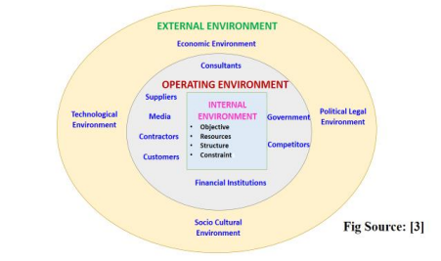
1. External Environment
The external project environment is made up of all the factors that are not under the direct control of project or your organization. It implies all the conditions, circumstances and influences surrounding and affecting the total project or any part of it. This external environment represents a complex set of inter-dependent relationships, which constantly react with the project as it is brought into reality. It provides the framework within which a project has to operate.
Prepared By: Associate Prof. Ishwar Adhikari/Department of Civil Engineering/Kathmandu Engineering College (Affiliated to Tribhuvan University), Kathmandu, Nepal
(a) Economic Environment
The economic system determines the economic environment. The major elements of economic environment are economic policies economic system, national income, distribution of income, market factors, product market, infrastructure facilities, inflation, fiscal policies, monetary policies and economic conditions in the national context and regional economic groups and cooperation in the international context. The economic environment is a major factor that influences the investment climate in the country.
Economic environment includes the economics system, national income, distribution of income, market factors, product market, infrastructure facilities, inflation, fiscal policies, etc. It affects the cost of inputs and demand of project products. Economic system refers to the method of resource allocation. In general, the economic system comprises of capitalistic, socialistic or mixed economies.
(b) Political Legal Environment
Political environment refers to various political and legal factors that affect public life. Legal environment refers to the legal framework and other provisions that affect the project management and project implementation. Political environment consists of ideological forces, political parties, election procedures and power centres. The legal environment protects the rights of various interest groups like society, project, employees and consumers.
It Consists of
(i) Political System
A stable, efficient and honest political system is essential for projects. Political instability resulting from civil war, emergencies and terrorist activities adversely affect the projects. [4]
(ii) Political beliefs
It can be democratic, totalitarian or a mix of both. Democracy vests power in the hands of people. Totalitarian vests power in the hands of the state. A mix of both is based on power sharing. Political philosophies influence project activities. Democracy provides greater role to the private sector. Totalitarianism provides greater role to the state. Mixed philosophies provide roles to both private sector and state.
(iii) Political Institutions
These are the three wings of the government. First, the parliament (legislature), enacts laws that protect the citizens and guides project activities. Second, government (executives), frames policies, regulations and procedures that influence all the project activities. Third, Judiciary (court of law), settle disputes of all kinds and reviews legal provisions raised inside the project.
(c) Socio Cultural Environment
Projects are operated in a society for the benefit of the society and includes all the social forces within which a project operates. It consists of factors related to human beings and influences the practices and activities as well as functioning of a project. It consists of demographic
Prepared By: Associate Prof. Ishwar Adhikari/Department of Civil Engineering/Kathmandu Engineering College (Affiliated to Tribhuvan University), Kathmandu, Nepal
structure, caste structure, education system, social values, life style, beliefs and expectation in a particular society. Culture is closely associated with society and includes values, norms beliefs and behavior of the people. Both these together constitute socio-cultural environment as they either promote or strain human relationships [1]
(d) Technological Environment
It consists of stare of technology, machinery, equipment, methods, systems, skills and rate of technological change etc. Drastic changes have taken place in the field of technology during last two or three decades. The information and communications technology has advanced to new heights and not only created tremendous opportunities but also enhanced project management techniques. The component of technological environment may be:
Process of innovation – Research and Development
Process of technology transfer – Taking Technology from laboratory to the project. 2. Operating Environment
It refers to a group of stakeholders, participants or interest groups who benefit from the project or get affected by it. The participants are directly or indirectly affected by the project activities. The project team does not have a direct control over the elements of the task environment but can influence them. It consists of media, customers, consultants, competitors, financial institutions, suppliers, contractors and government. Different elements of project task environment are interrelated to each other and are mutually complementary to each other. [3]
3. Internal Environment
If external environment determines what a project might do, internal environment dictates what it can do. It is located within the project and can be controlled by it. It not only shapes but also affects the effectiveness of a project. It consists of the following: Objective, Resources, Structure, constraints,
(i) Objectives
It is the desired end results, which the project wants to achieve which provides orientation to project manager. Every efforts of project manager should contribute to attaining objective of the organization as whole.
(ii) Resources
Projects have human and non-human resources. The human resources include specialized experts and managerial personnel. It is the key resources because objective of project can be achieved only through people. Non-human resources consist of financial resources and physical resources.
(iii) Structure
Structure provides the framework within which project functions. The structure of project is ad-hoc and cuts across organizational and departmental lines.
Prepared By: Associate Prof. Ishwar Adhikari/Department of Civil Engineering/Kathmandu Engineering College (Affiliated to Tribhuvan University), Kathmandu, Nepal
(iv) Constraints
A project functions in a dynamic environment characterized by constraints of time, cost and quality. The time cost and quality are the guiding parameters of project. A project manager should effectively balance these complex parameters of a project.
1.10 PROJECT ORGANIZATION
Project operates in a dynamic environment through the involvement of different types of stakeholders. A set-up where individuals from diverse backgrounds, different educational qualifications and varied interests come together to work towards a common goal is called an organization. An organization can described as a system where arrangement and relationships among component parts operates together as a whole. Team involvement is laid out in an organizational structure chart that graphically shows where each person is placed in the project structure.[5]
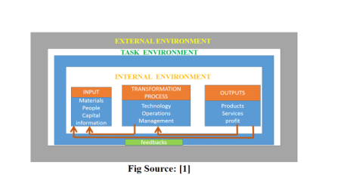
A project organization is a structure that facilitates the coordination and implementation of project activities. Its main reason is to create an environment that fosters interactions among the team members with a minimum amount of disruptions, overlaps and conflict. [6]. Project organization as an inter-organizational team pulled together for a specific purpose. [7]Project is a dynamic process and project organization is generally considered as engine of project management that ceases to exist once the project is terminated.[3]
Project Organizational Structure
Each project is unique and it is essential to develop project organization structure as works are performed by people and managed through people. It identifies the relationships
Prepared By: Associate Prof. Ishwar Adhikari/Department of Civil Engineering/Kathmandu Engineering College (Affiliated to Tribhuvan University), Kathmandu, Nepal
between project participants and defines their duties, responsibilities and authority. It outlines the relationship between various participants, line of authority and communication channels by means of graphical illustrations called organizational chart. One of the main objectives of the structure is to reduce uncertainty and confusion that typically occurs at the project initiation phase. [6]
Types of Project Organization
1. Pure Functional Organizational Structure
Functional project organization is structured around traditionally functioning departments with managers who report to an executive. It is the most commonly used project organization. In this form, a person is appointed with main responsibility of coordinating the work of the people in the functional department. This structure is usually used in organizations with a flat hierarchy, where the project team is formed of different units or departments. [8]
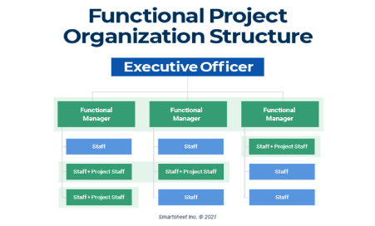Fig Source: [9]
Advantages
1. Maximum flexibility in use of staff.
2. Individual experts can be utilized by many different projects and promotes professional mobility.
3. Specialist in the division can be grouped to share knowledge and experience. 4. Foster better supervision of project.
5. Promotes creative and reflective thinking.
Disadvantages
1. Client is not the focus of the project.
2. Lack of responsibility and accountability as it fails to give full responsibility for the project.
Prepared By: Associate Prof. Ishwar Adhikari/Department of Civil Engineering/Kathmandu Engineering College (Affiliated to Tribhuvan University), Kathmandu, Nepal
3. Poor communication and lack of coordination.
4. Delay in decision making.
5. It is not problem oriented and directed towards the activities particular to its operations.
2. Pure Project Organizational Structure
This is the form of project organization in which project is separated from the parent organization or functional units. It becomes a self-contained unit with its own technical staff, administration tied to parent organization only through periodic progress report. [3]The project manager has its own line organization with project authority and responsibility. The project operates under almost total freedom with the limit of functional authority.
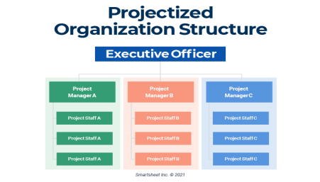Fig Source: [9]
Advantages
1. The project manager has full authority over the project.
2. All members of project work force are directly responsible to the project manager. 3. Better and effective communication system as it by passes the entire functional structure.
4. Facilitates unity of command.
5. Fast, better and effective decision due to centralization of authority. Disadvantages
1. Duplication of efforts due to several projects.
2. Develops false sense of ego and pride among project team, distorting the relationship with counterpart in the parent organization.
3. Promote wastage of resources.
4. Uncertainty and lack of job security of employees after the termination of project.
Prepared By: Associate Prof. Ishwar Adhikari/Department of Civil Engineering/Kathmandu Engineering College (Affiliated to Tribhuvan University), Kathmandu, Nepal
3. Matrix Organization
The functional and pure organization is conducive to an effective and efficient utilization of resources but not effective realization of project objectives. It is a hybrid of functional and pure project organizational structures, and project managers share authority with other program managers in this structure. It seeks to achieve the twin objective of efficient use of resources and effective realization of project activities at the cost of greater organizational complexity.
Advantages
⮚ Control of all resources, including cost and personnel by project manager ⮚ Separate procedures and policies for each project.
⮚ Functional organization exist to support.
⮚ No duplication of facilities and resources
⮚ Authority and responsibilities are shared.
⮚ Rapid response is possible to changes, conflict resolution and project needs.
Disadvantages
⮚ Multidimensional information and workflows.
⮚ Conflict between management goal and project goals.
⮚ Problems and difficulty in monitoring and control.
⮚ Conflict and power struggle between functional and project manager. ⮚ Continuous changing priorities due to dynamic project environment.
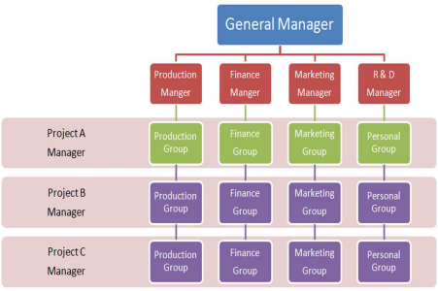Fig Source: [10]
Prepared By: Associate Prof. Ishwar Adhikari/Department of Civil Engineering/Kathmandu Engineering College (Affiliated to Tribhuvan University), Kathmandu, Nepal
CHAPTER 2
PROJECT APPRAISAL AND FORMULATION
2.1 CONCEPT OF PROJECT APPRAISAL
Project appraisal is a generic term used to refer the process of assessing the investment proposals. Appraisal is the evaluation of the ability of the project to succeed. Project appraisal is a process of detailed examination of several aspect a given project before recommending the same. [12] It is an evaluation report of proposed project that is prepared before signing the agreement or memorandum of understanding between the client and the sponsor.
Project appraisal is an overall assessment of the relevancy, feasibility and sustainability of a project prior to making decision whether to undertake it or not?? It is a technique of evaluating, analyzing the investments and effort of calculating the project’s viability. Project appraisal is the process of analysing the technical feasibility and economic viability of a project proposal with a view to financing their costs. Project appraisal is carried out in scientific and systematic manner because it determines the success or failure of a project. [1]
Project Appraisal Answers two important Questions
1. Will the project meet its objectives as well as the larger need of the societies or country? 2. How does project compare with other projects (alternatives) in term of funds and other resources?
The primary function of appraisal is to evaluate a project's ability to achieve its objective. For private project, profitability is the objective and for public project, socio economic development is objective.
Project Appraisal Document should include the following requirements:
⮚ Project Introduction
⮚ Project Objective and Scope
⮚ Project Description
⮚ Implementation Plan
⮚ Executing Agency
⮚ Project Organization
⮚ Parties Involved in project
⮚ Project Budget and Schedule
⮚ Benefits and Output of Project
⮚ Project Monitoring and Evaluation.
Prepared By: Associate Prof. Ishwar Adhikari/Department of Civil Engineering/Kathmandu Engineering College (Affiliated to Tribhuvan University), Kathmandu, Nepal
Aspects of project appraisal
The feasibility study serves as the groundwork for project appraisal. The aspects covered in feasibility study are re-examined during the appraisal.
(a) Market Analysis
It includes
∙ Market potential
∙ Raw material requirement and source of supply
∙ Sales forecast and market share
∙ Market demand levels
∙ Levels of competition and ability of the project to satisfy the customers.
(b) Commercial Analysis
The appraisal involves the assessment of the current demand/market scenario, which enables the project to get adequate demand. [11] Estimation, distribution and advertisement scenario also to be here considered into. It needs to be ensured that adequate input supplies are available for the profitable operations of the project.
(c) Economic Analysis
The impact of the proposed project on national economy and society is evaluated. It looks on social cost and benefits, project savings and investment as well as distribution of income and employment potential. Main steps in economic analysis are the pricing of project inputs and outputs and the identification of project costs and benefits. [1]
(d) Technical Analysis
Focuses on choice of technology, human resources requirement, design requirements, size, location and site, technical risks, procurement of plant and machinery, project scheduling and implementation etc.
(e) Managerial /Institutional Analysis
To determine strength and weakness whether the implementing agencies as identified in the report are capable for effective implementation, monitoring, and evaluation of the scheme. (stakeholder analysis)
(f) Environmental Analysis
It includes the study of impact of project on ecology, society and environmental suitability. An in-depth analysis of project’s effect on environment is very essential.
(g) Social Analysis
Evaluate the aspect like employment opportunities and income distribution. The project analyst examines the effect of a project on particular group or region.
(h) Financial Analysis
Prepared By: Associate Prof. Ishwar Adhikari/Department of Civil Engineering/Kathmandu Engineering College (Affiliated to Tribhuvan University), Kathmandu, Nepal
It consists of two major areas: Arriving at the cost of the project and Arriving at the appropriate means of financing the project. [12] Methods like Net present value (NPV), internal rate of return (IRR), Sensitivity analysis, and payback period are used for the financial analysis.
REFERENCES
[1] Project Management, Planning, Analysis and Control: Bhakti P. Sharma, First Edition, Ekta Books Distributors Pvt. Ltd, Kathmandu, Nepal, 2006.
[2] Managing the project environment, Wideman R.M., A E W services, Vancouver, B.C., Canada, 1990.
[3] Project Management: Dhurba P. Rizal, First Edition, Ratna Pustak Bhandar, Kathmandu, Nepal, 2001.
[4] https://analysisproject.blogspot.com/2011/08/political-environment - of-project.html [5] https://www.indeed.com/career-advice/career-development/project-organization [6] https://www.pm4dev.com/resources/free-e-books/3-the-project-management organizational-structures
[7] Project management: Strategic Design and Implementation: Cleland David, New York: McGraw Hill, 1995.
[8] https://www.knowledgehut.com/blog/project-management/project-management organizational-structure
[9] https://www.smartsheet.com/content/project-management-organization [10] https://analysisproject.blogspot.com/2015/07/matrix-organization-structure.html [11] http://atimysore.gov.in/wp-content/uploads/chapter-3-project-appraisal.pdf [12] Project Management: K. Nagarajan, 2001, New Age International (P) Ltd. Publishers, New Delhi, India.
Prepared By: Associate Prof. Ishwar Adhikari/Department of Civil Engineering/Kathmandu Engineering College (Affiliated to Tribhuvan University), Kathmandu, Nepal

