Examination
INTELLECTUAL PROPERTY LAW
Instructions:
This is an “open-book” examination. When preparing your answer, you may read, watch, or rely
on any material you wish. However, you may not consult in any way with any other person
concerning any aspect of the test.

Copyright and Related Rights (hereinafter “Copyright Law”)
- Discuss the nature and purpose of exceptions of Cambodian Copyright Law?
Answer:

Copyright and Related Rights (hereinafter “Copyright Law”)
- What is the idea/expression dichotomy? How will this principle be applied under the Cambodian Copyright Law?
Answer:

Case Question

Since 1998, David has been a freelance photojournalist. He lives in Phnom Penh and spends at least half of his time travelling for work. He earns a good income, but he is bored. When taking photographs of politicians giving speeches, he concentrates on making images that he will be able to license to newspapers. But, to keep himself amused, he also looks for opportunities to take unusual or irreverent photos, which he does not offer to newspapers. Instead, he prints and frames those photos – and then offers the prints for sale in a small gallery adjacent to his apartment. Among the photos on sale in David’s gallery in the summer of 2017 were some images he had taken of politicians manifesting surprise or alarm or determination. Copies of a few of these are set forth below:

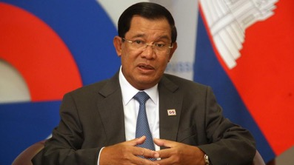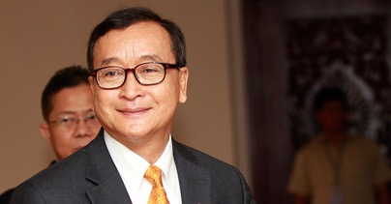
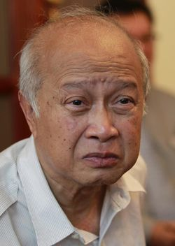

The politician who appears in the photograph in the lower right corner of this array is Kem Sokha. Over the course of the summer, David sold five copies of the photograph of Kem Sokha, each for $100. He did not keep a record of the names or addresses of the purchasers.
On July 7, 2018, David was in Svay Rieng province, covering the national elections. Outside a polling place, he encountered a group of men holding up signs that made clear that the men supported Hun Sen, a candidate from the ruling party. Most of the signs were conventional, but one poster caught his eye. A copy of it appears below.

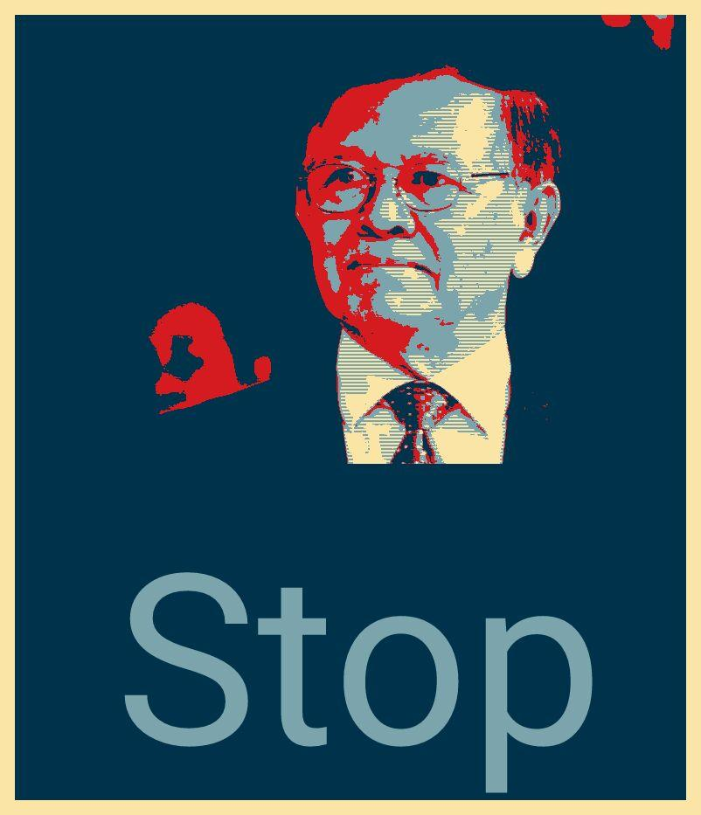
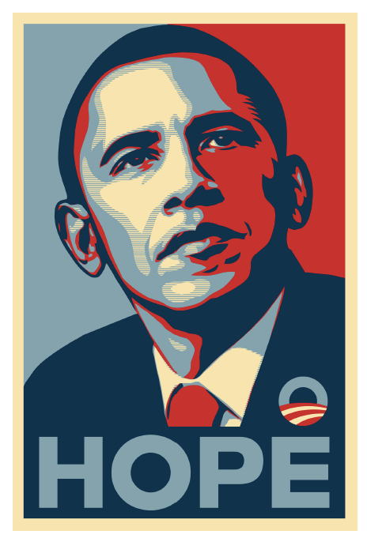
David recognized, of course, that the poster used the color scheme and motif of the famous Obama “Hope” poster (a copy of which appears at right). But something else about the “Stop”
poster intrigued and annoyed him. So he took a photograph of it. A week later, back in Phnom Penh, David was reviewing the photos he had taken in Svay Rieng and came upon his image of the “Stop” poster. Suddenly, he realized why it had struck him: the image of Kem Sokha contained in the poster resembled the photograph of Kem Sokha that appears on the previous page – which he himself had taken. The more he compared the two images, the more convinced he became that the poster had been derived without permission from his own photograph.

David does not have strong political affiliations. The possibility that one of his photographs was being employed to aid politician’s campaign infuriated him. So he set out to find its source. Using the Google “image” search function, David located a website, www.stopbros.org, that offered to send a copy of the “Stop” poster free of charge. The website provided contact information for its founder and operator: Tom Cruise, 2506 Street 87, Chamkar Mon, Phnom Penh.

David is considering taking legal action against Tom. Write David a letter, assessing his legal
Options using IRAC. If you need additional information to provide him guidance, say what that information is and why it matters. Your letter may not contain more than 1200 words (exluding any footnotes if any).

Answer:

