INTERMEDIATE MICROECONOMICS

WEEK 5-THEORY OF PRODUCTION

CONTENTS
1.O OBJECTIVES
2.0 INTRODUCTION
Definition of Production Concepts
3.0 Production function
4.0 Similarity and difference between Consumer Behavior and Production Theory
5.0 Types of Production curves
Total Product
Marginal Product
Average Product
6.0 Relationships between
Total Product and Marginal Product
MPP_{L} and APP_{L}

7.0 Stages of Production
8.0 Isoquant Analysis
Shapes of Isoquants
Characteristics of isoquants
9.0 Returns to Scale
10.0 Returns to scale and homogeneity of production function
11.0 Equilibrium of the firm (choice of optimal combination of factors of production
12. SUMMARY
13. REFERENCES

- OBJECTIVES

- Understand the production theory.
- Identify the three stages of production.
- Understand the isoquant analysis.
- Be able to use the concept of the returns to scale.
- Determine the equilibrium of the firm.

2.0 INTRODUCTION

THE PRODUCTION THEORY

Definition of production concept
(i) Production: - this is the creation of goods and services through the transformation of inputs into outputs.
(ii) Inputs: - these are the ingredients used by a firm to produce a good or service. Sometimes they are called factors of production or resources. These include, land, capital, labor, entrepreneurs etc.
(iii) Output: - this is the product of transforming input into goods or services. Output is thus a function of the various input expressed in the production function.

3.o (IV)PRODUCTION FUNCTION

A production function is a schedule (or table, or mathematical equation) showing the maximum amount of output that can be produced from any specified combination of inputs, given the existing technology.
The production function is like a “recipe book” showing what output are associated with which combination of inputs. It may be represented as follows.

Q = f (K, L, r)

Where:
Q is output
L is labour
K is capital
r are other input resources

v) Short run period: - refers to the period of time during which it is impractical to change the employment levels of some inputs so as to immediately increase output.
Factors input that cannot be varied during this period are referred to as fixed input incase an immediate change in output is desired, it would be extremely costly to immediately vary such inputs. Such inputs include buildings, machinery, managerial personnel. Therefore, changes in output must be accomplished exclusively by changes in the usage of variable inputs. A variable input: - is one whose quantity may be changed almost instantaneously in response to desired changes in output. Many types of labor services and the inputs of raw and processed materials fall in this category. Thus, in short run period one factor is held fixed (e.g., capital) while other one variable (labor).

(vi)Long run period: - is defined as that period in which inputs are variable in
the long run it may be economical to install additional productive facilities. To produce a certain level of output, we could use different combinations of labor and capital.
(vii)Isoquant: - is a curve that shows all the combinations of inputs that will produce a
certain level of output, given same level of technology.
In the analysis of theory of production two approaches will be used.
1) Analysis of production: in the short run when one factor is variable and
the other is fixed. (Short -run period function approach)
2) Isoquant analysis, which is long-run approach, and which assumes that
all factors are variable.

4.0 SIMILARITY AND DIFFRENCES BETWEEN CONSUMER BEHAVIOR & PRODUCTION THEORY
- Objectives: - the consumer aims at maximizing utility while producer aims at maximizing cost.
- Constraint: - the consumer is constrained by the income level and prices of commodities while the producer is constrained by technology level and the cost of inputs.
- Tools of analysis: - the analysis of consumer behavior employs indifference curves, while that of the production theory employs isoquant.

5.0 TYPES OF PRODUCTION CURVES

Here distinction is made between three types of production curves.
1) Total product curve
2) Marginal product curve
3) Average product curve

1) Total Product (TP)
In the short run, production function gives the total (maximum) output obtainable from different amounts of the variable inputs, given a specified amount of the fixed input. In the short-run, production function is written as Q = f (K, L) where capital is fixed, and labor is variable.

2) Average Product (AP) or Average Physical Product (APP)
The average product of an input is that product divided by the amount of the input used to produce this output.
AP_{L}=Q/L=f (K, L)/L

This can be read as average product of the variable input labor.

3) Marginal Physical Product (MPP or MP)
Is the change in total product that results from one unit change in the amount of variable inputs (e.g. labour), the fixed input remaining unchanged. (may also say, other inputs other than labour remaining unchanged). Therefore, marginal product of labour is the derivative of output with respect to labour.

MPL=δ Q/ δL = δf (K, L)/ δ L
Table shows the relationships- TP, MP,AP and the 3 stages of production.

No of capital | No of labor | TP_{L} | AP_{L}=(TP/L) | MP_{L=} δTP/ δ L | Stages
1 unit | 0 | 0 | 0 | 0 | I
1 unit | 1 | 5 | 5 | 5 | I
1 unit | 2 | 16 | 8 | 11 | I
1 unit | 3 | 36 | 12 | 20 | I
1 unit | 4 | 68 | 17 | 32 | I
1 unit | 5 | 95 | 19 | 27 | II
1 unit | 6 | 114 | 19 | 19 | II
1 unit | 7 | 119 | 17 | 5 | II
1 unit | 8 | 120 | 15 | 1 | II
1 unit | 9 | 117 | 13 | -3 | III
1 unit | 10 | 100 | 10 | -17 | III

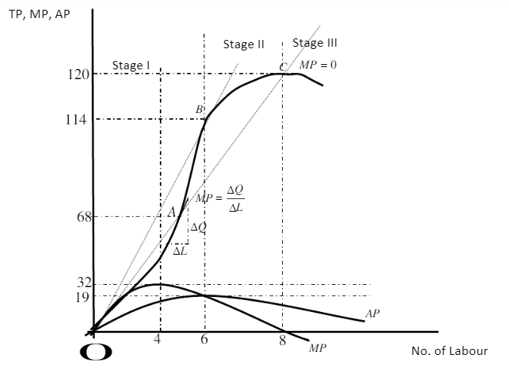

This is a short run case whereby not all inputs are variable. Labour (L) is variable, while capital is fixed at 1 unit.
TP Curve
From the table and figure, total output increases with more employment of labour, reaches a maximum at Q_{X}=120, and number of labour employed equal 8. as more and more laborers are employed beyond 8, output starts to decline.
MP Curve
As more laborers are employed, marginal product of labour increases, reaching maximum at L=4, then declines reaching zero, when L=8 beyond L=8, LMP becomes negative.
AP Curve
Average product curve also increases initially as L increases, reaching maximum at L=6 then start declining. AP_{L} remain positive as long as total product is positive.

6.0 RELATIONSHIPS IN PRODUCTION

- BETWEEN TP & MP

1) As long as LMP is increasing, TP will continue to raise at an increasing rate. This is the case as labour increases up to 4. Beyond L=4 up to L=8, MPL starts to decline although it is still positive. TP continues to increase but at a diminishing rate.
2) When MP_{L} reaches zero, TP reaches its maximum. At this point TP=120 while L=8.
3) When MP_{L} becomes negative, TP will start declining so any employment beyond L=8 yield negative MP.

The law of diminishing returns

It states that-
- If more and more units of a variable input (in our case labour) are applied to a given quantity of fixed input, the total output may initially increase at an increasing rate, but beyond a certain level of output, the rate of increase in the total output diminishes.
- The reason behind the operation of this law is that with increasing units of labour to a fixed factor (say capital) each additional worker has less and less tools and equipment to work with. Consequently, the productivity of the marginal worker eventually decreases. As a result, the total product increases at a diminishing rate beyond a point.
For the law to hold the following two condition must be fulfilled.
1) Some input(s) must remain fixed as the amount of the input in question, say labor is varied.
2) Technology must remain unchanged, since a change in technical know-how would cause the entire TP curve to shift. An upwards shift in TP curve reflects a change to superior technology while a downwards shift reflects a change to inferior technology relative to existing one.

ii) BETWEEN APP_{L &} MPP_{L}

- MPP_{L}>APP_{L}, when APP_{L} is rising (MP_{L} is above AP_{L})

- MPP_{L} = APP_{L} when APP_{L} is at maximum.

- MPP_{L} < APP_{L} when APP_{L} is declining (MP_{L} is below AP_{L})

Proof Q=f(K,L)

AP_{L} =Q/L = f(K,L)/L

7.0 THE THREE STAGES OF PRODUCTION

Using figure in section 5 above, we can identify three stages of production.
Stage I:
- Marginal product continues to increase making total product increase at an increasing rate. Marginal product reaches maximum at L=4
- It is a stage of increasing returns because output increases as you increase the use of the variable factor (Labor). Here fixed factors (capital) are underutilized. That is why as more and more workers are added utilization of machine increases and productivity of additional workers increases. At this stage it would be inefficient for firms to operate since there is still room for increased output and hence high profit.
Stage II:
- This is a stage of diminishing returns MP starts declining until it reaches zero. Total product increases but at a diminishing rate and reaches maximum when MP=0.
- Once optimum capital-labour ratio is reduced additional workers have less and less tools to work with. Consequently, the productivity of the marginal worker eventually decreases.
- Firms should operate in this stage because optimal utilization of factors is realized.
Stage III:
- It is the Stage of declining returns.
- TP is declining and MP is negative.
- It will be very illogical for a firm to operate in this stage because employment of additional labour adds nothing to total product.
- Thus, stages I and III are irrational stages of operation. In stage I, capital is under-utilized by small units of labour.
- In stage III, capital is over utilized/overburdened by large units of labour.
- Both extremes are uneconomical to operate in firms will thus operate in stage II, where MP is positive for both variables & fixed factors of production.

8.0 ISOQUANT ANALYSIS
- In the short-run, we assume that one factor of production remain fixed as the other one varies that is Q = f (K, L)
- However, in the long-run, all factors of production become variable so that Q =f (K, L).
- In isoquant analysis, all factors are assumed to be variable.

What is an isoquant?
- It can be defined as a curve joining various combinations of Inputs that yield a given amount of output.
- GraGra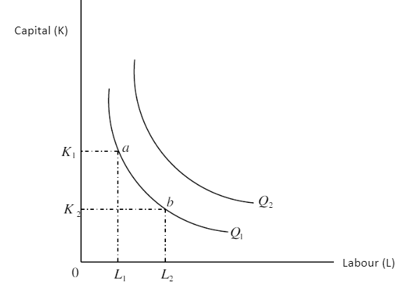

Graph-isoquant
- Combination of inputs (a) and (b) yield same level of output.
- A higher isoquant to the right represents superior output Q₂>Q₁
- The slope of the isoquant δK/δL defines the degree of substitutability of the factors of production (in our case, substitution between capital and labour).

Marginal rate of technical substitution (MRTS) of labor and capital.

Is the slope of isoquant it refers to the amount of capital (K) that firm must give up by increasing the amount employed of labor by one unit and remain on the same isoquant (output level).

The graph shows the MRS of labour and capital.
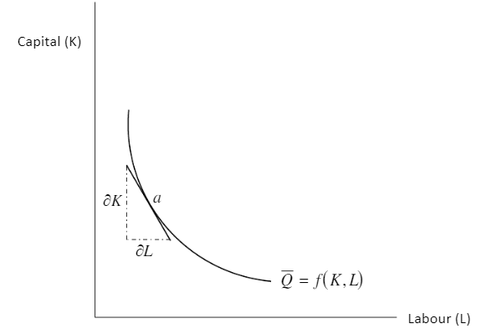

The slope of the isoquant at point (a) is given by the slope of the tangent at point.

Therefore slope =δK/δL

-δK/δL= MRTS_{K,L =} MP_{L}/MP_{K}

SHAPES OF ISOQUANTS
Isoquants may assume various shapes depending on the degree of substitutability. 1) Linear isoquant
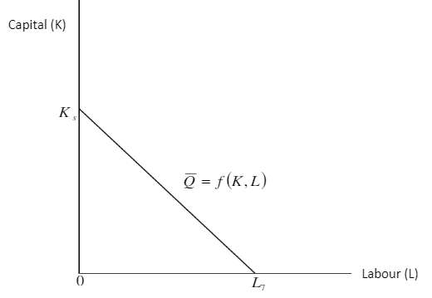
It reflects perfect substitution between factors of production i.e. Q could be produced wholly by using only capital and zero units of labour. It represents infinite methods of production, which in economic analysis is unrealistic assumption.
2) Input- output isoquant (Leontief isoquant)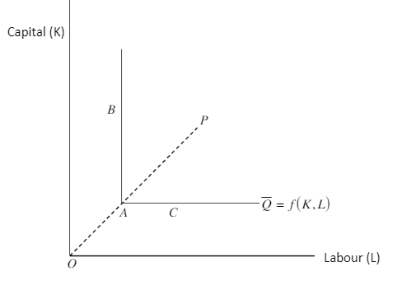

In this group of isoquants input cannot be substituted for one another.
There exists only one single production process (P).
All efficient production must take place at the corner of the isoquant (point A). The input combination represented by points B and C yield the same output as point A, but the A combination enables the use of less capital than the B combination with the same labour, or less labour than the C combination with capital the same.

In this group of isoquants input cannot be substituted for one another.
There exists only one single production process (P). All efficient production must take place at the corner of the isoquant (point A). the input combination represented by points B and C yield the same output as point A, but the A combination enables the use of less capital than the B combination with the same labour, or less labour than the C combination with capital the same.

3)Smooth convex isoquant

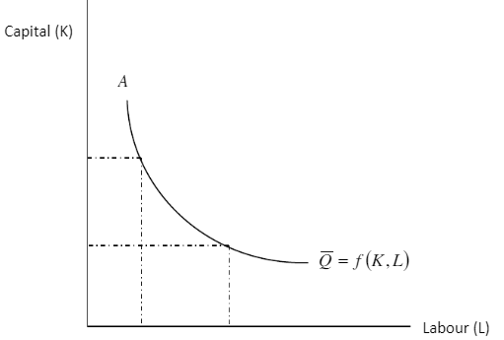

- Assume continuous substitutability between K and L over a certain range AB, beyond which factors cannot substitute each other.
- This type of isoquant is mostly adopted in economic theory because it is mathematically simpler to handle by the rules of calculus.
- E.g., to get its slope we differentiate the equation δL/δK.

CHARACTERISTICS OF ISOQUANTS
1) Are downwards sloping within the relevant range. Increasing one factor would require that the other factor be decreasing to yield same level of output.
2) Isoquants do not intersect.

Graph-Characteristics of isoquants
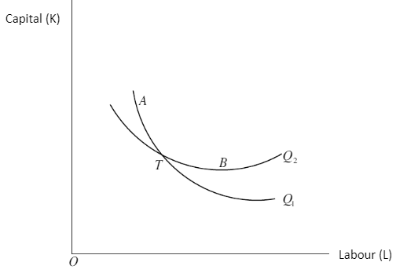

If the two intersect it means that combination of K and L at point T would yield higher output Q₂ as well as Q₁ which may not be the case.
3) Superior isoquants are represented by those far away from the graph origin.
4) This implies that the slope of the isoquant decreases (in absolute terms) as we move downwards along the isoquant, showing the increasing difficulty in substituting K for L.

9.0 THE LAW OF RETURNS TO SCALE

This is a long-term analysis of production it shows by how much total output will change because of a change in all factor inputs by same proportion.

Suppose we start from an initial level of input and output.

X₀=f (K, L)

And we increase all the factors by the same proportion k.
We will clearly obtain a new level of output X*, higher than the original level X_{O}

X*= f(K, L)

- X*increases by the same proportion k as the input, we say that there are constant returns to scale.
- If X* increases less than proportionally with the increase in the factors, we have decreasing returns to scale.
- If X* increases more than proportionally with the increase in the factors, we have increasing returns to scale.

Graphical presentation of the returns to scale
Returns to scale may be shown graphically by the distance between successive, multiple-level-of-output isoquant, that is, isoquant that show levels of output which are multiples of same base level of output.
Graph-constant returns to scale

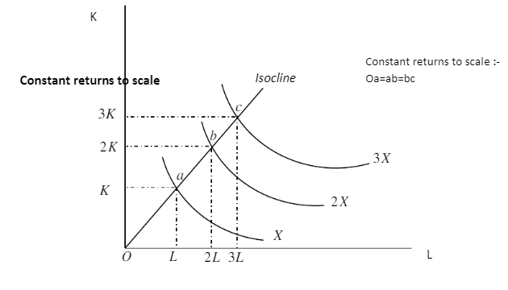
Constant returns to scale
- A line joining points a, b, c from origin is called an isocline. An isocline is a locus of points along which the marginal rate of technical substitution is constant.
- Doubling the factor inputs achieves double the level of initial output.
- Tripling inputs achieves triple output and so on.
Graph-Decreasing returns to scale

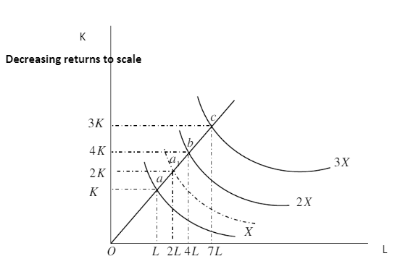

Decreasing returns to scale
By doubling the inputs, output increases by less than twice its original level.
The point a, defined by 2K and 2L lies on an isoquant below the one showing 2X Distance between the consecutive multiple isoquant increases.
0a < ab < bc

Graph-Increasing returns to scale

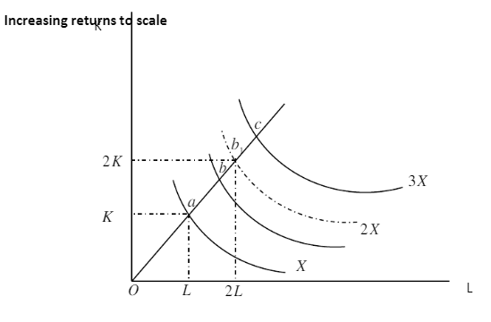

- When inputs are doubled output increases by more than double.
- Distance between consecutive multiple isoquant decreases. i.e 0a < ab < bc
- This implies in order to realize the next multiple level of output less amount of inputs than the previous level will be required.

10.0 RETURNS TO SCALE AND HOMOGENEITY OF PRODUCTION FUNCTION
- A homogeneous function is a function such that if each of the inputs is multiplied by a constant k can be completely factored out of the function.
- e.g., take production function X₀ =f (K, L)
- increase both factors L and K by same proportion k.
- new level of input X* =f(kL,kK)

If k can be factored out so that
X* K^{v} f(L,K)
- We say that the function is homogeneous of degree v. that is the power v of k is called degree of homogeneity of the function and is a measure of the returns to scale.
- A production function is said to be homogeneous of degree n, if when inputs are multiplied by some constant say k, the resulting output is a multiple of k^{n} times the original output.

e.g., X₀ = b₀ L^{b1} K^{b2}

multiplying L and K by a constant k
X* = b₀(kL)^{b1} (kK)^{b2}

= b_{o} k^{bl} k^{b2}(L^{b1}, K^{b2)}

=K^{(b1+b2)} (b₀ L^{b1}, K^{b2})
=K^{(b1+b2)}, X₀

Here returns to scale is measured by the power of k which is (b₁+b₂).
Notice b₁and b₂ are powers of factor inputs too.
If (b₁+b₂) = 1 constant returns to scale.

This production function is sometimes called linear homogeneity.

- If (b1+b2) < 1 decreasing returns to scale

- If (b1 + b2) > 1 increasing returns to scale.

11.o EQUILIBRIUM OF THE FIRM (CHOICE OF OPTIMAL COMBINATION OF FACTORS OF PRODUCTION

The goal of any firm is to maximize profit.

$π$ = R-C

Where;
R is revenue
C is cost.
- The firm strives to choose an optimal combination of factors of production that would maximize profits.
- The problem facing the firm would be that of constrained profit maximization.
- Constrained profit maximization may take one of the following forms.

Case 1: maximize output subject to a cost constraint.

Assumptions

- Price of output is given (P_{x} )
- Price of factor inputs are given
i.e. w is given wage rate (price of labour)
r is given price of capital.

In the case total cost (c) is given.
Therefore (c,p,w,r), implying that the profit maximization problem can be stated as Max $π$ = R – c
=P_{x} . X - C

Clearly, maximization of π is achieved in this case if x (output) is maximized, since c and P_{x} are given constants.

Case b: maximizing profit π if output and price are given.

For example, a contractor wants to build a ridge (x is given) with the maximum profit.
In this case;

Max π = Px X-C

Maximization of profit can only be achieved by minimizing cost.

Cost function is:

C=w.L =r.K

ISOCOST LINE
In the same way we derived a budget line for consumers budget constraint, we can derive an isocost line from the cost function. Isocost line is a locus of all combinations of factors the firm can purchase with a given monetary cost outlay.
Graph-Isocost line.

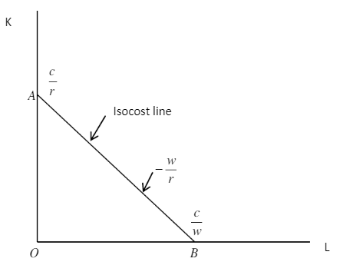

When :
K = 0
L = C/w

When:

L = 0
K= C/r

Slope = OA/OB= -C/r = w/r
C/w

Slope of the isocost line is equal to the ratio of the prices of the factor of production.

Shifts of isocost lines
- Due to change in expenditure or cost

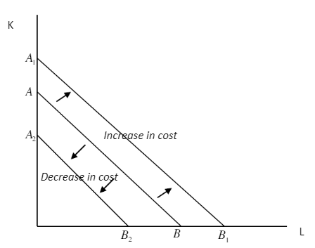

- Due to change in price of labour, price of capital and cost being held constant.

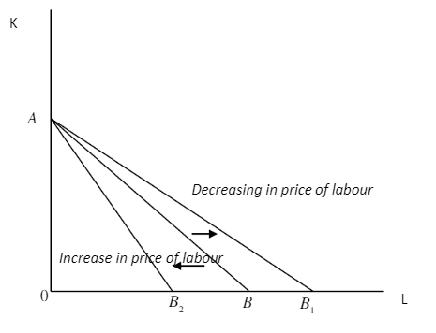

Graph-Equilibrium of the firm

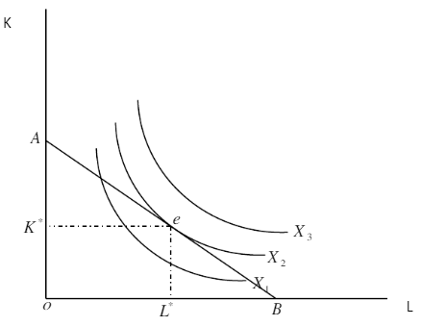

- Firm is maximizing output subject to cost constraint.
- Equilibrium is attained at the point of tangency between isocost line and the isoquant at point e.
- The optimal combination of inputs that maximize output is (K*,L*).

The maximum level of output the firm can produce given cost constraint is X₂.
At point e, the slope of isocost line w/r equal the slope of the isoquant MP_{L}/MP_{K}.
i.e MRTS = (MP_{L}/MP_{K}) = w/r this constitute the first condition for equilibrium.
Second condition is that isoquant be convex to the origin.

12.0 SUMMARY

- The law of increasing returns is also called the law of diminishing costs.
- The law of increasing return states that when more and more units of a variable factor is employed, while other factor remain fixed, there is an increase of production at a higher rate.
- The tendency of the marginal return to rise per unit of variable factors employed in fixed amounts of other factors by a firm is called the law of increasing return.
- An increase of variable factor, holding constant the quantity of other factors, leads generally to improved organization.
- The output increases at a rate higher than the rate of increase in the employment of variable factor.
- Isocost line is a locus of all combinations of factors the firm can purchase with a given monetary cost outlay.

13.0 REFERENCES

- Nicholson, W. (1992): Microeconomic Theory: Basic principles and extensions, 5th edition, San Diego, Dryden Press
- ii) Koutsoyiannis, A. (1979): Modern Microeconomics, 2nd edition, Macmillan
- iii) Mansfield, E, (1991): Microeconomic theory/applications, 7th edition, New York, Norton

