INTERMEDIATE MICROECONOMICS
WEEK 6- COMPETITIVE MARKETS
CONTENTS
0bjectives
2.0 Introduction
3.0 Characteristics of Competitive markets
4.0 Advantages and disadvantages of Perfectly Competitive Markets
5.0 Demand in a Perfectly Competitive Markets
6.0 Profit Maximization
7.0 Short-run Supply Curve
8.0 Long-run Supply Curve
9.0 Summary
10.0 References

- OBJECTIVES
- Discuss the characteristics of competitive markets.
- Differentiate competitive markets form other markets.
- Evaluate the Profit-Maximizing Output Level.
- State the equilibrium conditions.
- Explain supply in a competitive market.

- INTRODUCTION

What Is Perfect Competition?
- Perfect competition is an ideal type of market structure where all producers and consumers have full and symmetric information and no transaction costs.
- There are a large number of producers and consumers competing with one another in this kind of environment.
- Perfect competition is theoretically the opposite of a monopolistic market.
- Since all real markets exist outside of the plane of the perfect competition model, each can be classified as imperfect.
- The opposite of perfect competition is imperfect competition, which exists when a market violates the abstract tenets of neoclassical pure or perfect competition.
Types of Markets
- In most cases, it is the number of competitors in the market that most significantly affects the amount of influence firms have over their prices.
- A competitive firm is a firm that has many other firms producing identical goods and has no control over its price.
- Competitive firms are rather unusual and is on one end of the spectrum.
- The other extreme is a market with only one firm – a monopoly.
- Monopolies have a good bit of influence, but not total influence over the price.
- As price increases, quantity demanded will still decrease when buyers switch to other goods and services rather than other direct competitors.
- One way in which markets can differ is the existence of barriers to entry.
- Some markets are considered to have “free entry”, which means that it is relatively easy for a newcomer to start a business and be competitive.
- In between a totally competitive market and a monopoly, you have oligopolies which are markets with only a few competitors. oIn an oligopoly, firms have more influence over prices than firms in markets with many competitors.
How does Perfect Competition Work?
Perfect competition is a benchmark or ideal type to which real-life market structures can be compared. Perfect competition is theoretically the opposite of a monopoly, in which only a single firm supplies a good or service and that firm can charge whatever price it wants since consumers have no alternatives and it is difficult for would-be competitors to enter the marketplace. In a perfect competition model, there are no monopolies.

3.0 CHARACTERISTICS OF PERFECT COMPETITION
- A Large and Homogeneous Market
There are a large number of buyers and sellers in a perfectly competitive market. The sellers are small firms, instead of large corporations capable of controlling prices through supply adjustments. They sell products with minimal differences in capabilities, features, and pricing. This ensures that buyers cannot distinguish between products based on physical attributes, such as size or color, or intangible values, such as branding.
A large population of both buyers and sellers ensures that supply and demand remain constant in this market. As such, buyers can easily substitute products made by one firm for another.
Large Number of Buyers and Sellers If there are enough sellers, no firm can raise or lower the market price. An individual firm is a tiny percent of the entire market. The firm demand curve is a horizontal line at the market price.
- Perfect Information Availability
Information about an industry's ecosystem and competition constitutes a significant advantage. For example, knowledge about component sourcing and supplier pricing can make or break the market for certain companies.
In certain knowledge and research-intensive industries, such as pharmaceuticals and technology, information about patents and research initiatives at competitors can help companies develop competitive strategies and build a moat around their products.
- Absence of Controls
Governments play a vital role in market formation for products by imposing regulations and price controls. They can control the entry and exit of firms into a market by setting up rules to function in the market. For example, the pharmaceutical industry has to contend with a roster of rules pertaining to the development, production, and sale of drugs.
In turn, these rules require big capital investments in the form of employees, such as lawyers and quality assurance personnel, and infrastructure, such as machinery to manufacture medicines. The cumulative costs add up and make it extremely expensive for companies to bring a drug to the market.
In comparison, the technology industry functions with relatively less oversight as compared to its pharma counterpart. Thus, entrepreneurs in this industry can start firms with less to zero capital, making it easy for individuals to start a company in the industry.
Such controls do not exist in a perfectly competitive market. The entry and exit of firms in such a market are unregulated, and this frees them up to spend on labor and capital assets without restrictions and adjust their output in relation to market demands.
- Cheap and Efficient Transportation
Cheap and efficient transportation is another characteristic of perfect competition. In this type of market, companies do not incur significant costs to transport goods. This helps reduce the product’s price and cuts back on delays in transporting goods.
- Negligible Transaction Costs
Buyers and sellers don’t have to spend much time or money to interact with each other.
If this were not the case, buyers might absorb a higher price charged by firms who have a lower transaction cost.

4.0 ADVANTAGES AND DISADVANTAGES OF PERFECT COMPETITION
Perfect competition is an idealized framework for a market economy. While it provides a convenient model for how an economy works, it is not always accurate and has significant departures from the real-world economy. Like with other models, the value of a perfect competition framework is only accurate to the extent that it reflects actual conditions.
One notable feature of perfect competition is low profit margins. Since all consumers have access to the same products, they naturally gravitate towards the lowest prices. Firms cannot set themselves apart by charging a premium for higher-quality products and services. For instance, it would be impossible for a company like Apple (AAPL) to exist in a perfectly competitive market because its phones are more expensive than those of its competitors.
Another is the absence of innovation. The prospect of greater market share and setting themselves apart from the competition is an incentive for firms to innovate and make better products. But no firm possesses a dominant market share in perfect competition, meaning that the long-term profitability of their operations is zero.
Another disadvantage is the absence of economies of scale. Limited to zero profit margins means that companies will have less cash to invest in expanding their production capabilities. An expansion of production capabilities could potentially bring down costs for consumers and increase business profit margins. But the presence of several small firms cannibalizing the market for the same product prevents this and ensures that the average firm size remains small.

Pros and Cons of Perfect Competition
Pros
- Provides a convenient framework for modeling market activity.
- Demonstrates how producers are incentivized to provide lower prices.
Cons
- The perfect competition model does not always reflect real-world market conditions.
- The model does not account for geographical differences or variations between products.
- The model does not account for how producers benefit from economies of scale.
Conditions for Perfect Competition
First, there must be many firms in the market, none of which is large in terms of its sales. Second, firms should be able to enter and exit the market easily. Third, each firm in the market produces and sells a nondifferentiated or homogeneous product. Fourth, all firms and consumers in the market have complete information about prices, product quality, and production techniques.
Price‐taking behavior.
A firm that is operating in a perfectly competitive market will be a price‐taker. A price‐taker cannot control the price of the good it sells; it simply takes the market price as given. The conditions that cause a market to be perfectly competitive also cause the firms in that market to be price‐takers. When there are many firms, all producing and selling the same product using the same inputs and technology, competition forces each firm to charge the same market price for its good. Because each firm in the market sells the same, homogeneous product, no single firm can increase the price that it charges above the price charged by the other firms in the market without losing business. It is also impossible for a single firm to affect the market price by changing the quantity of output it supplies because, by assumption, there are many firms and each firm is small in size.

5.0 DEMAND IN A PERFECTLY COMPETITIVE MARKET
The demand and supply curves for a perfectly competitive market are illustrated in Figure (a); the demand curve for the output of an individual firm operating in this perfectly competitive market is illustrated in Figure (b).

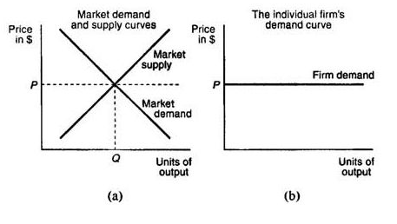
Note that the demand curve for the market, which includes all firms, is downward sloping, while the demand curve for the individual firm is flat or perfectly elastic, reflecting the fact that the individual takes the market price, P, as given. The difference in the slopes of the market demand curve and the individual firm's demand curve is due to the assumption that each firm is small in size. No matter how much output an individual firm provides, it will be unable to affect the market price. Note that the individual firm's equilibrium quantity of output will be completely determined by the amount of output the individual firm chooses to supply.
Demand Facing a Competitive Firm
- As long as the additional revenue earned from selling a unit is greater than the marginal cost of producing the unit, the firm should produce it.
- In perfect competition, the additional revenue earned from selling another unit of output is simply equal to the market price.
- Total revenue is the total amount received as firms sell their products.
- Marginal revenue is the change in total revenue as a firm sells on more unit of a good or service.
- Average revenue is the average amount received per unit.
6.0 PROFIT MAXIMIZATION
Choosing the Profit-Maximizing Output Level
- If the goal of a firm is to maximize profit, this can be done by choosing the output level where marginal revenue = marginal cost.
- If a firm is producing at an output where marginal cost equals marginal revenue, and yet the price is below average cost, the firm is earning a loss.
- If the marginal revenue is greater than the average variable cost, the firm is better off producing than not producing.
- If the marginal revenue is greater than average cost, the firm can reduce losses by producing more.

7.0 SHORT-RUN SUPPLY
In determining how much output to supply, the firm's objective is to maximize profits subject to two constraints: the consumers' demand for the firm's product and the firm's costs of production. Consumer demand determines the price at which a perfectly competitive firm may sell its output. The costs of production are determined by the technology the firm uses. The firm's profits are the difference between its total revenues and total costs.
Total revenue and marginal revenue. A firm's total revenue is
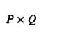
the dollar amount that the firm earns from sales of its output. If a firm decides to supply the amount Q of output and the price in the perfectly competitive market is P, the firm's total revenue is A firm's marginal revenue is the dollar amount by which its total revenue changes in response to a 1-unit change in the firm's output. If a firm in a perfectly competitive market increases its output by 1 unit, it increases its total revenue by P × 1 = P. Hence, in a perfectly competitive market, the firm's marginal revenue is just equal to the market price, P.
Short‐run profit maximization. A firm maximizes its profits by choosing to supply the level of output where its marginal revenue equals its marginal cost. When marginal revenue exceeds marginal cost, the firm can earn greater profits by increasing its output. When marginal revenue is below marginal cost, the firm is losing money, and consequently, it must reduce its output. Profits are therefore maximized when the firm chooses the level of output where its marginal revenue equals its marginal cost.
To illustrate the concept of profit maximization, consider again the example of the firm that produces a single good using only two inputs, labor and capital. In the short‐run, the amount of capital the firm uses is fixed at 1 unit. Assume that this firm is competing with many other firms in a perfectly competitive market. The price of the good sold in this market is $10 per unit. The firm's costs of production for different levels of output are the same as those considered in the numerical examples of the previous section, Theory of the Firm. These costs, along with the firm's total and marginal revenues and its profits for different levels of output, are reported in Table .
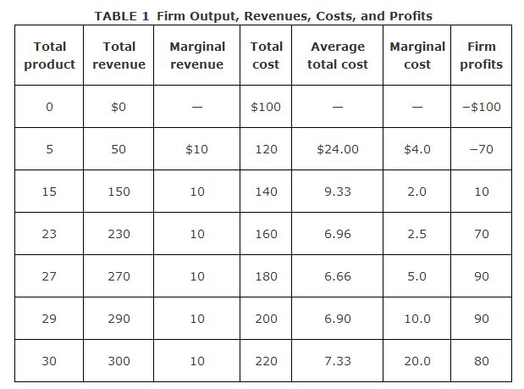
Because the price of the good is $10, the firm's total revenue is 10 × total product. The firm's marginal revenue is equal to the price of $10 per unit of total product. Notice that the marginal cost of the 29th unit produced is $10, while the marginal revenue from the 29th unit is also $10. Hence, the firm maximizes its profits by choosing to produce exactly 29 units of output. In choosing to produce 29 units of output, the firm earns $90 ($290 − 200) in profits.

Graphical illustration of short‐run profit maximization. The marginal revenue, marginal cost, and average total cost figures reported in the numerical example of Table are shown in the graph in Figure .
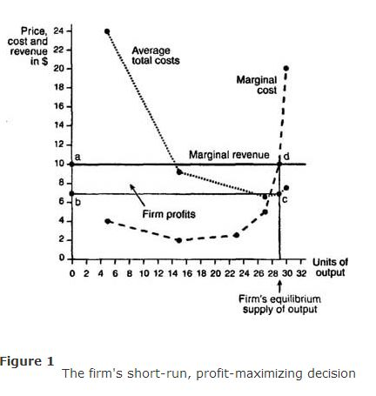
The firm's equilibrium supply of 29 units of output is determined by the intersection of the marginal cost and marginal revenue curves (point d in Figure ). When the firm produces 29 units of output, its average total cost is found to be $6.90 (point c on the average total cost curve in Figure ). The firm's profits are therefore given by the area of the shaded rectangle labeled abed.
The area of this rectangle is easily calculated. The length of the rectangle is 29. The width is the difference between the market price (the firm's marginal revenue), $10, and the firm's average cost of producing 29 units, $6.90. This difference is ($10 × $6.90) = $3.10. Hence, the area of rectangle abed is 29 × $3.1 = $90, the same amount reported in Table . In general, the firm makes positive profits whenever its average total cost curve lies below its marginal revenue curve.
Short‐run losses and the shut‐down decision. When the firm's average total cost curve lies above its marginal revenue curve at the profit maximizing level of output, the firm is experiencing losses and will have to consider whether to shut down its operations. In making this determination, the firm will take into account its average variable costs rather than its average total costs. The difference between the firm's average total costs and its average variable costs is its average fixed costs. The firm must pay its fixed costs (for example, its purchases of factory space and equipment), regardless of whether it produces any output. Hence, the firm's fixed costs are considered sunk costs and will not have any bearing on whether the firm decides to shut down. Thus, the firm will focus on its average variable costs in determining whether to shut down.
If the firm's average variable costs are less than its marginal revenue at the profit maximizing level of output, the firm will not shut down in the short‐run. The firm is better off continuing its operations because it can cover its variable costs and use any remaining revenues to pay off some of its fixed costs. The fact that the firm can pay its variable costs is all that matters because in the short‐run, the firm's fixed costs are sunk; the firm must pay its fixed costs regardless of whether or not it decides to shut down. Of course, the firm will not continue to incur losses indefinitely. In the long‐run, a firm that is incurring losses will have to either shut down or reduce its fixed costs by changing its fixed factors of production in a manner that makes the firm's operations profitable.
The case where the firm is incurring short‐run losses but continues to operate is illustrated graphically in Figure (a). At the market price, P ₁, the firm's profit maximizing quantity is Q ₁. At this quantity, the firm's average total cost curve lies above its marginal revenue curve, which is the flat, dashed line denoting the price level, P ₁. The firm's average variable cost curve, however, lies below its marginal revenue curve, implying that the firm is able to cover its variable costs. The firm's losses from producing quantity Q ₁ at price P ₁ are given by the area of the shaded rectangle, abcd. Despite these losses, the firm will decide not to shut down in the short‐run because it receives enough revenue to pay for its variable costs.
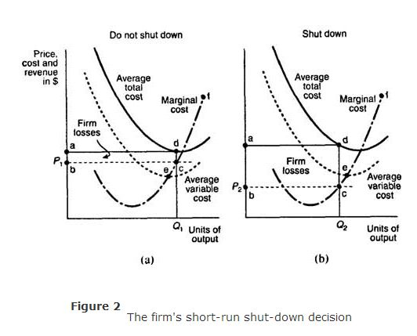
Figure (b) depicts a different scenario in which the firm's average total cost and average variable cost curves both lie above its marginal revenue curve, which is the dashed line at price P ₂. The firm's losses are given by the area of the shaded rectangle, abed. In this situation, the firm will have to shut down in the short‐run because it is unable to cover even its variable costs. As a general rule, a firm will shut down production whenever its average variable costs exceed its marginal revenue at the profit maximizing level of output. If this is not the case, the firm may continue its operations in the short‐run, even though it may be experiencing losses.
Short‐run supply curve.
The firm's short‐run supply curve is the portion of its marginal cost curve that lies above its average variable cost curve. As the market price rises, the firm will supply more of its product, in accordance with the law of supply. If, however, the market price, which is the firm's marginal revenue curve, falls below the firm's average variable cost, the firm will shut down and supply zero output.
The firm's short‐run supply curve is illustrated in Figures (a) and (b). Here, the firm's short‐run supply curve is the portion of the marginal cost curve labeled ef. The market short‐run supply curve, like the market demand curve, is simply the horizontal summation of all the individual firms' short‐run supply curves.
At short-run equilibrium, the firm has two conditions:
oIf price is less than the average variable cost, the firm should shut down.
oIf price is greater than the average variable cost, the firm should produce. ▪The firm always produces at the output level where marginal revenue equals marginal cost.
oBoth conditions apply to firms in all different types of markets.

8.0 LONG-RUN SUPPLY
In the long‐run, firms can vary all of their input factors. The ability to vary the amount of input factors in the long‐run allows for the possibility that new firms will enter the market and that some existing firms will exit the market. Recall that in a perfectly competitive market, there are no barriers to the entry and exit of firms. New firms will be tempted to enter the market if some of the existing firms in the market are earning positive economic profits. Alternatively, existing firms may choose to leave the market if they are earning losses. For these reasons, the number of firms in a perfectly competitive market is unlikely to remain unchanged in the long‐run.
Zero economic profits. The entry and exit of firms, which is possible in the long‐run, will eventually cause each firm's economic profits to fall to zero. Hence, in the long‐run each firm earns normal profits. If some firms are earning positive economic profits in the short‐run, in the long‐run new firms will enter the market and the increased competition will reduce all firms' economic profits to zero. Firms that are earning negative economic profits (losses) in the short‐run will have to either make some changes in their fixed factors of production in the long‐run or choose to leave the market in the long‐run. A perfectly competitive market achieves long‐run equilibrium when all firms are earning zero economic profits and when the number of firms in the market is not changing.
Minimization of long‐run average total cost. In the long‐run, a perfectly competitive firm can adjust the amount it uses of all factor inputs, including those that are fixed in the short‐run. For example, in the long‐run, the firm can adjust the size of its factory. In making these adjustments, the firm will seek to minimize its long‐run average total cost. If, in the short‐run, the firm is operating below its minimum efficient scale and experiencing economies of scale, in the long‐run it can adjust its use of factor inputs so as to increase its output to the minimum efficient scale level.
Alternatively, if the firm is experiencing diseconomies of scale because its short‐run level of output exceeds its minimum efficient scale, in the long‐run the firm can adjust its use of factor inputs so as to reduce its output to the minimum efficient scale level. Thus, in the long‐run the firm will be operating at the minimum point of its long‐run average total cost curve.

Graphical illustration of long‐run profit maximization. The long‐run equilibrium for an individual firm in a perfectly competitive market is illustrated in Figure .
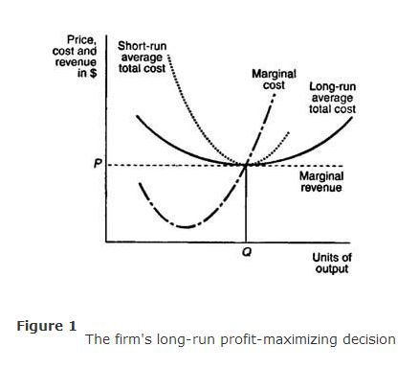
The profit maximizing level of output, where marginal cost equals marginal revenue, results in an equilibrium quantity of Q units of output. Because the firm's average total costs per unit equal the firm's marginal revenue per unit, the firm is earning zero economic profits. Furthermore, the firm is shown to be producing at the minimum point of its long‐run average total cost curve, at the minimum efficient scale level of output.
Long‐run market supply curve. The short‐run market supply curve is just the horizontal summation of all the individual firm's supply curves. The long‐run market supply curve is found by examining the responsiveness of short‐run market supply to a change in market demand. Consider the market demand and supply curves depicted in Figures (a) and (b). Here, the market demand curves are labeled D ₁, and D ₂, while the short‐run market supply curves are labeled S ₁ and S ₂.
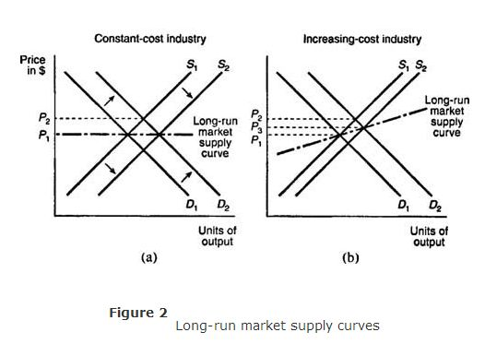

Figure (a) depicts demand and supply curves for a market or industry in which firms face constant costs of production as output increases. At the intersection of D ₁ and S ₁, the market is in long‐run equilibrium at a market price of P ₁. An increase in demand from D ₁ to D ₂ results in a new, higher market price of P ₂. In the short‐run, existing firms in this market will earn positive economic profits. In the long‐run, however, new firms will enter, causing short‐run market supply to shift from S ₁ to S ₂ and driving the market price back down to P ₁. The long‐run market supply curve is therefore given by the horizontal line at the market price, P ₁
Figure (b) depicts demand and supply curves for a market or industry in which firms face increasing costs of production as output increases. Starting from a market price of P ₁, an increase in demand from D ₁ to D ₂ increases the market price to P ₂. In the short‐run, firms are earning positive economic profits. In the long‐run, new firms will enter the market, the short‐run supply curve will shift from S ₁ to S ₂, and the new market price will be P ₃. The new, long‐run market price of P ₃ is greater than the old market price of P ₁ because in an increasing‐cost industry, the firm's average total costs rise as it produces more output. Thus, the long‐run market supply curve in an increasing‐cost industry will be positively sloped.
Supply in a competitive market
- In perfect competition, the firm’s short-run supply curve is just the marginal cost function above the shutdown price.
- The market supply curve is the horizontal sum of all the individual firm’s supply curves.
Profits: Economics and Accounting Profits
- Accounting profit is the difference between revenue and explicit costs.
- Economic profit accounts for costs of the factors of production.
- Accounting profit that could be earned elsewhere is the normal profit. This is the opportunity cost of capital and other inputs supplied by the owners of a business.
- Zero economic profit means that this firm is earning the same accounting profit in the current business that they could earn elsewhere.

9.0 SUMMARY
- If firms in an industry are earning positive economic profit, other firms will enter the industry.
- If there are positive economic profit new firms will enter, increasing the market supply.
- In the long-run, entry and exit of firms will cause the price to adjust back to the long-run equilibrium where economic profits are zero
- An increasing cost industry is one where the price of inputs increase as the industry expands.
- A decreasing cost industry is one where the price of inputs decreases as the industry expands.
- In the short run, demand increases, creating a shortage.
- Business also increase prices due to higher costs as they expand. As prices rise, some consumers reduce the amounts they are willing to purchase.
- This process continues until quantity demanded equals quantity supplied and firms are producing at levels of output that are maximizing profits in the short run.
- At this point, prices are still above average costs, so firms will be earning economic profit.
- This prompts additional firms to enter the market, which ultimately cycles to cause all firms to earn zero economic profit in the long run.
- Economic Efficiency-In the long run, a perfectly competitive market will create a technically efficient and allocatively efficient outcome.
10.0 REFERENCES
- Nicholson, W. (1992): Microeconomic Theory: Basic principles and extensions, 5th edition, San Diego, Dryden Press
- Koutsoyiannis, A. (1979): Modern Microeconomics, 2nd edition, Macmillan
- Mansfield, E, (1991): Microeconomic theory/applications, 7th edition, New York, Norton

