INTERMEDIATE MICROECONOMICS

Week 7-Monopoly

CONTENTS

1.0 OBJECTIVES

2.0 INTRODUCTION

Definition

Characteristics

Barriers to entry limiting competition.

3.0 TYPES OF MONOPOLY

Simple Monopoly and Discriminating Monopoly

Pure Monopoly and Imperfect Monopoly

Natural Monopoly

Legal Monopoly

4.0 MONOPOLY PRICING AND SHORT RUN EQUILIBRIUM

5.0 THE LONG-RUN IN MONOPOLY

6.0 IMPACTS OF MONOPOLY ON INEFFICIENCY.

7.0 GOVERNMENT RESPONSES TO MONOPOLY

8.0 SUMMARY

9. 0 REFERENCES

- OBJECTIVES
At the end of this unit, you should be able to:
- Describe the monopoly market.
- State the features of monopoly.
- Enumerate sources of monopoly power
- Explain total revenue, marginal revenue, and demand curve monopoly market.
- Explain profit maximization and loss minimization under monopoly market.
2.0 INTRODUCTION

A Pure monopoly exists when a single firm is the sole producer of a product for which there are no close substitutes.

There are several products where the producers have a substantial amount of monopoly power and are called “near” monopolies.

A monopoly is a single seller market structure, which sells a unique product on the market. The seller is not confronted with competition in a monopoly market because he is the only seller without an immediate replacement. In economics, monopoly and competition imply some complex relations between companies in an industry. Monopolistic competitive company is competing against a large number of companies that sell slightly different products. A monopolistic competitor arguably selects its profit-maximizing production quantity by generating a level of production where marginal income is equal to marginal costs. In the long term, monopoly competitive companies do not produce the lowest possible median wage cost that technology enables but achieves their production efficiency. Contrary to this, In the short term, a monopolistic competitive company maximizes profit or reduces losses by generating a marginal income = marginal cost. As far as revenue is concerned, rival monopolistic firms can make short-term economic profit or loss, but long-term entry and exit lead these companies to a zero-profit.

A monopoly is a single producer of a product, which does not have a close substitute. A monopoly has market power, which is the ability to increase the product's price above marginal cost without losing all customers, it provides firms the ability to increase the price by restricting supply, such that MR > MC. In other words, the ability to influence the market, and in particular the market price, by influencing the total quantity offered for sale.

2.1 Definition of monopoly

“Monopoly is made of two words—’Mono’ and ‘Poly’. ‘Mono’ means single and ‘Poly’ means seller. Thus, ‘Monopoly refers to a market situation where one firm or a group of firms which are combined to have a control over the supply of the product. ”

In other words, Monopoly is a market situation in which there is only one seller of a product with barriers to entry of others.

Monopoly may be defined as that – “Market form in which a single producer controls the whole supply of a single commodity which has no close substitutes.”

Thus, there are the following three essential conditions to constitute as Monopoly:

1. Single Producer or Seller:

There must be a single producer or seller. He may be an individual or a firm of partners or a joint

stock company. This condition is essential to eliminate competition.

2. Absence of Close Substitutes:

The commodity dealt in should have no closely competition substitutes. That is, there should be no other firm or firms producing similar products, otherwise there will be competition.

3. Barriers to the Entry of New Firm:

There must be strict barriers to the entry of new firms either in the market or to do production.

Those three conditions ensure that the monopolist can set the price of his commodity i.e., he can pursue an independent price output policy.

2.2 Characteristics of Monopoly

There are several characteristics that distinguish pure monopoly.

1.There is a single seller, so the firm and industry are synonymous.

2.There are no close substitutes for the firm’s product.

3.The firm is a “price maker,” that is, the firm has considerable control over the price because it can control the quantity supplied.

4. Entry into the industry by other firms is blocked.

5. A monopolist may or may not engage in nonprice competition. Depending on the nature of its product, a monopolist may advertise to increase demand.
Salient Features of Monopoly

1.Monopolist maximizes profits.
2. Monopolist decides the price of the good or product to be sold but does so by determining the quantity to demand the price desired by the firm.
3. Monopolist creates high barriers to entry, i.e. other sellers are unable to enter the market of the monopoly.
4.In a monopoly, there is one seller of the good that produces all the output. Thus, the whole market is being served by a single company; in other words, the company is similar to the industry.
5.A monopolist can change the price and quality of the product. He sells more quantities charging fewer prices for the product in a very elastic market and sells less quantities charging high price in a less elastic market.

  - Barriers to Entry Limiting Competition

1.Economies of scale constitute one major barrier. This occurs where the lowest unit costs and, therefore, lowest unit prices for consumers depend on the existence of a small number of large firms or, in the case of a pure monopoly, only one firm. Because a very large firm with a large market share is most efficient, new firms cannot afford to start up in industries with economies of scale.

2.Legal barriers to entry into a monopolistic industry also exist in the form of patents and licenses.

Patents grant the inventor the exclusive right to produce or license a product for seventeen years; this exclusive right can earn profits for future research, which results in more patents and monopoly profits.

Licenses are another form of entry barrier. Radio and TV stations, taxi companies are examples of government granting licenses where only one or a few firms are allowed to offer the service.

3. Ownership or control of essential resources is another barrier to entry.
- International Nickel Co. of Canada controlled about 90 percent of the world’s nickel reserves, and DeBeers of South Africa controls most of world’s diamond supplies.
- Aluminum Co. of America (Alcoa) once controlled all basic sources of bauxite, the ore used in aluminum fabrication.
- Professional sports leagues control player contracts and leases on major city stadiums.

4. Monopolists may use pricing or other strategic barriers such as selective price-cutting and advertising.

5. Technological superiority: A monopoly may be better able to acquire, integrate and use the best possible technology in producing its goods while entrants do not have the size or finances to use the best available technology. One large company can sometimes produce goods cheaper than several small companies.

6. No substitute goods: A monopoly sells goods for which there is no close substitute. The absence of substitutes makes the demand for the good relatively inelastic, enabling monopolies to extract positive profits.

7. Ownership/control of a key resource: A prime source of monopoly power is the control of resources that are critical to the production of final goods. A monopoly can hardly be established within a country without overt and covert government assistance in the form of a tariff or some other device. It is close to impossible to do so.

8. Network effects: The use of a product by a person can affect the value of that product to other people. This is the network effect. There is a direct relationship between the proportion of people using a product and the demand for that product. Thus, the more people using a particular good, the greater the chances of any individual starting to use that good. This effect can be seen in fads and fashion trends. It also can play a crucial role in the development or acquisition of market power. The most famous current example is the market dominance of the Microsoft operating system in personal computers.

9. Special right given by government: Legal rights can provide opportunity to monopolize the market of a good. Intellectual property rights, including patents and copyrights, give monopolist special control of the production and selling of certain goods. Property rights may give a firm special control of the materials necessary to produce a good.

10. Elimination strategies/ actions: A company wanting to monopolize a market may engage in various types of deliberate action to exclude competitors or eliminate competition. Such actions include collusion, lobbying governmental authorities, and force.

11. Difficulty to exit may be a source of market power: Barriers to exit include market conditions that make it difficult or expensive for a company to end its involvement with a market. Great liquidation costs are a primary barrier to exit. Market exit and shutdown are separate events. The decision whether to shut down or operate is not affected by exit barriers. A company will shut down if price falls below minimum average variable costs.

3.0 TYPES OF MONOPOLY:
Monopoly is of following kinds:
- Simple Monopoly and Discriminating Monopoly:
A simple monopoly firm charges a uniform price for its output sold to all the buyers. While a discriminating monopoly firm charges different prices for the same product to different buyers. A simple monopoly operates in a single market, a discriminating monopoly operates in more than one market.
- Pure Monopoly and Imperfect Monopoly:
Pure monopoly is that type of monopoly in which a single firm controls the supply of a commodity which has no substitutes not even a remote one. It possesses an absolute Monopoly power. Such a Monopoly is very rare. While imperfect monopoly means a limited degree of Monopoly. It refers to a single firm which produces a commodity having no close substitutes. The degree of Monopoly is less than perfect in this case, and it relates to the availability of the closeness of a substitute. In practice, there are many cases of such imperfect monopoly.
3. Natural Monopoly: When a Monopoly is established due to natural causes then it is called natural monopoly. To-day India has got Monopoly in mica production and Canada has got Monopoly in nickel production. These Monopoly natures has provided to these countries.
4. Legal Monopoly: When anybody receives or acquires Monopoly due to legal provisions in the country.

4.0 MONOPOLY PRICING AND SHORT RUN EQUILIBRIUM
What is firm demand/market demand in a monopoly market?
Recall that when we asked the same questions for perfectly competitive markets that we found that firm and market demand were quite different. In monopoly, however, firm and market demand are the same because only one firm exists in the market.
A monopoly can charge any price it wants, and the consumer must pay that price.
This statement is false even though the first part is correct. In fact, any firm can charge any price it wants generally.
Monopolies do have less competition, but consumers do not have to buy their product.
Hence, as the monopoly charges a higher price, we expect that the quantity demanded will fall (law of demand). Figure 1 shows the downward sloping demand curve of a monopolist market.

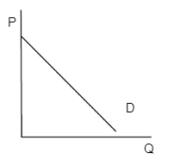
Demand is determined by consumers not by the monopoly firm and depends upon all the normal types of factors that affect consumer choice.
It is important to remember two points about market power:
• Price is a factor of market power, the ability to increase price without decreasing sales
• Monopoly has more market power than Perfect Competition, but does not have absolute market power
Short-run profit maximization
Recall that all profit maximizing firms produce where MR=MC. For a perfectly competitive firm, marginal revenue was easy to calculate because they could sell all they wanted at the market price. For monopolists, however, who have downward sloping demand curves to sell more they have to drop the price.
• Recall that MR = the extra revenue gained from selling one more unit of goods.

• Table 1 shows a downward sloping demand curve for a monopolist. Notice that as price falls quantity demanded rises. Use Table 1 to calculate both TR and MR.
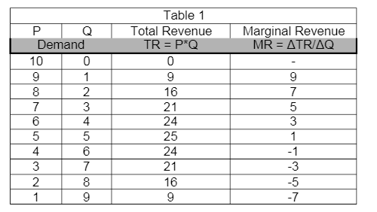
Why is MR = 7 when Q = 2 when price equals 8? (Hint: What happens to the price of the first unit sold?)
Figure 2-Marginal and Demand
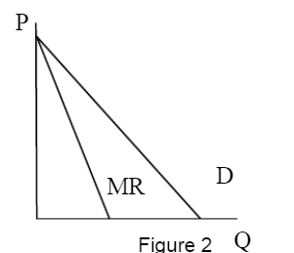
Notice that MR < P (which is given by the demand curve) as shown in Figure 2 to the above.

Figure 3 shows both D and MR for a monopolist as does Figure 2 but also adds in the cost curves we developed previously.
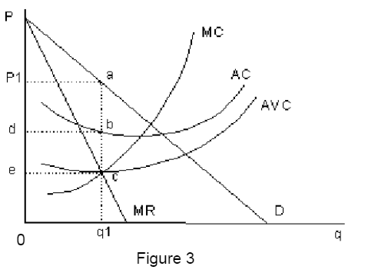
Because the firm is in the short run the ATC, AVC, and MC are all u-shaped (law of diminishing returns.)
The monopoly firm must answer the same questions that the perfectly competitive firm faced:
Graphical Analysis – Questions to be answered using Figure 3.
1. At what q is π maximized?
Recall from above that all profit maximizing firms produce at the quantity where MR = MC. In Figure 3 this occurs at q1.
2. What P does a firm charge?
The answer for a monopoly firm is a little more complicated than for a perfectly competitive firm. Here, unlike in perfect competition, the firm has a downward sloping demand curve and can increase its price without losing all its sales. How high should the price be? Recall that the firm is producing q1 and wants to be able to sell all that output. Hence, it cannot set the price so high that it cannot sell q1.
The appropriate price is the maximum price it can just sell all q1. This is given by the demand curve at q1 – which occurs at point a. Therefore, the appropriate profit maximizing price is P1.
3. What does π(profit) equal?
All firms are primarily interested in their profits. Like perfect competition, in order to calculate profits in Figure 3, there are a number of other questions that must be answered before profit can be calculated. All of these are calculated at the profit maximizing output, q1.
• Q = q1 = distance 0 to q1.
• The price is given by the demand at point a = P1.
• MR = MC at point c => both equal the distance from 0 to e.
The average costs:
- ATC = distance 0 to d.
- AVC = distance 0 to e.
- AFC = ATC – AVC = distance e to d.
Total Revenue and Total Costs
- TR = p*q = distance 0-q1 * distance 0 – P1 = area of the rectangle 0 – P1 – a – q1.
- TC = ATC*q = area of the rectangle 0 – d – b – q1.
- TVC = AVC*q = area of the rectangle 0 – e – c – q1.
- TFC = AFC*q = area of the rectangle e- d – b –c.
Profit. Recall that there are two methods of calculating profits.
- π = TR – TC = the area of the rectangle 0 – P1 – a – q1. minus the area of rectangle 0 – d – b – q1 = the area of rectangle d – P1 – a – b.
- π = TR – TC = p*q – ATC*q = (p – ATC) *q. Again, this is the most useful equation but gives the same answer. Notice that profit is positive here because P > ATC.
Loss minimization for monopolist firms
Loss minimization for a monopolist is the same basic decision as it is for perfectly competitive firms. Recall the three possibilities that can occur in the short run for all firms:
• π > 0, which occurs whenever P > ATC. In this case the firm clearly continues to produce.
• π = 0, which occurs whenever P = ATC. In this case, the firm will continue to produce (zero economic profit implies that all costs, including opportunity costs, are covered.)
• π < 0, which occurs whenever P < ATC. Should the firm shut down in this situation?
Recall the answer to this question for perfectly competitive firms – firms should only shut down if they cannot cover their variable (not fixed) costs. Thus, if prices fall below AVC then the firm will shut down.
A monopoly firm will shut down in the short run if the price falls below AVC.
What is the industry/market short-run supply curve?
A supply curve shows quantity supplied given the price, ceteris paribus. Recall that for perfectly competitive firms, the firm’s short-run supply curve equals their MC curve above AVC. Unfortunately, for monopoly firms the relationship between price and quantity supplied is more complicated.
To illustrate this fact, examine Figure 3 again. Recall that the firm produces where MR=MC at q1. Hence, the MC curve does show quantity supplied. If the MC curve were the firm’s supply curve, then the price would be given by MC at that output level or a price of 0 – e. However, the firm can, and will, charge a higher price for this level of output, all the way up to a price of P1, which is given by the demand curve.
Hence, the interaction of MC and MR determine quantity supplied but the demand curve determines price. This means that no single curve determines quantity supplied and price. Unlike for perfect competition, in monopoly no supply curve exists.
5.0 THE LONG-RUN IN MONOPOLY
The long-run equilibrium in monopoly markets:
• If π > 0, the positive profits attract firms to the market in the long run.
• However, monopolies have entry barriers which keep potential competitors from entering the market.
• Hence, π remains positive.
2. If π < 0, the negative profits cause the firm to go out of business / leave industry in the long run (there are no fixed costs, recall).
• If the firm exists in the long run, then it has no revenue but also avoids all costs so that π = 0.
• Thus, in the long run π is ≥ 0.
6.0 IMPACTS OF MONOPOLY ON EFFICIENCY
What are the reasons for Efficiency Loss?
A monopoly generates less surplus and is less efficient than a competitive market, and therefore results in deadweight loss.
We evaluate the economic inefficiency created by monopolies.
A monopoly exists when a specific enterprise is the only supplier of a particular commodity. Monopolies have little to no competition when producing a good or service. A monopoly is a business entity that has significant market power (the power to charge high prices).
Inefficiency in a Monopoly
In a monopoly, the firm will set a specific price for a good that is available to all consumers. The quantity of the goods will be less and the price will be higher (this is what makes the good a commodity). The monopoly pricing creates a deadweight loss because the firm forgoes transactions with the consumers. The deadweight loss is the potential gains that did not go to the producer or the consumer. As a result of the deadweight loss, the combined surplus (wealth) of the monopoly and the consumers is less than that obtained by consumers in a competitive market. A monopoly is less efficient in terms of total gains from trade than a competitive market.
Monopolies can become inefficient and less innovative over time because they do not have to compete with other producers in a marketplace. For private monopolies, complacency can create room for potential competitors to overcome entry barriers and enter the market. Also, long-term substitutes in other markets can take control when a monopoly becomes inefficient.
Market Failure
When a market fails to allocate its resources efficiently, market failure occurs. In the case of monopolies, abuse of power can lead to market failure. Market failure occurs when the price mechanism fails to consider all the costs and/or benefits of providing and consuming a good. As a result, the market fails to supply the socially optimal amount of the goods. A monopoly is an imperfect market that restricts output to maximize profit. Market failure in a monopoly can occur because not enough of the good is made available and/or the price of the good is too high. Without the presence of market competitors, it can be challenging for a monopoly to self-regulate and remain competitive over time.

Figure 3-Graph showing abnormal profits-monopoly as an imperfect market.

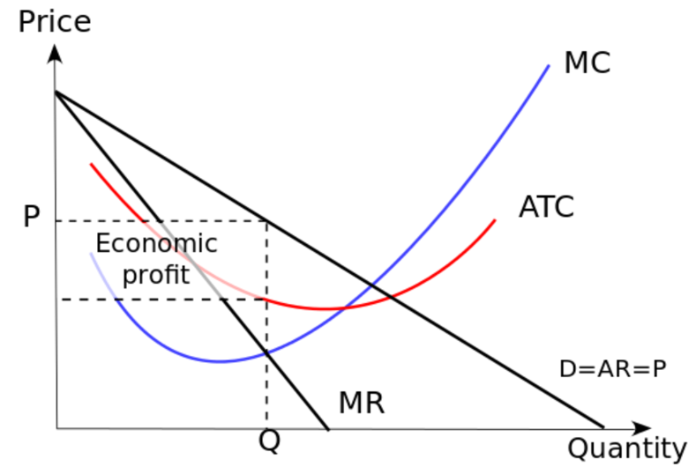

Imperfect competition: This graph shows the short run equilibrium for a monopoly. The dotted box illustrates the abnormal profit, although the firm could easily be losing money. A monopoly is an imperfect market that restricts the output to maximize its profits.
Understanding and Finding the Deadweight Loss
- Define deadweight loss.
- Explain how to determine the deadweight loss in a given market.

Deadweight Loss
In economics, deadweight loss is a loss of economic efficiency that occurs when equilibrium for a good or service is not Pareto optimal.
When a good or service is not Pareto optimal, the economic efficiency is not at equilibrium. As a result, when resources are allocated, it is impossible to make any one individual better off without making at least one person worse off. When deadweight loss occurs, there is a loss in economic surplus within the market. Deadweight loss implies that the market is unable to naturally clear.
Causes of Deadweight Loss
Deadweight loss is the result of a market that is unable to naturally clear, and is an indication, therefore, of market inefficiency. The supply and demand of a good or service are not at equilibrium.
Causes of deadweight loss include:
- Imperfect markets.
- Externalities.
- Taxes or subsidies.
- Price ceilings.
- Price floors.
Determining Deadweight Loss
To determine the deadweight loss in a market, the equation P=MC is used. The deadweight loss equals the change in price multiplied by the change in quantity demanded. This equation is used to determine the cause of inefficiency within a market.
For example, in a market for nails where the cost of each nail is $0.10, the demand will decrease from a high demand for less expensive nails to zero demand for nails at $1.10. In a perfectly competitive market, producers would charge $0.10 per nail and every consumer whose marginal benefit exceeds the $0.10 would have a nail. However, if one producer has a monopoly on nails, they will charge whatever price will bring the largest profit. If they charge $0.60 per nail, every party who has less than $0.60 of marginal benefit will be excluded. When equilibrium is not achieved, parties who would have willingly entered the market are excluded due to the non-market price.

Figure 4-Deadweight loss-a binding ceiling.
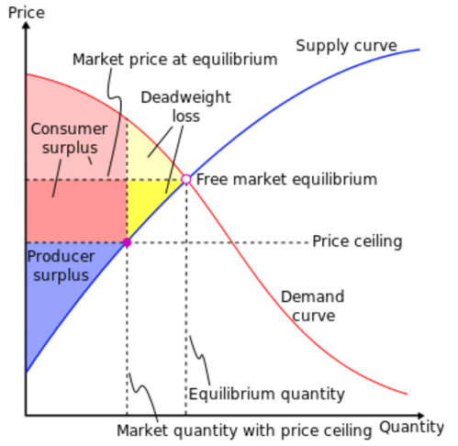

Deadweight loss: This graph shows the deadweight loss that is the result of a binding price ceiling.
Policy makers will place a binding price ceiling when they believe that the benefit from the transfer of surplus outweighs the adverse impact of the deadweight loss.
In general, we can make the following conclusions about deadweight loss in monopolies-
- The monopoly pricing creates a deadweight loss because the firm forgoes transactions with the consumers.
- Monopolies can become inefficient and less innovative over time because they do not have to compete with other producers in a marketplace.
- In the case of monopolies, abuse of power can lead to market failure. Market failure occurs when the price mechanism fails to consider all of the costs and/or benefits of providing and consuming a good.
- A monopoly is an imperfect market that restricts output to maximize profit. Without the presence of market competitors, it can be challenging for a monopoly to self-regulate and remain competitive over time.
- When deadweight loss occurs, there is a loss in economic surplus within the market.
- Causes of deadweight loss include imperfect markets, externalities, taxes or subsidies, price ceilings, and price floors.

7.0 GOVERNMENT RESPONSES TO MONOPOLY
One role of government is to correct problems of market failure associated with public goods, external costs and benefits, and imperfect competition.
Government intervention to correct market failure always has the potential to move markets closer to efficient solutions, and thus reduce deadweight losses. There is, however, no guarantee that these gains will be achieved.
Governments may seek to alter the provision of certain goods and services based on a normative judgment that consumers will consume too much or too little of the goods. Goods for which such judgments are made are called merit or demerit goods.
Governments redistribute income through transfer payments. Such redistribution often goes from people with higher incomes to people with lower incomes, but other transfer payments go to people who are relatively better off.
8.0 SUMMARY
The true monopoly exists where there is only one seller of a product for which no close substitute is available. Monopoly firm faces the industry demand curve; it can pick the most profitable point on the demand curve. Monopolist is a price maker rather than a price taker. Legal barrier to entry include patent right, licensing and the control of natural resources, and large entry cost, give monopolist power control the market.
This topic has evaluated the following-
The concept and features of monopoly market, and its characteristics.
The sources of monopoly power and the nature of its demand curve, marginal cost, marginal revenue, average total cost and average revenue.
How a monopolist maximizes profit and minimizes losses in case it fails to manage its fortune and market power it has.
9.0 REFERENCES
- Fashola, M.A. (2004). Microeconomic Theory: Highlights and Policy Extensions for Less-Developed Economies. Lagos: Concept Publications.
- Karl, E.C. & Ray, C. F. (2007). Principles of Microeconomics. New Jersey, USA: Pearson Education International.
- Umo, J.U. (1986). Economics: African Perspective. Lagos: John West Publications Limited.

