INTERMEDIATE MICROECONOMICS
WEEK 9-GENERAL EQUILLIBRIUM
CONTENTS
1.0 OBJECTIVES
2.0 INTRODUCTION
Definition
Assumptions
3.0 WORKING OF THE GENERAL EQILLIBRIUM SYSTEM
3.1 Product Market
3.2 Factor Market
4.0 LIMITATIONS
5.0 USES OF THE GENERAL EQUILLIBRIUM IN THE ECONOMY
6.0 COMPARISON OF THE MARSHALLIAN EQULLIBRIUM AND GENERAL EQULLIBRIUM
6.1 Walras General Equilibrium analysis
6.1.1 Edge Worth Box Model
7.0 SUMMARY
8.0 REFERENCES

1.0 OBJECTIVES
By the end of this topic, the learner should be able to:
- Explain the concept of general equilibrium.
- Evaluate general equilibrium in the factor and product markets.
- List the assumptions of general equilibrium.
- Discuss the uses of general equilibrium in the economy.
- Illustrate the concept of Edgeworth Box Diagram and its application.
2.0 INTRODUCTION
What Is General Equilibrium Theory?
General equilibrium theory, or Walrasian general equilibrium, attempts to explain the functioning of the macroeconomy, rather than as collections of individual market phenomena. The theory was first developed by the French economist Leon Walras in the late 19th century. It stands in contrast with partial equilibrium theory, or Marshallian partial equilibrium, which only analyzes specific markets or sectors.
• General equilibrium analyzes the economy, rather than single markets with partial equilibrium analysis.
• General equilibrium shows how supply and demand interact and tend toward a balance in an economy of multiple markets working at once.
• The balance of competing levels of supply and demand in different markets creates a price equilibrium.
• French economist Leon Walras introduced and developed the theory in the late 19th century. Understanding General Equilibrium Theory Walras developed the general equilibrium theory to solve a much-debated problem in economics. Up to that point, most economic analyses only demonstrated partial equilibrium—that is, the price at which supply equals demand and markets clear—in individual markets.
It was not yet shown that equilibrium could exist for all markets at the same time in aggregate. General equilibrium theory tried to show how and why all free markets tend toward equilibrium overall. The important fact was that markets did not necessarily reach equilibrium, only that they tended toward it. As Walras wrote in 1889, “The market is like a lake agitated by the wind, where the water is incessantly seeking its level without ever reaching it.” General equilibrium theory builds on the coordinating processes of a free-market price system, first widely popularized by Adam Smith's "The Wealth of Nations" (1776). This system says traders, in a bidding process with other traders, create transactions by buying and selling goods. Those transaction prices act as signals to other producers and consumers to realign their resources and activities along more profitable lines.

1. Definition of General Equilibrium:
General equilibrium analysis is an extensive study of several economic variables, their interrelations and interdependences for understanding the working of the economic system as a whole. It brings together the cause-and-effect sequences of changes in prices and quantities of commodities and services in relation to the entire economy.
An economy can be in general equilibrium only if all consumers, all firms, all industries and all factor-services are in equilibrium simultaneously and they are interlinked through commodity and factor prices. As Stigler has said: “The theory of General Equilibrium is the theory of interrelationship among all parts of the economy.”
General equilibrium exists when all prices are in equilibrium; each consumer spends his given income in a manner that yields him the maximum satisfaction; all firms in each industry are in equilibrium at all prices and output; and the supply and demand for productive resources (factors of production) are equal at equilibrium prices.

2. Assumptions:
The general equilibrium analysis is based on the following assumptions:
(1) There is perfect competition both in the commodity and factor markets.
(2) Tastes and habits of consumers are given and constant.
(3) Incomes of consumers are given and constant.
(4) Factors of production are perfectly mobile between different occupations and places.
(5) There are constant returns to scale.
(6) All firms operate under identical cost conditions.
(7) All units of a productive service are homogeneous.
(8) There are no changes in the techniques of production.
(9) There is full employment of labour and other resources.

3. THE WORKING OF THE GENERAL EQUILIBRIUM SYSTEM
Given these assumptions, the economy is in a state of general equilibrium when the demand for every commodity and service is equal to the supply for it. It implies perfect harmony of the decisions made by all the market participants. The decisions of consumers for the purchase of each commodity must be in perfect accord with the decisions of producers for the production and sale of each commodity.
Similarly, the decisions of owners for selling each factor service must be in perfect harmony with the decisions of their employers. It is only when the decisions of buyers of goods and services fit in perfectly with the decisions of sellers that the market is in general equilibrium.
3.1 Product Market
Given the tastes, preferences and aims of the consumers in the economy, the quantity of each commodity demanded depends not only on its own price but also on the price of each other commodity available in the market. Thus, each consumer maximizes his satisfaction relative to the prices ruling the market. For him, the marginal utility of each commodity equals its price.
Each consumer is assumed to spend his entire income on consumption, so his expenditure equals his income. His income, in turn, depends on the prices at which he is selling his productive services. In other words, a consumer earns by selling the productive services he owns. Thus, the demand of consumers for the various commodities depends upon their prices and the prices of services.
Let us take the supply side. Given the market structure, the state of technology and the aims of firms, the price at which a commodity sells depends on its costs of production. The costs of production, in turn, depend on the quantities of the various productive services employed and the prices paid for them.
Assuming constant returns to scale and identical cost conditions for all firms, each producer will produce and sell that quantity of output at which the demand price for the commodity equals both the minimum average cost and the marginal cost.
The equilibrium of the commodity market is illustrated in Figure 1 (A).
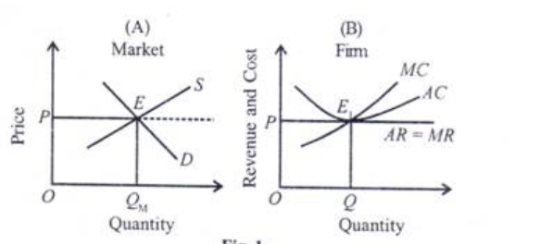
The market is in equilibrium at point E where the market demand and supply curves D and S intersect. It determines OP price at which OQM quantity of the product is bought and sold in the market. There being identical cost conditions, each firm in the market produces and sells the commodity at the given price OP.
It is in equilibrium when MC=MR and AC=AR at point E1producing OQ units of the commodity, as shown in Panel B. If, say, there are 100 firms in the market each producing 60 units of the commodity, the total production will be 6000 (=100 x 60) units. This analysis inter alia can be extended to all commodities being produced in the economy.

3.2 Factor Market:
Like the equality of demand and supply of commodities, the equality of demand and supply of factor services is also essential for the general equilibrium system. The demand for productive services comes from the producers and supply from the consumers. Given the state of technology and the profit maximisation objective of the producers, the quantity of a factor used in producing a commodity depends on the relationship between the prices of that factor and of all other factors and on the prices of commodities.
Each producer maximises his profits relative to the ruling factor prices by employing the various factors in such proportions and quantities that their marginal revenue productivities are equal to their prices. Since there is full employment in the economy, the markets for factors are in equilibrium when the total quantities of factors offered and the total quantities employed are equal.
The equilibrium of the factor market is illustrated in Figure 2, where in Panel (A), the price of a factor OP and its quantity ON are determined in the market by the interaction of its demand and supply curves D and 5 respectively at point E. Panel (B) shows that the supply curve of this factor to an individual firm is perfectly elastic and is the same as the marginal cost of that factor, MFC.
Figure 2- The equilibrium of the factor market 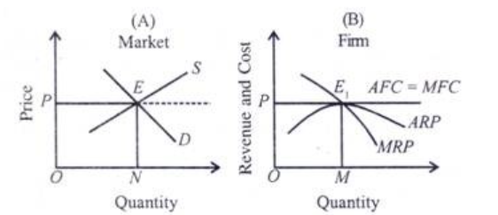

The firm will employ units of the factor at the given factor price OP where MFC=MRP and average factor cost, AFC=ARP (average revenue product) to the firm. Such an equilibrium point is E1 at which it employs OM units of the factor. If there are 10 identical cost firms and each employ 100 units of the factor, the total market demand and supply of this factor will be 1000 units in the market. This analysis can be extended to the economy.

General Equilibrium:
Thus, the economy is in general equilibrium when commodity prices make each demand equal to its supply and factor prices make the demand for each factor equal to its supply so that all product markets and factor markets are simultaneously in equilibrium.
Such a general equilibrium is characterised by two conditions in which the set of prices in all product and factor markets is such that:
(1) All consumers maximise their satisfactions and all producers maximise their profits; and
(2) All markets are cleared which means that the total amount demanded equals the total amount supplied at a positive price in both the product and factor markets.
General equilibrium-Case Example
To explain it, we begin with a simple hypothetical economy where there are only two sectors, the household and the business. The economic activity takes the form of flow of goods and services between these two sectors and monetary flow between them.
These two flows which are called real and monetary are shown in Figure 3 where the product market is shown in the lower portion and the factor market in the upper portion. In the product market, consumers purchase goods and services from producers while in the factor market, consumers receive income from the former for providing services.
Figure 3-Flow between factor and product market
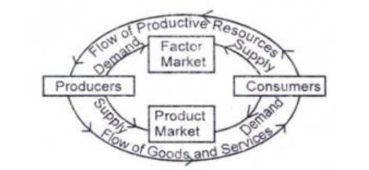

Thus consumers purchase all goods and services provided by producers and make payments to the latter in lieu of these. The producers, in turn, make payments to consumers for the services rendered by the latter to the business, wage payments for labour services, interest for capital supplied, etc. Thus payments go around in a circular manner from producers to consumers and from consumers to producers, as shown by arrows in the outer portion of the figure.

There are also flows of goods and services in the opposite direction to the money payments flows. Goods flow from the business sector to the household sector in the product market, and services flow from the household sector to the business sector in the factor market, as shown in dies inner portion of the figure.
These two flows are linked by product prices and factor prices. The economy is in general equilibrium when a set of prices is allowed at which the magnitude of income flow from producers to consumers is equal to the magnitude of the money expenditure from consumers to pro­ducers.

4. LIMITATIONS
The general equilibrium analysis of the economy has several limitations:
1. It is based on several unrealistic assumptions which are contrary to the actual conditions prevailing in the world. Perfect competition, the very basis of this analysis, is a myth.
2. It is a static analysis. All consumers and producers in this analysis consume and produce the same products day in and day out without any time-lag. Their tastes, preferences, and aims are the same, and their economic decisions are in perfect harmony with each other.
In reality, nothing of this sort happens. Producers and consumers never act and think alike. Changes are taking place continuously in tastes and preferences.
3. There are no constant returns to scale and no two factor services are homogeneous. Thus, cost conditions differ from producer to producer. Since the given conditions are continuously changing, the movement towards general equilibrium is ever thwarted and its attainment has ever remained a wishful ideal.
4. Prof. Stigler regards general equilibrium as a misnomer. According to him, “No economic analysis has ever been general in the sense that it considered equilibrium studies as more inclusive than partial equilibrium studies, never that they are complete. Moreover, the more general the analysis, the less specific its content must necessarily be.”

5 MAIN USES OF GENERAL EQUILIBRIUM ANALYSIS | ECONOMICS

1. A Picture of Economy Equilibrium:
It presents a picture of a private enterprise economy in equilibrium, where consumers are attuned to a position of maximum satisfaction and the producers to that of maximum profits. There is no wastage of resources. All is fully employed. Economic efficiency is at its maximum so that economic welfare of the community is maximized. Thus, it helps in understanding the determinants of the pattern of an economy.

2. To Understand the Working of Economic System:
Even otherwise, the theory is a schematic point of departure from which, by removing certain unwarranted assumptions, the actual working of an economic system can be understood. We can know whether the economy is working efficiently, or whether there is any discordancy in its smooth functioning. The problems of disequilibrium and the restoration of equilibrium can be studied with the help of this analysis.

3. To Understand the Complex Problems of the Market:
The general equilibrium analysis further helps in predicting the consequences of an autonomous economic event. Suppose the demand for commodity A rises which may lead to a rise in its price. This, in turn, reduces the prices of its substitutes and raises the prices of complements.
These may thus reduce the demand for A somewhat. The demand for A may be further affected if the prices of productive services also tend to rise. Thus, the general equilibrium analysis aids in understanding the nature of the complex chains of relationships of the market on a step-by-step basis.

4. To Understand the Working of the Pricing Process:
The general equilibrium analysis is also useful in explaining the functions of prices in an economy. As relative prices change three main decisions are made for the entire economy: what to produce and how much to produce, how to produce, and who will buy them when commodities are produced.
These decisions are made by individual producers and consumers because each commodity and service they want to produce, sell and buy, have a price that reacts to changes in their demand and supply. The general equilibrium analysis helps in integrating a variety of individual decisions affected by price changes.

5. To Understand the Input-Output Analysis:
The main importance of general equilibrium analysis lies in its providing the conceptual basis for the input-output analysis developed by Leontief. In this analysis which is regarded an outstanding variant of the general equilibrium analysis, the household and industries are related in an invisible interdependent system of inputs and outputs of the economy.

6.0 COMPARISON OF THE MARSHALLIAN EQULLIBRIUM AND GENERAL EQULLIBRIUM

Marshall’s Partial Equilibrium Analysis
In partial equilibrium approach to the pricing, we seek to explain the price determination of commodity, keeping the prices of other commodities constant and assuming that the various commodities are not interdependent.
Marshall’s partial equilibrium analysis seeks to explain the price determination of a single commodity through the intersection of demand and supply curves, with prices of other goods, resource prices etc., remaining the same.

6.1 Walras General Equilibrium Analysis:
In general equilibrium analysis, put forward by French Economist Walras the price of a good is not explained to be determined independently of the prices of other goods. Since the changes in price of good X affect the prices and quantities demanded of other goods and in turn the changes in prices and quantities of other goods will affect the quantity demanded of the good X, the general equilibrium approach explains the simultaneous determination of prices of all goods and factors.
As stated above, partial equilibrium approach assumes that the effect of the change in price of a good A” will be so diffused in the rest of the economy (i.e., over all other goods) to have negligible effect on the prices and quantities of other individual goods.
Therefore, where the effect of a change in the price of a good on the prices and quantities of some other goods is significant, as is there in the case of inter-related goods, that is, substitutes and complementary goods, the partial equilibrium approach cannot be validly applied in such cases and therefore there is need for applying general equilibrium analysis which should explain the mutual and simultaneous determination of their prices and quantities.
General equilibrium analysis deals with inter-relationship and inter-dependence between equilibrium adjustments with each other. General equilibrium exists when at the going prices, the quantities demanded of each product and each factor are equal to their respective quantities supplied.
A change in the demand or supply of any good, or factor would cause changes in prices and quantities of all other goods and factors and there will begin the process of adjustment and readjustment in demand, supply and prices of other goods and factors till the new general equilibrium is established. Indeed, the general equilibrium analysis is solving a system of simultaneous equations.
In a general equilibrium system, the quantity demanded of each good is described by an equation in which its quantity demanded is a function of prices of all goods. Likewise, in general equilibrium analysis, quantity supplied of each good is the function of price of all factors of production.
In a general equilibrium system, the prices of all goods affect the quantity demanded of each good. Further, the prices of all factors affect the quantity supplied of each good. Besides these crucial equations, there will be equations determining the price of each of the factors of production. As noted above, a change in any of the demand or supply equations would cause changes in all prices and quantities and as a result the system will tend to move to the new general equilibrium.
To explain the inter-relationship and interdependence among the prices and quantities of goods and factors and ultimately to explain the determination of the relative prices of all goods and factors, the proportion in which different goods are being produced and different factors are being used to produce different goods is the essence of general equilibrium analysis.
In this topic, we shall explain the general equilibrium analysis using Edge-worth Box diagram.

6.1.1 EDGE WORTH BOX MODEL
Edgeworth box , named after F.Y. Edgeworth, is a powerful tool of economic analysis used for representing various distributions of resources. In its elementary form it was presented by Edgeworth in 1881, improved upon by Pareto and Bowley. The modern version is referred to as Edgeworth-Bowley box. This tool is used in general equilibrium analysis and is an indicator of Pareto optimal distribution of resources, showing the level of social welfare. Here the explanation is in terms of a simple case of exchange of given quantities of the two commodities, X and Y between two individuals, A and B. The analysis can be extended to two groups and two countries too.
Figure 4- indifference maps of two individuals
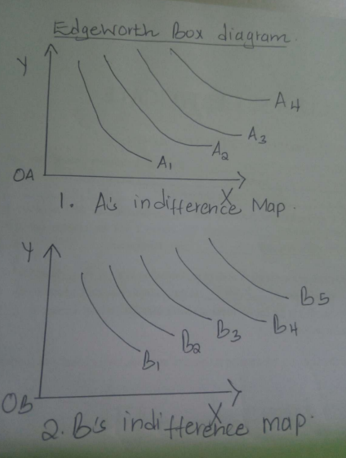

The above diagram shows the indifference maps of two individuals representing their scale of preferences, with slope of indifference curves showing MRSy,x and higher curve meaning higher utility and so on.
Edgeworth box can be utilized to show that exchange between two individuals may lead to an increase in the welfare of an individual without causing a reduction in the welfare of the other, leading to an increase in the overall social welfare from a given bundle of resources. This is a Pareto improvement. A Pareto optimum exists when it is not possible to improve an individual’s welfare without reducing the welfare of the other individual (details in the chapter on welfare economics).
To understand the optimum distribution of the given quantities of x and y between A and B, we superimpose indifference map of B over that of A to get a box like structure shown below.

Figure 4- Edgeworth box

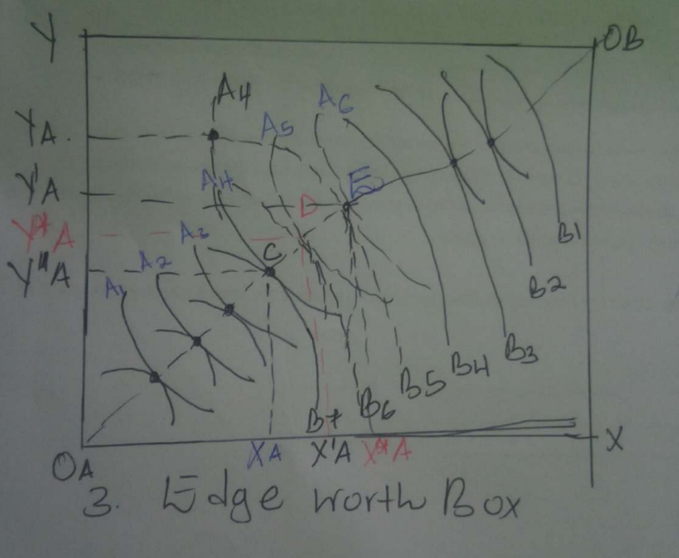
OA-origin point of A and OB –origin point of B. The horizontal axis shows given quantity- OAx of commodity x and vertical axis shows given quantity OBy of commodity y. As indifference curves are labelled as A1, A2 and so on and Bs as B1, B2 and so on.
Any point of the Edgeworth box shows a certain distribution of the two commodities between the two individuals. The indifference curves of A and B are of opposite curvature and thus are tangential to each other. The locus of these points of tangency is Edgeworth contract curve, shown as OA OB in the figure above. Any point on the contract curve shows the equality of marginal rate of substitution between the two commodities for the two individuals (if it is not true for certain distribution then the indifferences curves tangency does not occur, as can be seen in certain cases).
Thus, at the points of tangency of the two indifference curves of A and B respectively, the following condition will hold:
Only the distribution on the contract curve represents an optimal distribution of resources, as any distribution off this curve represents lesser welfare for at least one individual.
In figure 2, point F does not lie at the contract curve. At this point consumer A is having OA XA of x and OA YA of y leaving XA X of x and YAY of y for individual B. The level of welfare of A is given by IC A4 and for B by IC B5.
This is a suboptimal distribution because any exchange which causes them to move at a point on the contract curve will result in the increase in welfare of either one of them or of both.
If the individuals move to point E on the contract curve-with A having additional XA X’A of x and giving up YA Y’A of y, his level of utility increases as he moves from IC A4 to A6 whereas B remains on the same level of welfare as points E and F lie on the same IC B5. Thus the exchange which involves movement from a point off the contract curve to a point on the contract curve has improved the welfare of one individual without worsening the condition of the other.
This is a case of Pareto improvement, resulting in an increase in social welfare- if we assume society to be made up of two individuals only. Similarly a movement from F to C on the contract curve improves the welfare of B, as can be seen by his movement from IC B5 to B7 as a result of this exchange in which he is having YA and Y”A additional units of y in Exchange of giving up X”A
If they move to point D then both are gainers as A moves from A4 to A5 and B moves from B5 to B6. So, any distribution of resources in which the two individuals move on the segment denoted by segment CE on the contract curve leads to improvement in social welfare. Ultimately which individual will be a greater beneficiary in this exchange process depends on the noneconomic factors, such as bargaining power of the two. But it is clear from this analysis that the distribution denoted by a point on contract curve represents an optimal distribution of resources as either one of them or both are beneficiaries by moving from a point off the contract curve to a point on it. Edgeworth box is also a tool which can be used in the analysis of general equilibrium. In general equilibrium of production, the vertical and horizontal axes represent the two factor inputs and instead of ICs we have isoquants for products x and y.
7.0 SUMMARY
General Equilibrium Theory shows how supply and demand in a multi-market economy interact and create an equilibrium of prices.
French economist Léon Walras is credited with developing and expanding the theory in the late 19th century.
Walras applied the theory to calculate price ratios and helped economics evolve into a study that includes mathematical analysis.
The Edgeworth box considers a two-person, two-good “exchange economy.” The Edgeworth box is a graphical representation of the exchange problem facing these people and also permits a straightforward solution to their exchange problem. A point in the Edgeworth box is the consumption of one individual, with the balance of the endowment going to the other.
Pareto efficiency is an allocation in which making one person better off requires making someone else worse off—there are no gains from trade or reallocation.
In the Edgeworth box, the Pareto-efficient points arise as tangents between isoquants of the individuals. The set of such points is called the contract curve. The contract curve is always increasing.

8.0 REFERENCES
Brauweiler, H-Ch, et al. "Problems of increasing the innovation activity of industrial enterprises
in the context of global competition." IOP Conference Series: Materials Science and
Engineering. Vol. 828. No. 1. IOP Publishing, 2020.
Yu, Song-min, et al. "Modeling the emission trading scheme from an agent-based perspective:
System dynamics emerging from firms’ coordination among abatement
options." European Journal of Operational Research 286.3 (2020): 1113-112
- Fashola, M.A. (2004). Microeconomic Theory: Highlights and Policy Extensions for Less-Developed Economies. Lagos: Concept Publications.
- Karl, E.C. & Ray, C. F. (2007). Principles of Microeconomics. New Jersey, USA: Pearson Education International.
- Umo, J.U. (1986). Economics: African Perspective. Lagos: John West Publications Limited.
- Brauweiler, H-Ch, et al. (2020) "Problems of increasing the innovation activity of industrial enterprises in the context of global competition." IOP Conference Series: Materials Science and Engineering. Vol. 828. No. 1. IOP Publishing.

