INTERMEDIATE MICROECONOMICS
Week 10- EXTERNALITIES
CONTENTS
- OBJECTIVES
- INTRODUCTION
- TYPES OF EXTERNALITIES
  - POSITIVE EXTERNALITY
  - NEGATIVE EXTERNALITY

- PRIVATE SOLUTION TO EXTERNALITIES-
- Coase Theorem
- Failures of Private Remedies for Externalities
- PUBLIC SECTOR SOLUTIONS TO EXTERNALITIES –
- Market-based solutions
- REGULATION
- IMPLICATIONS OF EXTERNALITY
- SUMMARY
- REFERENCES

1.O OBJECTIVES
At the end of the Lecture the student should be able to:
- Explain the concept of externalities in economics and give examples.
- Explain the various types of externalities.
- Discuss the private and public remedies for externalities.
- Explain the implications and solutions of externality.

2.0 INTRODUCTION
This refers to the favorable and unfavorable effects which are associated with the production or consumption of goods. Such economic effects are also referred to as spill-over effect, neighborhood effects or third-party effects.
These externalities may either be economic gain or economic loss to other parties e.g., the setting up of a factory in a backward region will help to develop it. This is an example of economic gain associated with externalities. On the other hand, environmental pollution resulting from the establishment of a paper mill in an area may be an example of economic loss associated with externalities.
This economic gain or loss cannot be priced in the market and apportioned to parties i.e., it is not possible to find out how much is the benefit of a factory set up in a backward region or exact economic loss due to air or water pollution of a paper mill.
Market price is fixed in terms of the internal cost of goods and services whereas social cost of some goods and services must be borne by the society in the form of physical inconvenience and disease.
Definition
What is an externality?
Externality is a cost or benefit from production or consumption activities that affect people who are not part of the original activity. Externalities may be negative or positive.
External cost (negative externality) - cost of producing a good/service not borne by consumers but by others. Consumers can create externalities when they purchase and consume goods and services.
Externality ≡ cost or benefit accruing to party not involved in economic transaction.
Positive externality ≡ benefit accruing to party not involved in economic transaction.
Negative externality ≡ cost accruing to party not involved in economic transaction.
What is market failure?
A problem that violates one of the assumptions of the 1st welfare theorem and causes the market economy to deliver an outcome that does not maximize efficiency.
In a Market Without Externalities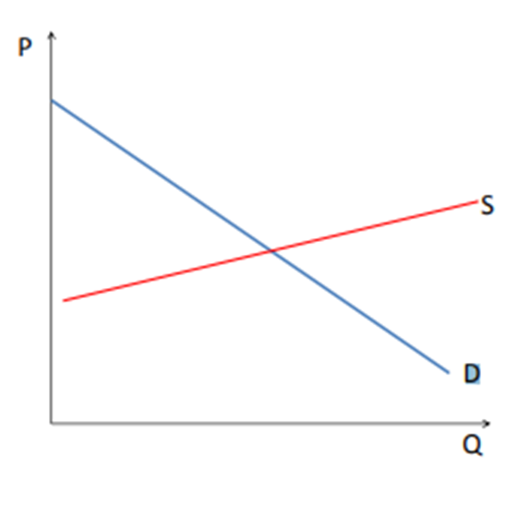
If private demand = private marginal benefit = social marginal benefit and
Private supply =private marginal cost =social marginal cost.
Then market equilibrium maximizes social welfare, which is total surplus, provides goods to consumers at lowest possible cost.

In a Market with Externalities
Assume a negative externality-
=⇒ Social marginal cost 6= private marginal cost.
=⇒ Social marginal cost = Private marginal cost + external marginal cost.

Assume a positive externality-
=⇒ Social marginal benefit 6= private marginal benefit.
=⇒ Social marginal benefit = Private marginal benefit +external marginal benefit.

What Does a Negative Externality Do to Market Supply?
Figure 1-Negative Externality
What are the Socially Optimal P and Q?
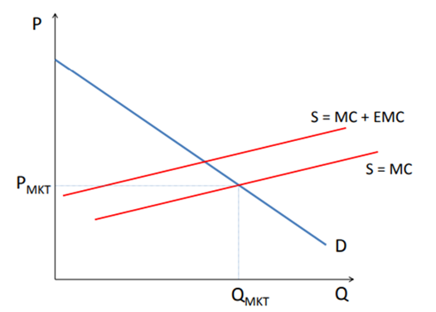

Figure 2- Positive Externalities
What are the Socially Optimal P and Q?

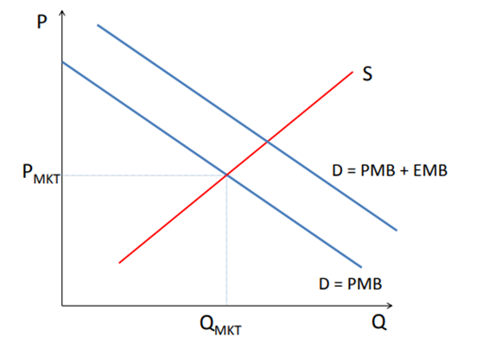

Examples of Externalities
• Pollution from cars and motorbikes.
• Litter on streets and in public places.
• Noise pollution from using car stereos or ghetto-blasters.
• Negative externalities created by smoking and alcohol abuse.
• Externalities created through the mistreatment of animals.
• Vandalism of public property.
• Negative externalities arising from crime.
Externalities create market failure (allocative inefficiency). Markets overproduce goods/services with external cost and overproduce goods/services with external benefits.

Figure 3- Excessive Production of Goods Yielding Negative Externalities

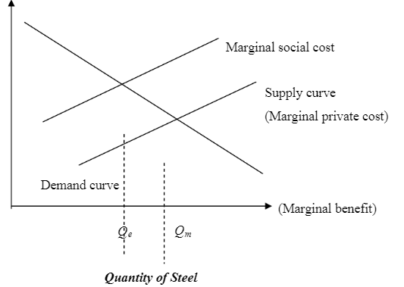
The level of production of negative externality generating commodity will be excessive. Figure 3 shows conventional demand and supply curves. The absence of externalities will result the market equilibrium efficient. The demand curve reflected the individual’s marginal benefits from the production of an extra unit of the commodity, and the supply curve reflected the marginal costs of producing an extra unit of commodity. At the intersection of the two curves the marginal benefits just equal the marginal costs.
Now, with externalities, the industry’s supply curve will not reflect marginal social costs, only marginal private costs, those borne privately by the producers.
If the expansion of steel production increases the level of pollution, there is a real cost to that expansion in addition to the costs of the iron, ore, labor, coke, and limestone that go into the production of steel. But the steel industry fails to take the cost of pollution into account.
Figure 1 also shows the marginal social cost curve, giving the total extra costs (private and social) of producing an extra unit of steel. This cost curve lies above the industry supply curve. Efficiency requires that marginal social cost equals the marginal benefit of increasing output: production should occur at Qe, the intersection of the marginal social cost and the demand curve. The efficient level of production is lower than the market equilibrium level.
A business may purposely underfund one part of their business, such as their pension funds, to push the costs onto someone else, creating an externality. Here, the "cost" is that of providing minimum social welfare or retirement income; economists more frequently attribute this problem to the category of moral hazards.
Consumption by one consumer causes prices to rise and therefore makes other consumers worse off, by reducing their consumption. These effects are sometimes called "pecuniary externalities" and are distinguished from "real externalities" or "technological externalities". Pecuniary externalities are externalities but occur within the market mechanism and are not a source of market failure or inefficiency.
3.0 TYPES OF EXTERNALITIES
There are 2 types of externalities-
- Positive
- Negative

  - POSITIVE EXTERNALITY- EXTERNAL BENEFIT
Benefit from consuming a good/ service going not to consumers but to others. In some cases, the actions of an individual or firm confer (uncompensated) benefits on others, like for example a homeowner who maintains his property; including planting attractive flowers in front, and provide a positive externality.
The issue of external benefits is related to that of public goods, which are goods where it is difficult if not impossible to exclude people from benefits. The production of public goods has beneficial externalities for all or almost all the public.
As with external costs, there is a problem here of societal communication and coordination to balance benefits and costs. This also implies that pollution is not something solved by competitive markets.
Example of positive externalities includes:
Knowledge spillover of inventions and information (most other forms of practical information) is discovered or made more easily accessible, others benefit by exploiting the invention or information.
Copyright and intellectual property law are mechanisms to allow the inventor or creator to benefit from a temporary, state-protected monopoly in return for “sharing” the information through publication or other means.
Examples of positive externalities (beneficial externality, external benefit, external economy, or Merit goods) include:
A beekeeper keeps the bees for their honey. A side effect or externality associated with his activity is the pollination of surrounding crops by the bees. The value generated by the pollination may be more important than the value of the harvested honey. An individual planting an attractive garden in front of his or her house may provide benefits to others living in the area, and even financial benefits in the form of increased property values for all property owners. A public organization that coordinates the control of an infectious disease preventing others in society from getting sick. An individual buying a product that is interconnected in a network (e.g., a video cellphone) will increase the usefulness of such phones to other people who have a video cellphone. When each new user of a product increases the value of the same product owned by others, the phenomenon.

Externality theory: positive externalities
Positive production externality:
When a firm’s production increases the well-being of others, the firm is not compensated by those others. Example: Beehives of honey producers have a positive impact on pollination and agricultural output Positive consumption externality: When an individual’s consumption increases the well-being of others, but the individuals are not compensated by those others. Example: Beautiful private garden that passers-by enjoy seeing
Figure 4- Postive Production Externality

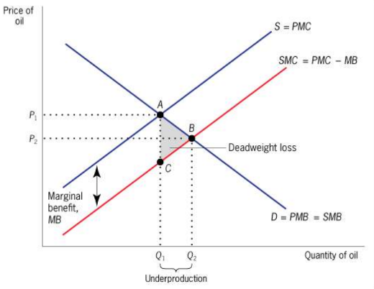
Market failure due to positive production externality in the oil exploration market.
Expenditures on oil exploration by any company has a positive externality because they offer more profitable opportunities for other companies.
This led to a social marginal cost that is below the private marginal cost and a social optimum quantity that (Q2) that is greater than the competitive market equilibrium quantity (Q1). There is overproduction of Q1-Q2 with an associated dead weight loss area of ABC.

  - NEGATIVE EXTERNALITIES
A negative externality is an action of a product on consumers that imposes a negative side effect on a third party; it is "social cost". Many negative externalities (also called "external costs" or "external diseconomies") are related to the environmental consequences of production and use.
Air pollution from burning fossil fuels causes damage to crops, (historic) buildings and public health. The most extensive and integrated effort to quantify and monetize these impacts was in the European External project series. Anthropogenic climate change is attributed to greenhouse gas emissions from burning oil, gas, and coal.
The Stern Review on the Economics of Climate Change says, "Climate change presents a unique challenge for economics: it is the greatest example of market failure we have ever seen." Water pollution by industries that add poisons to the water, which harm plants, animals, and human ssystemic risk describes the risks to the overall economy arising from the risks which the banking system takes. A condition of moral hazard can occur in the absence of well-designed banking regulation, or in the presence of badly designed regulation.
Negative production externality: When a firm’s production reduces the well-being of others who are not compensated by the firm.
Private marginal cost (PMC): The direct cost to producer of producing an additional unit of a good.
Marginal Damage (MD): Any additional costs associated with the production of the good that are imposed on others but that producers do not pay.
Social marginal cost (SMC = PMC + MD): The private marginal cost to producers plus marginal damage
Example: steel plant pollutes a river, but plant does not face any pollution regulation (and hence ignores pollution when deciding how much to produce)
A negative production externality: When a firm’s production reduces the well-being of others who are not compensated by the firm.
Private marginal cost (PMC): The direct cost to producers of producing an additional unit of a good.
Marginal Damage (MD): Any additional costs associated with the production of the good that is imposed on others but the at producers do not pay.
Social marginal cost (SMC = PMC + MD): The private marginal cost to producers plus marginal damage.
Example: steel plant pollutes a river, but plant does not face any pollution regulation (and hence ignores pollution when deciding how much to produce).
Externality Theory -
- Economics of Negative Production Externalities
Figure 5- Market failure due to negative production

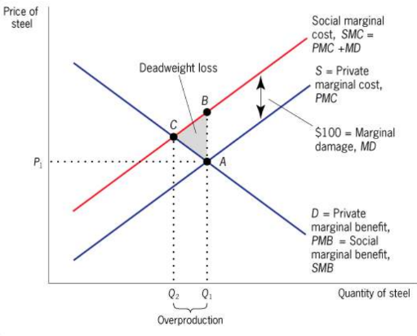

Market failure due to negative production
Externalities in the steel market
A negative production externality of USD 100 per unit of steel produced (marginal damage, MD) leads to a social marginal cost that is above the private marginal cost and a social optimal quantity Q2 that is lower than competitive market equilibrium quantity(Q1). There is over productivity of (Q1-Q2) with an associated dead weight loss of the area BCA.
Externality theory:
Negative consumption externality:
When an individual’s consumption reduces the well-being of others who are not compensated by the individual.
Private marginal cost (PMB): The direct benefit to consumers of consuming an additional unit of a good by the consumer.
Social marginal cost (SMB): The private marginal benefit to consumers plus any costs associated with the consumption of the good that are imposed on others.
Example: Using a car and emitting carbon contributing to global warming.

- Externality Theory Negative Consumption Externalities
Figure 6- Negative Consumption Externalities

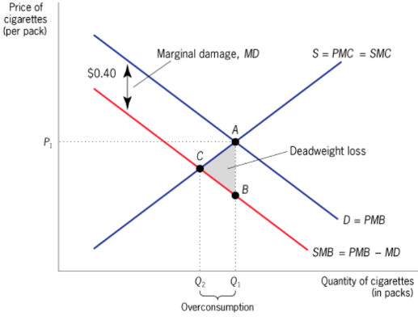

Market failure due to negative consumption externalities in the cigarette market. A negative consumption externality of 40 C per pack of cigarettes consumed leads to a social marginal benefit that is below the private marginal benefit and a social optimum quantity(Q2) that is lower than the competitive equilibrium (Q1). There is overconsumption (Q1-Q2) with an associated deadweight loss area ACB.

4.0 SOLUTIONS TO EXTERNALITIES
4.1 PRIVATE SOLUTION TO EXTERNALITIES
Sometimes economic efficiency can be attained without resort to government intervention.
-By establishing sufficiently large economic organizations, the externalities can be internalized.
-By establishing clear property rights, private parties can bargain toward an efficient solution, as suggested by Coase.
COASE THEOREM-
If the property rights are established and transaction costs are low, there will be efficiency. The costs imposed on people who are not part of the original activity can be recovered through the legal process and thus be paid by those involved in the activity. The costs will become internal (private).
The Coase theorem suggests that we may be able to do even better. If property rights are fully assigned, then the regulatory body should not, in theory, be involved. Instead, parties will negotiate among themselves on the lowest cost solution to correcting the externalities.
By using the legal system, imposers of externalities can be forced to compensate victims.
The legal system can provide protection against externalities. Our system of common law does not allow one party to injure another, and “injury” has been interpreted to include a variety of economic costs imposed on others.
Failures of Private Remedies for Externalities
Public Good (free rider) problems Many externalities involve the provision of a public good, such as clean air or clean water: in particular, it may be very costly to exclude anyone from enjoying the benefits of these goods.
Compounded by imperfect information problems The problem of arriving voluntarily at an efficient solution is exacerbated by the presence of imperfect information. -
Take for example the smokers will try to persuade nonsmokers that they require a lot of compensation to induce them not to smoke. In such a bargaining situation, one party may risk the possibility of not arriving at a mutually advantageous agreement to get more out of any bargain that might be made.
Transactions costs Transaction costs are a major disadvantage of dealing with externalities through judicial processes. For many externalities, the losses involved may simply be too small to justify undertaking litigation. Since those generating externalities know that litigation is expensive, they may be inclined to generate their externality just up to the point where it pays the injured party to sue—giving rise to considerable inefficiencies. Uncertainty about the extent of the injury frequently compounds the problem of transaction costs, and there is also some ambiguity about the outcome of most suits.
Additional problems with litigation If litigation costs are large, the uncertainty acts as a further deterrent to individuals contemplating using the court system to deal with externalities. The high litigation costs and uncertain outcome of the litigation process imply that there is, in effect, differential access to legal remedies—poor people may not be able or willing to bear the risks of litigation—a situation which conflict with our usual notion of justice in democracy.

4.2 PUBLIC SECTOR SOLUTIONS TO EXTERNALITIES
MARKET-BASED SOLUTIONS
1. Fines and Taxes- In general, whenever there is an externality, there is a difference between the social cost and the private cost, and between the social benefit and private benefit. A properly calculated fine or tax presents the individual or firm with the true social costs and benefits of its actions. Fine of this sort—designed to make marginal private costs equal marginal social costs, and marginal private benefits equal to marginal social benefits- are called corrective taxes, or sometimes Pigouvian taxes.
2. Subsidizing pollution abatement- Rather than taxing pollution, the government could subsidize pollution abatement expenditures. By providing a subsidy equal to the difference between the marginal social benefit of pollution abatement and firm’s marginal private benefit, the efficient level of pollution abatement expenditures can be attained.
3. Marketable Permits- An increasingly popular market-based solution involves marketable permits. These limit the amount of pollution that any firm can emit. Under this system, firms will be willing to sell permits so long as the market price of the permit is greater than the marginal cost of reducing pollution, and firms will be willing to buy permits so if the marginal cost of reducing pollution is greater than the market price of the permit. Thus, in equilibrium, each firm will reduce pollution to a level such that the marginal cost of pollution reduction is equal to the market price of the permit. Marketable permits have one advantage over fines. With fines, the government may not be sure about the level of emissions that the firms will choose to produce.
1. Defining property rights
A strict definition of property rights can limit the influence of economic activities on unrelated parties. However, it is not always a viable option since the ownership of things such as air or water cannot be unambiguously assigned to a particular agent.

2. Taxes
A government may impose taxes on goods or services that create externalities. The taxes would discourage activities that impose costs on unrelated parties.
3. Subsidies
A government can also provide subsidies to stimulate certain activities. The subsidies are commonly used to increase the consumption of goods with positive externalities.

5.0 REGULATION
Most economists believe that market-based solutions provide the most promise for curbing environmental externalities, but government traditionally has relied upon direct regulation. It has set emission standards for automobiles; put forth detailed regulations relating to the disposal of toxic chemicals; outlawed smoking on domestic airline flights; imposed laws requiring oil companies with wells in the same oil pool to unitize their production; imposed restrictions on fishing and hunting to reduce the inefficiencies associated with excessive utilization of these common resources.
6.0 IMPLICATIONS OF EXTERNALITY
Standard economic theory states that any voluntary exchange is mutually beneficial to both parties involved in the trade. This is because either the buyer or the seller would refuse the trade if it won't benefit both. However, an exchange can cause additional effects on third parties. From the perspective of those affected, these effects may be negative (pollution from a factory), or positive (honeybees that pollinate the garden).
Welfare economics has shown that the existence of externalities results in outcomes that are not socially optimal. Those who suffer from external costs do so involuntarily, while those who enjoy external benefits do so at no cost. A voluntary exchange may reduce societal welfare if external costs exist. The person who is affected by the negative externalities in the case of air pollution will see it as a lowered utility: either subjective displeasure or potentially explicit costs, such as higher medical expenses. The externality may even be seen as a trespass on their lungs, violating their property rights. Thus, an external cost may pose an ethical or political problem. Alternatively, it might be seen as a case of poorly defined property rights, as with, for example, pollution of bodies of water that may belong to no-one (either figuratively, in the case of publicly owned, or literally, in some countries and/or legal traditions).
On the other hand, a positive externality would increase the utility of third parties at no cost to them. Since collective societal welfare is improved, but the providers have no way of monetizing the benefit, less of the good will be produced than would be optimal for society.
Goods with positive externalities include education (believed to increase societal productivity and well-being; but controversial, as these benefits may be internalized), public health initiatives (which may reduce the health risks and costs for third parties for such things as transmittable diseases) and law enforcement.
Positive externalities are often associated with the free rider problem. For example, individuals who are vaccinated reduce the risk of contracting the relevant disease for all others around them, and at high levels of vaccination, society may receive large health and welfare benefits; but any one individual can refuse vaccination, still avoiding the disease by "free riding" on the costs borne by others.
There are several potential means of improving overall social utility when externalities are involved-
The market-driven approach to correcting externalities is to "internalize" third party costs and benefits, for example, by requiring a polluter to repair any damage caused. But, in many cases internalizing costs or benefits is not feasible, especially if the true monetary values cannot be determined. The monetary values of externalities are difficult to quantify, as they may reflect the ethical views and preferences of the entire population. It may not be clear whose preferences are most important, interests may conflict, the value of externalities may be difficult to determine, and all parties involved may try to influence the policy responses to their own benefit. An example is the externalities of the smoking of tobacco, which can cost or benefit society depending on the situation. Because it may not be feasible to monetize the costs and benefits, another method is needed to either impose solutions or aggregate the choices of society when externalities are significant. This may be through some form of representative democracy or other means. Political economy is, in broad terms, the study of the means and results of aggregating those choices and benefits that are not limited to purely private transactions.

7.0 TOPIC QUESTIONS AND ANSWERS
We answer the following topic questions-
1. What is an externality? Define it.
Answer- Externalities are spillover costs or benefits. They arise whenever a production or consumption decision affects a third party.
2. What are the four kinds of externalities? Give examples.
Answer-Positive externality in consumption, positive externality in production, negative externality in consumption, negative externality in production.
3. "Social cost" and "private cost": what is the difference between these two kinds of costs?
Answer-Social cost- Private cost= external cost (example: pollution).
4. Social benefit" and "private benefit": what is the difference between these two kinds of benefits?
Answer- External benefits
5) Explain why the consumption of alcohol entails a social cost that is higher than private cost. Answer-The person drinking alcohol only considers the private cost and the private benefit of her/his decision. This person neglects the costs imposed to the society due to her/his choice (cost for a medical treatment, loss of productivity).
6) Explain why the consumption of education entails a social benefit that is higher than private benefit.
Answer-When deciding to go to university you only consider your private cost and benefit. You consider the fees to pay to the University, the lack of income for the years that you spend studying, and the additional income you will receive one day when able to start your first job as a graduate. However, if you decide to go to university, it is not just you who benefits from this decision but also the society you are living in. More people with a degree will favor more investments in your community and more wealth will be generated.

8.0 SUMMARY
Externalities are the classic answer to the “when” question of public finance: when one party’s actions affect another party, and the first party doesn’t fully compensate (or get compensated by) the other for this effect, then the market has failed, and government intervention is potentially justified. This naturally leads to the “how” question of public finance.
There are two classes of tools in the government’s resource for dealing with externalities: price-based measures (taxes and subsidies) and quantity-based measures (regulation). Which of these methods will lead to the most efficient regulatory outcome depends on factors such as the heterogeneity of the firms being regulated, the flexibility embedded in quantity regulation, and the uncertainty over the costs of externality reduction.

9.0 REFERENCES
- Aronson, Richard J (1985) Public Finance, USA, New York: Mc Graw Hill Book Co.
- Rosen, Harvey S (1999) Public Finance, 5th edition, USA, New York: Mc Graw Hill Book Co.
- Stiglitz, Joseph E (2000), Economics of the Public Sector, 3rd edition, W.W. Norton & Co., New York.
- Border, K. C. (1985) Fixed Point Theorems with Applications to Economics and Game Theory, Cambridge: Cambridge University Press.
- Luenberger, D (1995) Microeconomic Theory, McGraw-Hill, Appendixes A-D.
- Takayama (1985) A. Mathematical Economics, the second edition, Cambridge: Cambridge University Press, Chapters 1-3.
- Tian, G (2004) The Basic Analytical Framework and Methodologies in Modern Economics.

