Lecture Notes
Postgraduate Writing
Week 10
Contemporary issues and trends in Communication Research I
  - Topic Introduction
In our previous lesson, we have discussed what a research concept note/paper is and the key sections of a concept note which include the working title, the background of the study, the research problem, the objectives of the study, the significance of the study, the literature review, the proposed methodology, the expected outcomes, the timeline, the estimated budget and the references. We have also discussed the purpose of a concept note which includes getting preliminary approval, applying for grants, for research collaboration purposes and for the sake of ethics clearance. Finally, we have looked at some of the challenges that one may encounter when developing concept notes.

In this lesson, we shall focus on some of the contemporary issues and trends in Communication research. This is a two-part lesson where we shall begin by looking at Big Data, AI, cyber bullying and digital privacy in the first part. In the second part of the lesson on contemporary issues in Communication research, we shall focus on the issues concerning Communicating Science and technology.

10.2 Intended Learning Objectives

By the end of this lesson, students will be able to:
- Identify the role of Big Data in research.
- Identify the role of AI in research.
- Explain core concerns with regards to digital privacy

10.3 The Future of Research with AI

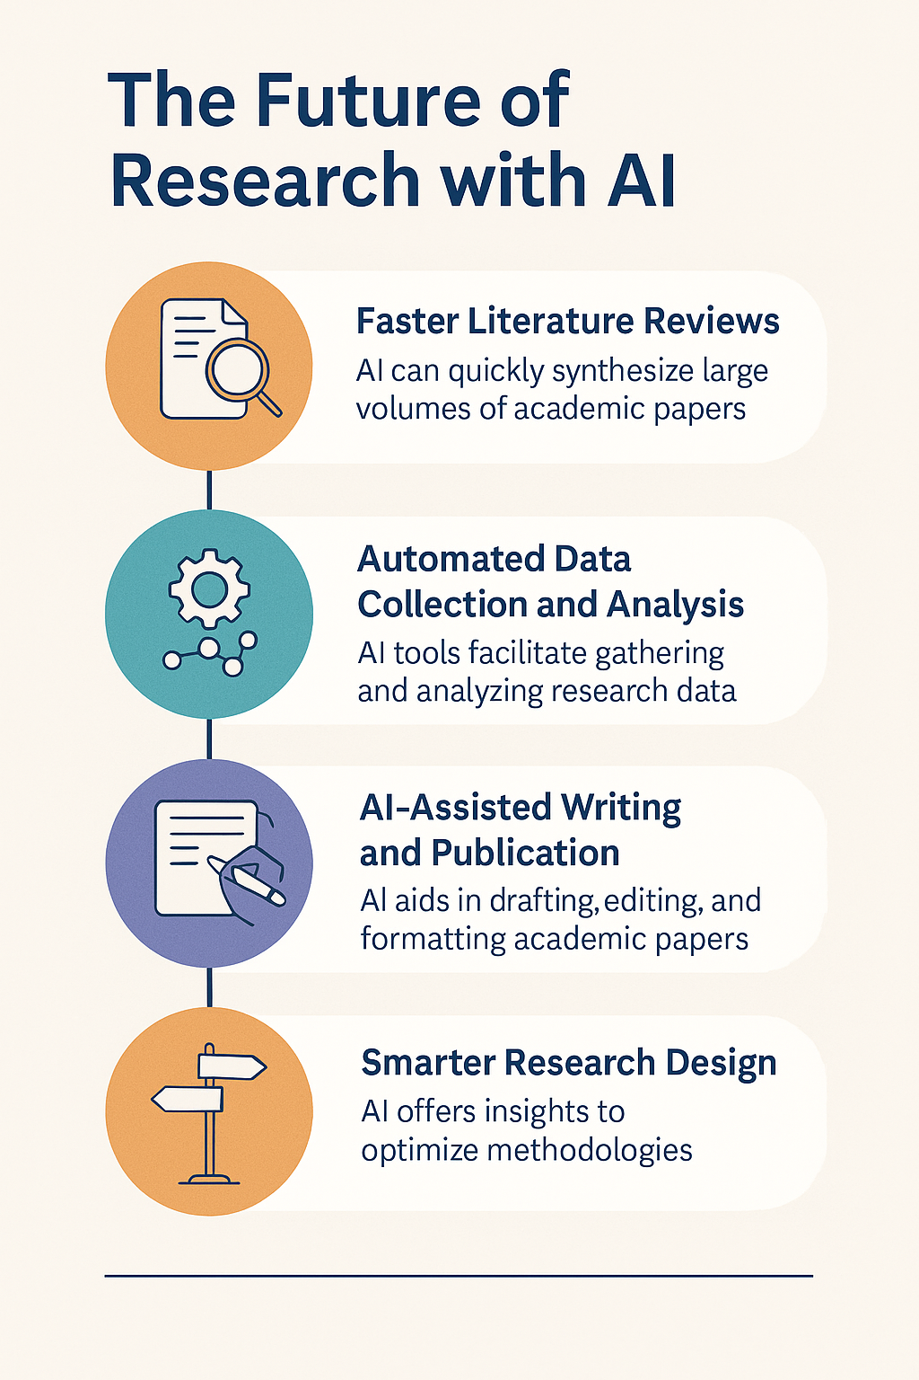
Source of Infographic: ChatGPT

AI tools have the potential to turn around the world of research. The future of research with Artificial Intelligence (AI) is both exciting and transformative. AI is reshaping how research is conducted, analyzed, and shared, opening new possibilities while also raising important ethical and academic questions.
As we discussed in one of our previous classes, AI tools are enhancing the research process and making it more manageable. The following specific stages of the research process have greatly been enhanced by AI tools:
The Role of AI in Research:
- AI supports data analysis, automation, language processing, and prediction.
- Tools like machine learning and natural language processing (NLP) help analyze text, images, or speech.

Applications:
- Literature review automation (e.g., Elicit, Scite)
- Medical imaging and diagnosis
- Sentiment and discourse analysis in social science
- AI-assisted writing and translation

Faster and Smarter Literature Reviews
- AI can search, summarize, and synthesize thousands of papers in minutes (e.g., using tools like Elicit, Semantic Scholar, Scite).
- Future AI systems may map entire research fields, identifying gaps and emerging trends in real time.

Automated Data Collection and Analysis
- AI will increasingly handle large datasets, from climate sensors to social media to genomic data.
- Tools like machine learning, natural language processing, and image recognition will streamline research in:
  - Medicine
  - Psychology
  - Social sciences
  - Education

AI-Assisted Writing and Publication
- AI will assist in drafting, editing, translating, and even formatting academic papers.
- Tools like ChatGPT, Grammarly, and Quillbot are early examples.
- In the future, AI might also recommend journals, generate citations, and flag potential plagiarism or ethical issues.

Smarter Research Design
- AI can simulate research scenarios and suggest optimal methodologies, sample sizes, or instruments.
- It may even assist in predicting experiment outcomes before real-world testing.

5. Real-Time Collaboration and Knowledge Sharing
- AI-enabled platforms will connect researchers across the world by matching topics, skills, and datasets.
- Voice assistants, automated note-takers, and intelligent research dashboards may become standard.

Ethical and Methodological Concerns:
- Bias in algorithms – AI can reflect or amplify social biases
- Transparency – black-box models lack interpretability
- Plagiarism and originality – use of generative AI like ChatGPT in academic writing requires clear disclosure

10.4 Big Data in Research

What is Big Data?
- Big data refers to extremely large and complex data sets that cannot be easily managed or analyzed with traditional data processing tools, particularly spreadsheets.
- Big data includes structured data, like an inventory database or list of financial transactions; unstructured data, such as social posts or videos; and mixed data sets, like those used to train large language models for AI.
- Big data is a combination of structured, semi-structured and unstructured data that organizations collect, analyze and mine for information and insights.

Big data is often characterized by three V's:
- The large volume of data in many environments.
- The wide variety of data types frequently stored in big data systems.
- The high velocity at which the data is generated, collected and processed.

Role of Big Data in Research:
- Refers to extremely large datasets from sources like social media, sensors, mobile devices, and online platforms.
- Used in health research, social behavior studies, market analysis, education, etc.

Applications:
- Predictive modeling
- Real-time analysis
- Pattern and trend discovery (e.g., disease outbreaks, consumer behavior)

Ethical Concerns:
- Informed consent is tricky when data is collected passively
- Anonymization risks – identities can often be re-identified
- Data ownership – who controls and benefits from the data?

10.5 Cyberbullying as a Research Topic

What is Cyberbullying?
- Cyber bullying can be defined as the use of internet and/or mobile technology to harass, intimidate, or cause harm to another.
- The intentions and results of cyber bullying is not a new problem. However, it has migrated from the workplace and playground to social networking sites, over email and via text.
- Cyber bullying can be much more pervasive than traditional bullying and therefore increasingly traumatising. In addition, the public nature of it can mean that anyone can view the victim being cyber bullied; adding shame and embarrassment on top of the already painful experience.

According to Ann Craft Trust (2025) here are seven typical ways a victim may be bullied online:
- Harassment– repeatedly sending offensive, rude, and insulting messages.
- Denigration – sharing information about another person that is fake, damaging and untrue with the purpose to ridicule them.
- Flaming– purposely using extreme and offensive language to cause reactions of distress in the victim.
- Impersonation– hacking into someone’s email or social networking account to use their online identity to post vicious or embarrassing material.
- Outing and Trickery– sharing personal information about another or tricking them into revealing secrets and forwarding it to others.
- Cyber Stalking – repeatedly sending messages that include threats of harm, harassment or intimidating messages. This may be illegal.
- Exclusion – intentionally leaving someone out of group messages, online apps, gaming sites and other online engagement.

Relevance of Cyberbullying in Digital Society Research:
- Cyberbullying involves harassment or abuse via digital platforms (e.g., social media, messaging apps, gaming).
- Increasingly studied in education, psychology, media, and youth studies.

Research Approaches:
- Surveys and interviews with victims and bystanders
- Content analysis of social media posts or forums
- Sentiment analysis using AI tools
- Case studies in schools or communities

Ethical Issues:
- Emotional harm to participants – sensitivity and care are critical
- Data privacy – need permission when analyzing posts or chats
- Legal reporting obligations – in severe cases involving minors

10.5 Digital Privacy in Research

What is digital privacy?
- Digital privacy is the ability of an individual to control and protect the access and use of their personal information as and when they access the internet. Digital privacy helps individuals stay anonymous online by safeguarding personally identifiable information such as names, addresses, and credit card details.
- Digital privacy can be protected through various measures, such as using strong passwords, encrypting data, and being cautious about sharing personal information online. However, individuals also rely on laws and regulations to protect their privacy rights online.

The Importance of Digital Privacy
- Digital privacy is important because it includes the safeguarding of a person’s private data, online activities, and online interactions.
- The Internet Society website states that our privacy is a key right as it allows us to have freedom of expression.
- Having the right to privacy gives individuals the privilege of sharing their own personal data to their own extent and being comfortable with the information they share in confidence with online services.

Core Concern Across All Digital Research:
- Digital privacy involves protecting users' personal, behavioral, and location data from unauthorized access or misuse.

Impact on Research:
- Informed consent must cover what data is collected and how it’s stored/shared
- Researchers must comply with regulations like GDPR or local data protection laws
- Use of encrypted tools, secure servers, and anonymized datasets is often required

Challenges:
- Public data isn’t always ethically fair game (e.g., social media posts may be public but still personal)
- Cloud-based tools may store data overseas, raising jurisdictional concerns

Summary Table
Topic | Role in Research | Key Concerns
Big Data | Massive data analysis | Consent, ownership, anonymization
AI | Automation, prediction | Bias, transparency, originality
Cyberbullying | Research topic | Emotional harm, consent, sensitivity
Digital Privacy | Research ethics issue | Security, legal compliance, trust

10.6 Ethical Considerations in the use of AI and other digital tools

1. Academic Integrity
- Use of AI must be transparent—students and researchers must cite or disclose its use.
- Over-reliance on AI could erode critical thinking and original scholarship.

2. Bias and Fairness
- AI systems can inherit biases from training data, leading to skewed results or unethical outcomes.
- Future research must include bias detection and correction protocols.

3. Data Privacy and Security
- AI research often involves massive personal or behavioral data.
- Stronger data protection laws and ethical guidelines will be essential.

4. Job Roles and Skills
- Researchers will need to adapt, learning data literacy, AI ethics, and prompt engineering.
- Traditional roles may shift toward AI-guided analysis and decision-making.

10.7 Real-World Example Use Cases
Field | AI Use Case Example
Medicine | Diagnosing diseases from images (AI radiology)
Education | Personalized learning analytics
Climate Science | Modeling and predicting environmental trends
Business | Market forecasting and sentiment analysis
Humanities | Digital text analysis and historical patterns

10.8 Summary
In this lesson, we have focused on contemporary issues and trends in communication research, specifically examining the impact of Big Data, Artificial Intelligence (AI), cyberbullying and digital privacy. AI is revolutionizing the research process by automating literature reviews, enabling faster data collection and analysis, assisting in writing and publishing, and supporting research design. Tools like machine learning and natural language processing are widely used across disciplines, including medicine and social sciences. However, ethical concerns such as bias, lack of transparency, and potential misuse in academic writing must be addressed. Big Data also plays a significant role in research by enabling predictive modeling and real-time analysis, although issues around consent, data ownership, and re-identification of anonymized data remain critical.

We also discussed cyberbullying as a rising research topic in education and digital media studies. Researchers often use surveys, case studies, and sentiment analysis, while taking special care with ethics and participant well-being. Digital privacy emerges as a cross-cutting concern in all digital research areas, requiring strict compliance with data protection laws and ethical protocols. Ethical considerations also include transparency in AI usage, awareness of algorithmic bias, and the need for researchers to evolve with digital tools. Ultimately, the future of research is expected to be collaborative, data-driven, and ethically grounded, with AI enhancing—not replacing—human insight.

10.9 References
Ajuoga, M., Echaune, M., Maiyo, J., Mwangi, S., Odek, A., Kipkenei, S. Awour, D., &
Andiema, N. (2023). Social Science in the New Era. Aura Publishers.
OpenAI. (2025). ChatGPT (May 16 version) [Large language model]. https://chat.openai.com/
Data Center Upgrade. Big Data. https://www.techtarget.com/searchdatamanagement/definition/big-data
Chen, M. (2024). What is Big Data? https://www.oracle.com/ke/big-data/what-is-big-data/
Hosain, O. (2023). Digital Privacy Definition: What is Digital Privacy and Digital Safety? https://www.enzuzo.com/blog/digital-privacy-definition
Kowtha. (2023). The Importance of Digital Privacy. https://medium.com/@abshi039/digital-privacy-bf955a86a636
Ann Craft Trust (2025). What Cyberbullying? https://www.anncrafttrust.org/resources/what-is-cyber-bullying/

