Lecture Notes
Postgraduate Writing
Week 11
Contemporary issues and trends in Communication Research II

11.1 Topic Introduction
In this lesson, we shall focus on some of the contemporary issues and trends in Communication research. This is the second part of a two-part lesson where we shall discuss issues concerning Communicating Science and Technology. In the previous lesson, we focused on contemporary issues and trends in communication research, specifically examining the impact of Big Data, Artificial Intelligence (AI), cyberbullying and digital privacy. AI is revolutionizing the research process by automating literature reviews, enabling faster data collection and analysis, assisting in writing and publishing, and supporting research design. Tools like machine learning and natural language processing are widely used across disciplines, including medicine and social sciences. However, ethical concerns such as bias, lack of transparency, and potential misuse in academic writing must be addressed. Big Data also plays a significant role in research by enabling predictive modeling and real-time analysis, although issues around consent, data ownership, and re-identification of anonymized data remain critical.

11.2 Intended Learning Objectives
By the end of this lesson, students will be able to:
- Define what Science Communication is.
- Discuss the importance of Communicating Science & Technology
- Discuss the principles of effective science and technology communication
- Identify key audiences and tailor messages appropriately
- Explain the challenges of translating scientific information for non-experts
- Apply tools and techniques for engaging communication

11.3 What is Science Communication?
Science communication is the practice of explaining scientific ideas, discoveries, and technologies to non-expert audiences in a clear, engaging, and accurate way. Science Communication is a term that is not easy to define although it is a growing area of research and practice. Despite the growing recognition of the importance of science communication, there is no simple, comprehensive, and universally accepted definition of the term, other than the most general one that science communication refers to the transfer of scientific knowledge to audiences outside the scientific community. The notion is usually defined in very general terms, without a clear distinction from related terms, which is not necessarily perceived as a problem: “science communication is not just one thing — and that’s okay” (Lewenstein 2022).

In some cases, Science Communication has been equated to public awareness of science or the public understanding of science. According to Burns, O’Connor and Stoklmayer (2003), Science Communication (SciCom) can be defined as the use of appropriate skills, media, activities and dialogue to produce one or more of the following responses to science: Awareness, Enjoyment, Interest, Opinion-forming and Understanding. According to the Estonian Research Council, Science Communication is the practice of informing, raising awareness of science-related topics, and also getting involved with audiences that include, at least in part, people from outside the science community.

Science communication is usually understood as the activity of disseminating scientific knowledge to people outside the scientific community in which the scientific knowledge is created. However, this definition does not cover all the essential elements of a reliable practice of science communication.

Generally, science communication can be viewed as a two-step process that requires careful preparation of scientific content and an effective selection of communication strategies to ensure that the information is conveyed accurately and effectively to a specific audience. To successfully communicate scientific information, a science communicator needs to be skilled in both the evaluation of scientific knowledge and communication skills. The science communicator is not only responsible for the way in which information is communicated, but must also be the guarantor of the credibility of the information he or she communicates.
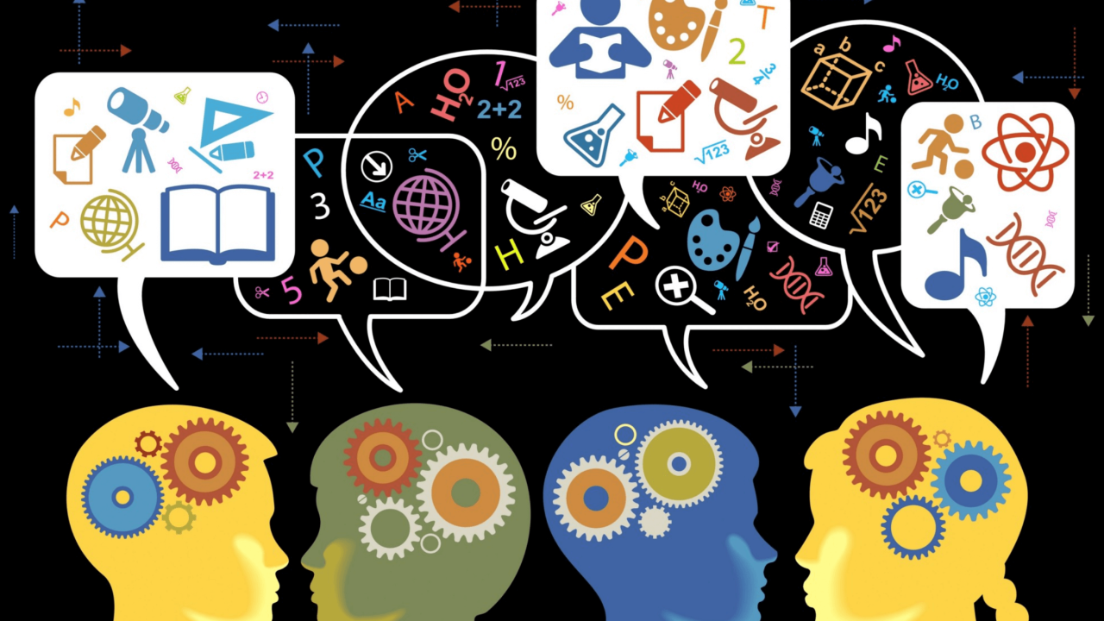
Source: Science Says. (2017). https://davissciencesays.ucdavis.edu/blog/next-level-science-communication-humanize-normalize-illuminate

11.4 Why is Science Communication Important?
Science Communication is important for the following reasons:

- Research and innovation play a crucial role in generating new knowledge which needs to be transformed into concrete applications.
- There are many societal challenges that need to be addressed by science such as pandemics, artificial intelligence, big data, food security, climate or energy.
- Science Communication presents scientific evidence in an objective and diverse manner.
- Appropriate science communication is key to research-informed policu making and societal debates.
- Science Communication should involve various stakeholders who participate in the research process. Science Communication includes stakeholder involvement and public engagement.
- Science Communication informs public decisions with regards to health, climate, AI. The COVID-19 pandemic has shown how vital science communication is for successful response to a public health crisis. During the rapid spread of the virus, the public was bombarded with conflicting information from various sources, leading to confusion and mistrust in science. This situation has highlighted the need for effective and transparent science communication to build trust in science and prevent the spread of fake news, misinformation, and disinformation (Matta 2020).
- Science Communication builds trust in science
- Science Communication encourages policy support and funding
- Science Communication helps combat misinformation

Real-World Examples:
- COVID-19 vaccine hesitancy
- AI ethics in media
- Climate change debates

  - The Audience for Science Communication
There are different audiences that require different approaches to access science communication. These include the general public, policymakers, educators and students, industry stakeholders and media professionals. The key questions that the audiences want to ask are:
- What does the audience already know?
- What do they care about?
- What action do I want them to take?

Communication about Science and Technology may be done by science journalists, science communicators or public relations officers in a scientific institution. The difference between the communication is that the latter is primarily concerned with promoting a particular perspective or agenda. One of the main tasks of PR officer is to manage the reputation of individual scientists or scientific organizations and to promote a positive public image for their clients or employers. This can create potential conflicts of interest, particularly in cases where the client or employer has financial or political reasons for promoting a particular scientific finding or development.

A science communicator is primarily focused on explaining scientific concepts and findings in a way that is understandable and engaging to a broad audience, often with the goal of increasing public interest and understanding of science. A science journalist, on the other hand, is a type of journalist who specializes in reporting on scientific topics. Their goal is often to inform the public about new scientific findings, debates, and implications, and to hold scientists and institutions accountable by questioning their claims and methods.

11.6 The Role of Science Communication
Science communication, in its traditional sense, is often perceived as the mere dissemination of scientific insights to an audience outside of its originating scientific community. However, such a simplistic view does not capture the depth and complexity inherent in this discipline. In our analysis, we have presented a more nuanced and detailed definition. This refined perspective highlights two key components:
(1) The ability to discern and accurately represent the prevailing scientific consensus, as well as pinpoint areas of ambiguity or contention within the scientific community regarding a specific subject.
(2) The skill to articulate this knowledge in a manner that not only fosters comprehension, but also builds trust and encourages active engagement among the intended recipients.
It is important for the development of the field of science communication that these insights become part of the very definition of science communication.
The role of a science communicator is to bridge the gap between various scientific communities and the other groups of people, and to make scientific concepts, research, and discoveries accessible and understandable to a wider audience. Science communicator is not only a translator of scientific achievements from professional to lay language, but also a guarantor of the credibility of the message.

11.7 Principles of Effective Communication
Techniques for Clarity and Engagement:
- Avoid jargon or explain it simply
- Use analogies or metaphors
- Tell a story (narrative framing)
- Highlight relevance (“Why it matters to you”)
- Use visuals (infographics, videos)
Example: Compare a dense scientific abstract to a simplified blog version of the same research.

11.8 Challenges in Communicating Science
Common Barriers:
- Complexity of the subject
- Public mistrust or skepticism
- Sensationalism in media
- Misuse or oversimplification of facts
Case Study Discussion:
How was science misunderstood or misrepresented in a recent public issue? (e.g., AI replacing jobs, vaccine rumors)

11.9 Tools and Platforms Used to Communicate Science and Technology
There are several tools and platforms where Science meets the audience:
- Blogs, podcasts, science YouTube channels
- Twitter/X, LinkedIn, and academic TikTok
- Science journalists and media outlets
- Visual platforms (e.g., Canva, Piktochart)

11.10 DOs of Science Communication

Let us now look at some of the key DO’s and DON’Ts that can be used in Science Communication to ensure that the communication is clear and the message is well understood.

Tip | Description
Know your audience | Tailor your message based on who you're speaking to—general public, students, policymakers, etc.
Use clear, simple language | Replace jargon with everyday words, or explain terms simply.
Tell a story | Use storytelling techniques: characters, conflict, resolution—this helps people care.
Make it relevant | Show how the topic affects people’s lives (health, environment, jobs, etc.).
Use analogies and metaphors | Help explain abstract ideas with familiar comparisons (e.g., DNA is like a recipe).
Include visuals | Graphs, diagrams, and infographics make data easier to understand.
Engage on digital platforms | Share your research on blogs, YouTube, or social media to reach wider audiences.
Be transparent | Clearly state limitations, uncertainties, or conflicts of interest.
Practice ethical communication | Be accurate, avoid exaggeration, and give credit to sources.

11.11 DON’Ts of Science Communication
Warning | Description
Don’t assume everyone understands the basics | Always explain key concepts—even if they seem obvious to you.
Don’t use too much jargon or technical terms | It confuses and alienates non-experts.
Don’t oversimplify to the point of distortion | Make it accessible, but keep the science honest.
Don’t sound arrogant or dismissive | Speak with empathy—especially when addressing public concerns.
Don’t ignore opposing views or fears | Acknowledge them respectfully and provide evidence.
Don’t make it all about facts and data | Include emotion, impact, and storytelling.
Don’t just talk—listen | Be open to questions, feedback, and dialogue.
Don’t rely only on one platform | Different audiences use different media—adapt accordingly.

11.11 Summary

In this lesson, we have focused on some of the contemporary issues and trends in Communication research. This is the second part of a two-part lesson where we shall discuss issues concerning Communicating Science and Technology. We have explained what Science Communication is and the role of Science Communication. We also discussed why Science Communication is important and the tools and platforms used to communicate Science and Technology. Finally, we looked at the DO’s and DON’Ts of Science Communication and the challenges in communicating Science.

11.12 References

Burns, T. W., O’Connor, D. J., & Stocklmayer. Science Communication: A Contemporary

Definition. Public Understanding of Science. 12(2)
https://journals.sagepub.com/doi/abs/10.1177/09636625030122004
Dolenc, S. (2023). The essence of science communication. https://sci-highs.com/essence-of-
scicom/
Lewenstein, Bruce. 2022. “What Is ‘“Science Communication”’?” Journal of
Science Communication 21 (7): C02. https://doi.org/10.22323/2.21070302.
Matta, Gagan. 2020. “Science Communication as a Preventative Tool in the
COVID19 Pandemic.” Humanities and Social Sciences Communications 7 (1): 1–14. https://doi.org/10.1057/s41599-020-00645-1.
Science Europe. (2024). Our Priorities. https://scienceeurope.org/our-priorities/science-communication/
Science Says. (2017). https://davissciencesays.ucdavis.edu/blog/next-level-science-communication-humanize-normalize-illuminate

